Profile for Waterfall Country Volunteer Warden
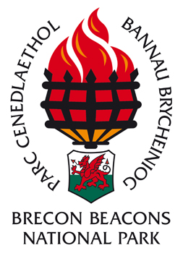

Accountable to: Brecon Beacons National Park Assistant Area Warden / National Park Volunteers Service Coordinator

Location: Gwaun Hepste Car Park, Clun Gwyn Car Park,
Craig y Ddinas Car Park

Hours: A minimum of 10 days p/a from 9:30am-4pm on weekends and bank holidays with some midweek work in the busy summer period.

PURPOSE OF ROLE
To offer a friendly and approachable public face by having a Brecon Beacons National Park Volunteer presence at our visitor sites in Waterfall Country; to have a good knowledge of the area to provide education, advice and reassurance to the public; to help maintain a pleasant environment for visitors, by organising car parking and removing litter.

KEY ELEMENTS

- To engage with the public and provide information and advice on:
- Route Choice
- Suitable equipment for the terrain (footwear etc)
- Local amenities
- Safety considerations when using Waterfall Country

- To be provide a visible base by using a branded vehicle, flags and display boards in either Gwaun Hepste, Clun Gwyn or Craig y Ddinas car park (as per rota) and use this base for the day for the provision of information and sale and distribution of leaflets and maps to visitors.

- Committed to working a minimum of ten days per year on weekends, bank holidays and occasionally week days in the busy summer period.

- To collect and return the float along with a record of sales to relevant venue.

- To call out the emergency services and inform the duty warden in the event of a serious accident. To keep a record of and report to the duty warden at the end of the day any major or minor accidents/incidents.

- Intermittent checks and litter picks of the car parks, issuing of parking tickets (if safe and comfortable to do so) and promoted Waterfall Country routes and reporting of any issues to the Assistant Area Warden.

- To participate in training sessions and meetings with other volunteers and the Assistant Area Warden.

8. To adhere to the Waterfall Country Volunteer Warden Health and Safety Policy at all times.

KNOWLEDGE and SKILLS

Knowledge:
An interest in providing information and advice to the general public.
Previous knowledge of the area or a willingness to promptly gain relevant knowledge.
Understanding and supporting the Brecon Beacons National Park purposes.
Useful Skills:
Full driving licence.
Good spoken communication skills and an enjoyment in meeting and talking to people and the confidence and ability to work alone or in pairs in the remote countryside.
Map reading and navigation
Basic IT skills – use of internet and e-mail
A good level of physical fitness
Basic first Aid

Personal Qualities:
Good interpersonal skills
A sensible regard for your health and safety and that of others
Reliable

Further Training will be provided where possible, to potentially include:

Basic map reading and navigation.
Dealing with the public.
First Aid.
Basic public right of way law.
Basic customer service training.

