Brecon Beacons National Park Authority
Affordable Housing Strategy
February 2016
Contents

1.0 Introduction. 2
2.0 Background 2
3.0 Allocation Process 3
4.0 Affordable Housing Priority Areas 3
5.0 Eligible Organisations 7
6.0 Eligible Schemes 7
7.0 Monitoring and Review 7
Appendix A Application form 8
Appendix B Balance of Affordable Housing Fund as of August 2016 10

1.0 Introduction.
1.1 This is the Affordable Housing Strategy for the Brecon Beacons National Park. Following an 8 week period of consultation in the Autumn of 2016, this document has been endorsed by the National Park Authority for use in the allocation of funds collected for the provision of affordable housing.
1.2 The Authority committed to the production of this strategy in September 2014 with the publication of the adopted Affordable Housing Supplementary Planning Guidance. Since that time the Authority has been working with Housing Authorities and Registered Social Landlords to determine the contents of this strategy.
1.3 This document provides further detail in relation to the process by which monies collected under Policy 28 and CYD LP1 of the LDP will be spent for the provision of Affordable Housing. It does this in three ways:
- By providing detail in relation to the process by which such money will be allocated to appropriate affordable housing schemes.
- Sets out the priority areas for the spending of such monies in accordance with housing need.
- Defines bodies eligible to apply to the Authority to utilise such monies for the provision of affordable housing.

2.0 Background
2.1 As the Local Planning Authority, the National Park authority is responsible for developing, implementing and monitoring policies to enable the provision of affordable housing within the National Park. However, it is the responsibility of the respective Unitary Authorities as Housing Authorities to deliver affordable housing. It is also their responsibility to determine the mix of units to be provided within the National Park.
2.2 During the development of the Local Development Plan it was determined that there was a need for 1248 new affordable dwellings to be built between 2007 and 2022. Amounting to approximately 103 new affordable dwellings to be delivered per annum.
2.3 It is recognised that the housing allocations within the Local Development Plan are not sufficient by themselves to provide all the affordable housing needed within the National Park area. It is therefore the strategy of the National Park Authority, working with our partners, to maximise all opportunities to contribute to the provision of affordable housing. One of the ways we attempt to achieve this aim, is by requiring a contribution towards affordable housing from all development which results in the net gain of dwellings, in areas where it is viable to do so.
2.4 Where such a contribution would be less than one whole unit, the obligation is met through the provision of a financial contribution (commuted sum). Details on how this is calculated is provided in the Authority Approved Affordable Housing Supplementary Planning Guidance (September 2014).
2.5 Commuted sums towards the provision of affordable housing are held by the National Park Authority in an ear marked reserve for the provision of affordable housing. This reserve is referred to as ‘The Brecon Beacons National Park Authority Affordable Housing Fund’ or AHF. Such money will be released to eligible organisations for the development of new affordable housing. The allocation of such funds is set out below.

3.0 Allocation Process
3.1 On May 1st of each year this strategy is operational, the National Park Authority will invite applications from eligible bodies to the AHF. This invitation will be published to the Authorities Website and will include details of:
- The total amount of money available for allocation.
- The areas from which the money has been collected.
- Information that will need to be submitted in support of an application (see appendix a for further details)
- Closing date for the submission of application (usually a 6 week application period)
3.2 Any application received by the Authority will be passed to the relevant Strategic Housing Authority for their comment. The Strategic Housing Authority will provide a report on the appropriateness of each scheme considering the following three elements
- Appropriateness of the scheme to meet housing need within the area
- Deliverability of scheme
- Compliance with Unitary Authority Affordable Housing Strategies.
3.3 The Authority will then hold a meeting of the Members Affordable Housing Working Group. Where relevant Strategic Housing Officers will be invited to attend these meetings to provide advice in relation to the applications being considered.
3.4 The Members Affordable Housing Working Group will consider the applications along with the following information;
- The location from which monies were originally collected
- The priority areas for spending monies (see section 4 below for more information)
- The information supplied by the Strategic Housing Officers relating to the appropriateness of each scheme
- Appropriateness of the scheme in Planning Terms
3.5 The Members Affordable Housing Working Group will make a recommendation in relation to each application.
3.6 A report will then be provided to the next available meeting of the National Park Authority detailing the findings of the Members Affordable Housing Working Group including recommendations for the allocation of available monies to named schemes.
3.7 The allocation of monies from the AHF will be the decision of the National Park Authority. This decision will be made in public session and will be a matter of public record.
3.8 Monies will be released to successful applicants following the decision of the NPA, with the condition that it is spent on the scheme applied for, the Authority be kept informed of the progress of the scheme and provided with evidence as to when the money has been spent.
3.9 Monies must be spent within three years of allocation. Any unspent monies retained by the applicant after this time must be returned to the BBNPA AHF.

4.0 Affordable Housing Priority Areas
4.1 Utilising the latest housing waiting list data the Authority has mapped housing need across the Authority by Community/Town Council area. The need is broken into six bands as follows

Category | Colour on map | Number of people on waiting list
No known need |  | Not known/less than 1
Low need |  | Between 1 and 63 people
Moderate need |  | Between 64 and 125 people
High need |  | Between 125 and 250 people
Very High need |  | Between 250 and 750 people

4.2 The map showing the spatial distribution of these categories is shown at figure 1 below. This map is correct as of the 23rd January 2017.
4.3 In assessing applications to the AHF priority will be given to those schemes within areas with the highest level of need.
4.4 However in allocating the monies, consideration must also be given to where such monies were collected. It is the intention of the NPA to utilise monies within the settlement or community council area in which they were collected if this is at all possible. However, often the value of such contributions is such that it would not provide a meaningful amount of grant to bring forward an appropriate development scheme. Accordingly it may be necessary to pool contributions (up to five) to provide greater opportunities for the money to bring forward affordable housing development on the ground.
4.5 The cascade for spending affordable housing contributions is set out at Appendix 9 of the Authority Approved Affordable Housing Supplementary Planning Guidance (BBNPA September 2014). Criteria e of this cascade sets out that where money cannot be utilised within the community council and adjoining community council areas then it is possible to utilise Affordable Housing Submarket Areas as a geographical area for the spending of monies. The NPA consider this to be the most appropriate geographical area of search for suitable schemes to be funded by the BBNPA AHF. For example, if monies were collected from the Settlement of Sennybridge, and no suitable scheme could be found within Maescar, Llywel or Crai Community Council, areas, that money could potentially be utilised for suitable Affordable Housing Schemes anywhere within the Brecon and Rural Hinterland Submarket Area. It must be stressed however, that it will always be the intention of the NPA to spend monies as close to their point of collection as is possible. Boundaries for the Affordable Housing Submarket Areas area are shown on the Affordable Housing Need Map (figure 1).

4.5 For each affordable housing submarket area the priority areas for spending are as follows (areas are listed in priority of need)

Affordable Housing Submarket Area | Need | Priority Community/Town Council
Brecon and Rural Hinterland |  | Brecon
 |  | Glyn Tarell
 |  | Talgarth
Abergavenny, Hay and Crickhowell |  | Llanfoist Fawr
 |  | Crickhowell
 |  | Llanelly
 |  | Crucorney
 |  | Llangattock
 |  | Cwmdu and District
 |  | Llangynidr
Heads of the Valley and Rural South |  | Llanelly (Llanelly Hill)

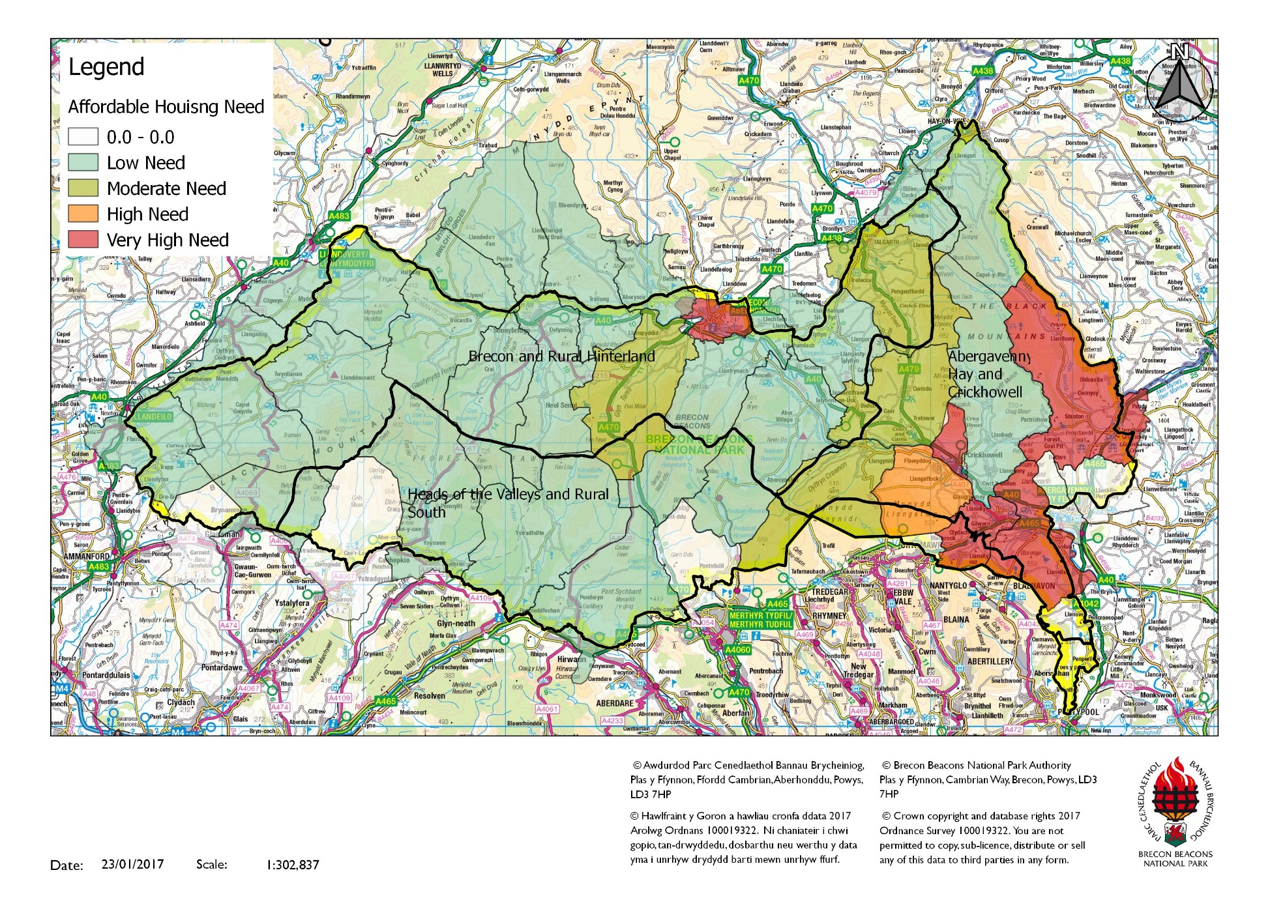
Figure 1 –Affordable Housing Need by Category of Need

5.0 Eligible Organisations
5.1 The following organisations will be eligible to apply for funding from the AHF
- Registered Social Landlords
- Housing Authorities with powers to develop their own Affordable Housing
- Housing co-operatives for schemes that meet the definition of eligible schemes (given below)
- Community Land Trusts for schemes that meet the definition of eligible schemes (given below)

6.0 Eligible Schemes
6.1 A scheme will be considered eligible if it is to provide, in perpetuity, affordable housing in accordance with the following definition.
- Social rented Defined as properties provided by Local Authorities and Registered Social Landlords (RSLs) for rent at the Welsh Government guideline rents and Benchmark Rent Levels (or equivalent); and
- Intermediate Housing where prices or rents are above those of social rented housing but below market housing prices or rents, such as properties available for intermediate rent or shared equity schemes.
6.2 Schemes with any element of market housing or houses with unrestricted occupancy will not be considered acceptable for funding from the AHF.
In addition to the above:-
- Eligible schemes will ideally by on the Unitary Authorities reserve list for Social Housing Grant, or be at least known to the Housing Authority as potential sites for the provision of affordable housing.
- Eligible schemes will ideally have received planning permission however schemes known to the NPA, which have received pre-application advice, will also be considered.

7.0 Monitoring and Review
7.1 In order to ensure that the information within this document remains relevant this document will be reviewed annually and re-issued each April. Please ensure that you are viewing the most up-to-date version of this document. The elements that are most subject to change are Section 4 – Priority areas for spending and Appendix b – Balance of Affordable Housing Fund.
7.2 The NPA will also require successful applicants to provide frequent updates in relation to the progress of the scheme. Where money is unspent within a three year period the NPA will require that it is returned for re-allocation.
7.3 The NPA will produce an annual report detailing the spending of the AHF and the progress of the schemes allocated funds. This will be published alongside the reviewed Affordable Housing Strategy each April.

Appendix A Application form
Request to Draw Down BBNPA Affordable Housing Fund
Affordable Housing Development
PART 1 SCHEME
Registered Social Landlord/Developer | Unitary Authority
Name and Address of Site | Community Council Area
Vendor of Site/Property | Has sale been agreed?
Has Unitary Authority agreed that the site meets their Housing Need Yes | This request must be accompanied by confirmation from the Unitary Authority that the site meets strategic housing need
What stage in the planning process is the site in question?
Please provide any planning referneces provided by the NPA

Amount of Affordable Housing Fund Requested | Total Scheme Cost (specify whether estimated or tendered)
Other public subsidy e.g. SHG, HFG | Amount

PART 2 PROCUREMENT ROUTE
Package Deal |  | DIY LCHO
Design and Build |  | Existing Dwelling
Off-the-Shelf |  | Conventional Procurement (Framework)

PART 3 SCHEME DETAILS
Type of Scheme e.g. Social Rent, Intermediate Rent or LCHO | Number of Units
Bedrooms - General Needs | 1 | 2 | 3 | 4/5
Bedrooms - OAP
Bedrooms - OAP/Disabled Bungalows | 1 | 2 | 3

PART 4 SCHEME COSTS
£
Land/property purchase price
Other public subsidy
Affordable Housing Fund amount requested
RSL contribution
Total scheme costs (specify whether estimated or tendered)

Appendix B Balance of Affordable Housing Fund as of January 2017
Application number | Date Permission granted | Proposal | SM area |  | Settlement | Amount detailed in S106 | Date Received | Date Allocated
13/10295/FUL | Permitted 07.10.2014 | Construction of 92 dwellings, Cae Meldon | A,C&H | Mon | Gilwern | £175,200.60
13/09841/FUL | Permitted 27.10.2015 | Construction of one dwelling at Ael Y Bryn | B&R | Powys | Bwlch | £15,056.80
13/10285/FUL | Permitted 30.09.2014 | Erection of 1 dwelling - Roayl Oak, Pencelli | B&R | Powys | Pencelli | £16,251.60
13/10289/OUT | Permitted 25.10.2016 | Multiple Housing Development - Ty Clyd Close | A,C&H | Mon | Govilon | £5,045.84
14/11036/FUL | Permitted 12.10.2016 | The studio, Upper House Farm | A,C&H | Powys | Crickhowell | £5,000 | 04.01.2017
14/11337/FUL | Permitted 01.02.2016 | Canal Bank Gardens, Brecon | B&R | Powys | Brecon | £24,151.20
14/11607/FUL | Permitted 12.06.2016 | Single Dwelling, 19 Fairhome, Gilwern | A,C&H | Mon | Gilwern | £24,377.40
14/11655/FUL | Permitted 07.04.2015 | Dan Y Castell, Crickhowell | A,C&H | Powys | Crickhowell | £2,000
15/11949/FUL | Minded to permit S106 9.11.2015 | Captain's Walk, Brecon | B&R | Powys | Brecon | £17,144.80
15/12528/FUL | Permitted 16.12.2016 | 2 Dwellings to the rear Bronant | B&R | Powys | Talgarth | £15,000
15/12509/FUL | Permitted 18.03.2016 | 1 dwelling, Green Meadows | B&R | Powys | Brecon | £19,105.20
16/13164/FUL | Minded to permit 22.03.2016 | Change of use of chapel to dwelling | B&R | Powys | Maescar | £20,450.80
15/13000/FUL | Permitted 26.05.2016 | 1 dwelling, Peppercorn Lane | B&R | Powys | Brecon | £2,465.53
16/13189/FUL | Minded to permit 12.04.2016 | Divide House into 2 flats | A,C&H | Powys | Hay | £17,730.00
16/13266/FUL | Permitted 24.05.2016 | Conversion Triley Court Nursing Home | A,C&H | Mon | Abergavenny | £25,000
14/11593/CON | Permitted 11.03.2015 | Variation of Planning obligation to 11/06647/FUL | A,C&H | Powys | Llangynidr | £89,262 | 01.04.2016
16/13533/OUT | Minded to permit S106 11.08.16 | Outline application detached dwelling | B&R | Powys | Libanus | £22,190.80
16/13213/FUL | Minded to permit S106 07.08.16 | Conversion to 3 flats 29 High Street | B&R | Powys | Brecon | £15,000
14/10864/FUL | Permitted 24.09.15 | Erection of a 2 bedroom bungalow | B&R | Powys | Pennorth | £16,959.20
16/13832/FUL | minded to permit s106 23.11.2016 | New Dwelling Ty'r Berllan | A,C&H | Powys | Crickhowell | £5,000.00
12/08575/OUT | Permitted 13.01.17 | Mixed use development Cwrt Y Gollen | A,C&H | Powys | Crickhowell | £517,528.20*
Total |  |  |  |  |  | £1,049,919.97 | £94,262
Total Abergavenny, Crickhowell and Hay Sub Market area |  |  |  |  |  | £866,144.04 | £94,262
Total Brecon and Rural Hinterland and Sub Market area |  |  |  |  |  | £183,775.93 | £0
Total Heads of the Valleys and Rural South area |  |  |  |  |  | £0 | £0
Total Powys |  |  |  |  |  | £820,296.13 | £94,262
Total Carms |  |  |  |  |  | £0 | £0
Total Mons |  |  |  |  |  | £229,623.84 | £0

*Indicative figure based on allocation of 70 dwellings, actual figure may be subject to change through Reserved Matters Process.

