Brecon Beacons National Park Authority

Local Development Plan

Biodiversity in the Towns of the Brecon Beacons National Park

March 2015 &
September 2016

Supplementary Planning Guidance

Policy B LP1 Brecon Appropriate Development
Policy K LP2 Key Settlement Appropriate Development

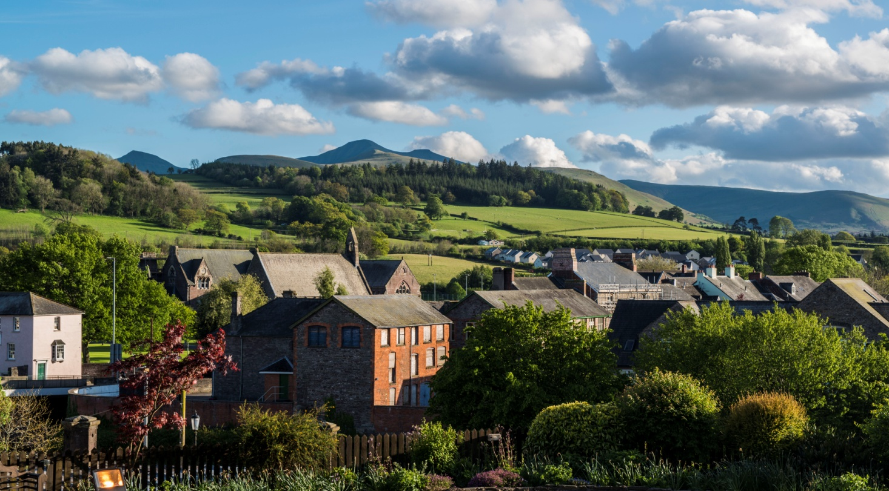
Contents
1.0 Introduction 4
2.0 Legislation and Policy Context 5
2.1 Legislative Context 5
2.2 National Policy Context 5
2.3 Local Policy Context 6
3.0 Green Infrastructure and identifying the existing biodiversity assets 9
4.0 Biodiversity in and around Brecon 11
4.1 Overview 11
4.2 International and nationally designated sites (Special Areas of Conservation, SACs and Sites of Special Scientific Interest, SSSIs) 11
4.3 Locally important habitats and wildlife features (including Sites of Importance for Nature Conservation, SINCs) 11
4.4 Protected and priority species 12
4.5 Habitat protection and enhancement 13
4.6 Opportunities for habitat creation 13
4.7 Green Infrastructure map of Brecon 14
5.0 Biodiversity in and around Crickhowell 16
5.1 Overview 16
5.2 International and nationally designated sites (Special Areas of Conservation, SACs and Sites of Special Scientific Interest, SSSIs) 16
5.3 Locally important habitats and wildlife features 16
5.4 Protected and priority species 17
5.5 Habitat protection and enhancement 18
5.6 Opportunities for habitat creation 18
5.7 Green Infrastructure map of Crickhowell 18
6.0 Biodiversity in and around Hay-on-Wye 20
6.1 Overview 20
6.2 International and nationally designated sites (Special Areas of Conservation, SACs and Sites of Special Scientific Interest, SSSIs) 20
6.3 Locally important habitats and wildlife features 20
6.4 Protected and priority species 21
6.5 Habitat protection and enhancement 22
6.6 Opportunities for habitat creation 22
6.7 Green Infrastructure map of Hay on Wye 22
7.0 Biodiversity in and around Talgarth 24
7.1 Overview 24
7.2 International and nationally designated sites (Special Areas of Conservation, SACs and Sites of Special Scientific Interest, SSSIs) 24
7.3 Locally important habitats and wildlife features 24
7.4 Protected and priority species 25
7.5 Habitat protection and enhancement 25
7.6 Opportunities for habitat creation 26
7.7 Green Infrastructure map of Talgarth 26
8.0 Biodiversity in and around Sennybridge 28
8.1 Overview 28
8.2 International and nationally designated sites (Special Areas of Conservation, SACs and Sites of Special Scientific Interest, SSSIs) 28
8.3 Locally important habitats and wildlife features 28
8.4 Protected and priority species 28
8.5 Habitat protection and enhancement 28
8.6 Opportunities for habitat creation 29
Appendices 31
Appendix 3 Section 7 List of Priority Habitats in Wales 31
Appendix 4 Glossary of Terms 32

1.0 Introduction

1.1 This document is being presented for public consultation. It is intended that following consultation, the guidance will be adopted by the National Park Authority for use as Supplementary Planning Guidance and be material in the determination of planning applications.

1.2 The purpose of this guidance is to expand upon the policies in the Local Development Plan in relation to development in and around the Key Settlements of the Brecon Beacons National Park as follows:

- Brecon
- Crickhowell
- Hay
- Talgarth
- Sennybridge

1.3 This guidance should be read in conjunction with the BBNPA’s Biodiversity and Development Supplementary Planning Guidance (September 2016).

1.4 The guidance identifies habitats and species in and around the Key Settlements and provides guidance on their protection and enhancement. This document is informed by a detailed biodiversity audit commissioned by the National Park Authority in 2012. This was undertaken by the Brecknock Wildlife Trust (BWT) with assistance from the Biodiversity Information Service for Powys and Brecon Beacons (BIS) and covered the towns of Brecon, Crickhowell, Hay-on-Wye and Talgarth. Since commissioning the study, Sennybridge/Defynnog has been identified as a Key Settlement within the LDP; further biodiversity information will therefore need to be gathered to complete the guidance for this settlement.

1.5 The document includes information on the following key themes:
- Relevant nature conservation legislation, policy and guidance
- Analysis of the biodiversity assets in the Key Settlements
- Biodiversity protection and enhancement measures
- Opportunities for habitat creation
- Additional sources of information and guidance

1.6 Please note that since the endorsement of the original SPG document in March 2015, the Environment (Wales) Act 2016 came into force in March 2016. This replaces the Natural Environment and Rural Communities (NERC) Act 2006 in Wales. Section 6 of the new Act has a new and enhanced “biodiversity duty” that requires public authorities to seek to maintain and enhance biodiversity. Lists of species and of habitats of principal importance in Wales are issued under Section 7; this replaces the lists issued under Section 42 of the NERC Act that were referred to in this document. At time of publication, the two sets of lists are identical, but will be subject to review.

2.0 Legislation and Policy Context

2.1 Legislative Context
2.1.1 The protection of biodiversity is afforded the highest protection under European and UK legislation.

2.1.2 The Environment Act 1995 states that the first Statutory Purpose of National Parks is to conserve and enhance the natural beauty, wildlife and cultural heritage of the National Park. In addition to this, the Environment (Wales) Act 2016 (Section 6) sets out a ‘Biodiversity duty’ for all Local Authorities in Wales (including National Park Authorities), stating that:-

A public authority must seek to maintain and enhance biodiversity in the exercise of functions in relation to Wales, and in so doing promote the resilience of ecosystems, so far as consistent with the proper exercise of those functions.

2.1.3 There are a number of sites within the National Park which are afforded protection under the Conservation of Habitats & Species Regulations 2010 (as amended) (also known as the Habitat Regulations) and the Wildlife and Countryside Act 1981 (as amended). These include Special Areas of Conservation (SACs) and Sites of Special Scientific Interest (SSSIs) respectively. The Wildlife and Countryside Act also places a duty on Local Authorities [through the proper exercise of their functions] to further the conservation and enhancement of SSSIs.

2.1.4 In addition to specific sites, certain species of wildlife are also afforded specific protection. Species which are protected by UK law are listed in the Wildlife and Countryside Act 1981 (as amended). European protected species are listed in the Habitats Regulations, Schedules 2 and 4. Developers should make sure they understand and comply with this legislation, including that afforded to nesting birds during the nesting season.

2.1.5 The UK Biodiversity Action Plan (UKBAP) includes objectives to conserve and, where practicable, enhance:

- The quality and range of wildlife habitats and ecosystems;
- The overall populations and natural ranges of native species;
- Internationally important and threatened species, habitats and ecosystems;
- Species, habitats and natural and managed ecosystems characteristic of local areas; and
- Biodiversity of natural and semi-natural habitats where this has been diminished over recent decades.

2.1.6 Accordingly the Brecon Beacons National Park Authority has produced a Local Biodiversity Action Plan for the area (LBAP). This document sets out the species and habitats for priority conservation within the National Park area. Section 7 of the Environment (Wales) Act 2016 lists the habitats and species of principal importance for conserving biodiversity in Wales (see Appendix 3 for the relevant list of priority habitats).

2.2 National Policy Context
2.2.1 Planning Policy Wales (PPW) sets out the land use planning policies of the Welsh Government. It is supplemented by a series of Technical Advice Notes. National policy must be taken into consideration in the formation of local policy and is material to decisions on individual planning applications and will be taken into account by the Welsh Ministers and Planning Inspectors in the determination of called-in planning applications and appeals.

2.2.2 Chapter 5 of PPW relates to the conservation and improvement of Wales’ Natural Heritage. It sets out the Welsh Government’s objectives for the conservation and improvement of Wales’ Natural Heritage to:

- Promote the conservation of landscape and biodiversity, in particular the conservation of native wildlife and habitats;
- Ensure that action in Wales contributes to meeting international responsibilities and obligations for the natural environment;
- Ensure that statutorily designated sites are properly protected and managed;
- Safeguard protected species; and to
- Promote the functions and benefits of soils, and in particular their function as a carbon store.

2.2.3 Section 5.2.8 of PPW states ‘the planning system has an important part to play in meeting biodiversity objectives by promoting approaches to development which create new opportunities to enhance biodiversity, prevent biodiversity losses, or compensate for losses where damage is unavoidable. It sets out that local planning authorities must address biodiversity issues, insofar as they relate to land use planning in both development plans and development management decisions. Local planning authorities should consider how they might accommodate a response to climate change as part of their overall approach towards meeting biodiversity objectives. Ways in which the adaptation needs of biodiversity could be considered include identifying the scope for minimising or reversing the fragmentation of habitats and improving habitat connectivity through the promotion of wildlife corridors. Local Planning Authorities should ensure that development minimises impact within areas identified as important for the ability of species to adapt and/or to move to more suitable habitats’.

2.2.4 This position is supplement by Technical Advice Note 5 Nature Conservation and Planning (TAN 5) (2009) which sets out detailed information on Nature Conservation in Development Control Procedures, including information necessary to be submitted in support of a planning application. In addition to guidance on designated sites and protected species covered by the above legislation, it also recognises the importance of the role of Local Sites (Sites of Importance for Nature Conservation and Regionally Important Geological Sites) in delivering biodiversity targets and contributing to the well-being of communities.

2.3 Local Policy Context
2.3.1 The development plan for the area is the Local Development Plan (LDP) which was adopted by resolution of the National Park Authority in December 2013. This document forms the policy context against which all development management decisions are made within the National Park area.

2.3.2 Key objective of the LDP is to conserve and enhance the rich and complex biodiversity of the Park. This objective is implemented by the following policies:-

- SP3 Environmental Protection
- Policy 3 Sites of European Importance
- Policy 4 Sites of National Importance
- Policy 5 Sites of Importance for Nature Conservation
- Policy 6 Biodiversity and Development
- Policy 7 Protected and Important Wild Species
- Policy 8 Trees and Development
- Policy 9 Ancient Woodland and Veteran Trees

2.3.3 Of particular relevance within the context of this guidance note are Policy 6 and Policy 7. These are set out below.

Policy 6
Biodiversity and Development

Development will only be permitted where;

1. the developer proves to the satisfaction of the NPA that there is no unacceptable loss or fragmentation or other impact of a habitat or landscape feature and/or increased isolation on important species as listed under Section 42 of the NERC act (habitats and species of principal importance to Wales), OR
2 A the developer identifies habitats and landscape features of importance for wildlife within the site and provides for the further creation, positive management, restoration, enhancement or compensation for these habitats and features to ensure that the site maintains its nature conservation importance; and
B B full provision is made for the future management of the site's habitats and features of nature conservation value. This will be secured either through Planning Obligations or the imposition of Planning Conditions; and
C C there is no unacceptable loss/breaching of linear features (e.g. hedgerows, woodland belts). Development should seek to enhance linear habitat features (e.g. hedgerow, woodland belts) ‘dark corridors’ and roosts used by bats
The NPA will require all development being judged against this policy to provide biodiversity enhancement through the scheme in accordance with the direction of the Planning Obligation Strategy.

Policy 7
Protected and Important Wild Species

Proposals on land or buildings that support protected or important species will only be permitted where:

    - the need for the development outweighs the nature conservation importance of the site, and in the case of European protected species, the criteria for derogation under the Habitats Regulations are met; and
    - positive measures are provided to contribute to species and habitat conservation targets; and
    - the developer proves to the satisfaction of the NPA that

a) the disturbance of the species and habitat in terms of the effect on species survival and reproductive potential or habitat function will be kept to a minimum; or

b) alternative areas are provided to sustain at least the current levels of populations or size of habitat affected by the proposal.

3.0 Green Infrastructure and identifying the existing biodiversity assets

3.1 Green Infrastructure (GI) is the network of natural and semi-natural features, green spaces, and water bodies that intersperse and connect our villages and towns. Living close to green spaces provides important benefits to our daily lives including to our health and well-being. Development pressures in and around our settlements can have impacts on these features. However, when appropriately planned, designed and managed, the green infrastructure assets and functions have the potential to deliver a wide range of benefits to wildlife as well as to the people living and working in our towns and villages. Knowledge of the existing distribution of habitats and species in and around the Key Settlements of the National Park helps us to provide appropriate guidance on their protection as well as identifying opportunities for their enhancement. It also provides an understanding of how species can move in and around our towns and how and where the provision of green infrastructure plays an important role in this.

3.2 The key principles of positive planning for nature conservation are set out in chapter 2 of TAN 5. These include:
- Integrating nature conservation into all planning decisions
- Looking for development to provide net benefits for biodiversity conservation
- Preparing Supplementary Planning Guidance that highlights ways in which the planning system can help to deliver the objectives of the Local Biodiversity Action Plan
This document therefore seeks to highlight the existing biodiversity assets in and around the towns of the Brecon Beacons National Park and to provide ideas for delivering biodiversity enhancements through the Development Management process.

3.3 This guidance is informed by a detailed biodiversity audit that was commissioned by the National Park Authority and was undertaken by the Brecknock Wildlife Trust (BWT) with assistance from the Biodiversity Information Service for Powys and the Brecon Beacons National Park (BIS). The Biodiversity Audit Project report was published in 2012; the main report is reproduced in Appendix 1 of this document and Appendix 2 contains the maps produced at that time. Inevitably, new records of species and [to a lesser extent] habitats will come forward that will need to be accommodated in a future review of this guidance. It should also be noted that the absence of records of species does not mean that they are not present, just that they haven’t been recorded there.

3.4 The following key principles should be adopted when considering habitat creation and enhancement schemes in development proposals:
- Schemes should seek to use native species and of local provenance where possible, whether seed, shrubs or trees.
- Major developments should incorporate community aspirations for biodiversity within the proposals and foster community participation in the long-term management of wildlife areas.
- Interpretation of the wildlife interest is beneficial where there is public access to wildlife areas.
- There should be encouragement of wildlife-friendly gardening for new home owners (and allotment tenants).
- It will be important to secure long-term management agreements for wildlife areas on development sites to ensure delivery of biodiversity benefits in the future; this may be through a Section 106 agreement.
- Opportunities to accommodate green roofs and green walls should be sought where possible.
- New developments that require Sustainable Drainage Systems (SuDS) to manage surface-water run-off should seek to incorporate biodiversity features.
- Where a development proposal increases areas of hard surfaces, consideration should seek to utilise permeable surfaces to limit the impact of surface runoff on nearby water courses.
- Schemes should seek to protect, enhance and/or create wildlife corridors and connectivity.

3.5 The following sections of this guidance document provide information on the biodiversity assets that have been identified in and around our Key Settlements. Protection and enhancement measures are then identified along with opportunities for habitat creation to strengthen the provision of green infrastructure within development proposals. Developers can consult these sections to ensure that they deliver appropriate biodiversity enhancement measures as part of their development proposals. It should be noted that this guidance provides an overview of the issues, but does not negate the need for up-to-date and detailed ecological surveys of development sites.

3.6 Green infrastructure maps of the Key Settlements have been produced using information from the biodiversity audit; these highlight the areas of green space within the towns as well as features such as rivers, woodlands and trees. Strengthening and/or linking these areas will improve connectivity and opportunities for movement of wildlife in our towns.

3.7 Invasive non-native species (INNS) are any non-native animals, plants or other organisms that have the ability to spread, causing damage to the environment, the economy, our health and the way we live. Examples of such species that may be found on or adjacent to development sites in the Brecon Beacons include Himalayan balsam, Japanese knotweed and giant hogweed. It is important for developers to understand the harm that these species can cause to our native flora and fauna and to ensure that appropriate action is taken to remove them from development sites.

4.0 Biodiversity in and around Brecon

4.1 Overview
4.1.2 Brecon lies on the northern foothills of the Brecon Beacons. The River Usk is a dominant feature, flowing west to east through the town; two main tributaries, the Honddu and the Tarrell join the Usk at Brecon. The river corridors are generally tree-lined and provide cover and foraging habitat for a number of species. There is dense woodland along the steep slopes of the Honddu and southern slopes of Slwch Tump. The surrounding land is predominantly mixed farmland – pasture and arable fields with hedgerow boundaries. The green infrastructure map for Brecon at the end of this section shows the distribution of green space and biodiversity features within and at the edge of the town.

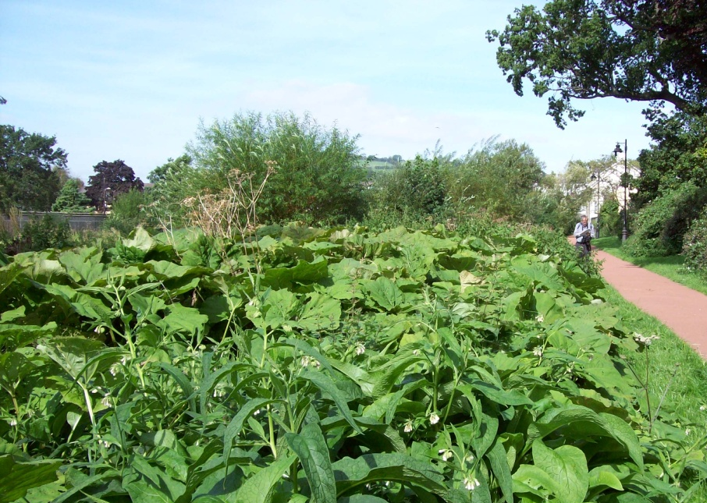
Photo 1: Captain’s Walk, Brecon

4.2 International and nationally designated sites (Special Areas of Conservation, SACs and Sites of Special Scientific Interest, SSSIs)
- River Usk SSSI and SAC
- River Usk Tributaries SSSI (including the Afon Tarrell and the Afon Honddu)

4.3 Locally important habitats and wildlife features (including Sites of Importance for Nature Conservation, SINCs)
- Rivers and streams and their associated habitats are a key feature of the green infrastructure in Brecon, with the main rivers afforded international protection
  - River Usk
  - River Tarrell
  - River Honddu
  - Stream at Maen-du Well
- Standing water
  - The Brecon and Monmouthshire Canal
  - Ponds to the north-east at Penlan (including Penlan Pond SINC) and Slwch Farm
  - St David’s Water Treatment Works
- Woodland
  - Priory Woods
  - Slwch Tump woodland
  - Disused railway corridors (sections of the Brecon & Merthyr Railway and the Neath & Brecon Railway)
- Unimproved grassland
  - Plas y Ffynnon/Police Station SINC
- Amenity grassland
  - Patches throughout town
  - The schools’ grounds to the north-east
  - Christ College grounds to the south-west
  - The playing fields to the south-east
  - The golf course to the west
- Allotments and gardens including:
  - Newgate Allotment Gardens
  - The Watton Allotments
  - Newmarch Street Allotment Gardens
- Urban trees
- Hedgerows

4.4 Protected and priority species
4.4.1 The presence of protected species is a material consideration in the planning process. Species that have been identified as qualifying features for the designation of SSSIs and SACs require particular consideration. For example, the otter is one of the qualifying features of the River Usk SAC. Many protected species are also included in the Section 7 list under the Environment (Wales) Act; that is, they have been identified as species of principal importance for conserving biodiversity in Wales. Habitat enhancement measures for these species should be incorporated into development proposals.

4.4.2 The following is a selection of the protected and/or priority species have been recorded in the Brecon area:

European protected species:
- Otter
- Great crested newt
- Bats (including common and soprano pipistrelle, Brown long-eared, lesser horseshoe, whiskered, Brandt’s, Daubenton’s, Natterer’s and noctule)

Nationally protected species:
- Kingfisher
- Barn owl
- Smooth and palmate newts
- Slow worm
- Adder
- Bluebell

Priority species:
- West European hedgehog
- Weasel
- Song thrush
- Lesser spotted woodpecker
- Yellowhammer
- Spotted flycatcher
- Bullfinch

4.5 Habitat protection and enhancement
The following are suggested actions for the protection and enhancement and creation of habitats that are appropriate to the Brecon area; the list is not exhaustive. The maps in Appendix 2 show the habitats in and around Brecon. Priority species recorded in the area that will benefit from the implementation of these actions are also included; other species not previously recorded may also benefit.

 | Priority habitats & biodiversity features | Actions | Species
1 | Rivers and streams | Retention of ‘buffer zones’ to protect water quality by reducing siltation  Sensitive management of trees and river banks e.g. pollarding of trees | Otter  Kingfisher  Fish species associated with the R. Usk SAC
2 | Standing water | Restoration of ponds  Sensitive management of canal banks (trees and grassland) | Great crested newt  Otter  Kingfisher
3 | Grasslands | Retention and protection of existing “pockets” of unimproved grassland | Barn owl  Reptiles
4 | Hedgerows | Retention and enhancement of existing hedgerows (see maps in Appendix 2)  Planting of new native, mixed-species hedgerows, particularly to buffer and provide links between habitats | Nesting birds  Bats  Great crested newt
5 | Street trees | Retain street trees & protect during development  Installation of bat and bird boxes on existing trees (where appropriate) | Bats  Nesting birds
6 | Gardens and allotments | Promotion of wildlife-friendly gardening to new home owners and allotment tenants
7 | Amenity grassland | Reduce cutting regimes where possible  Introduce locally-sourced wildflowers (seed or plants) | Insects

4.6 Opportunities for habitat creation

The following are suggested actions for the creation of habitats that are appropriate to the Brecon area; again, the list is not exhaustive.

 | Priority habitats and biodiversity features | Actions | Species
1 | Ponds | Pond creation  Construction of newt hibernacula and creation of habitat corridors between ponds | Great crested newt
2 | Rivers and streams  Wet woodland | Construction of otter holts in undisturbed areas  Planting of alder and willow woodland | Otter  Nesting birds
3 | Hedgerows | Planting of mixed, native-species hedgerows with hedgerow trees | Bats  Birds  Insects
4 | Grasslands | Creation of new wildflower meadows, preferably using locally-sourced seed  Use of wildflower seed mixes in Sustainable Drainage Systems (SuDS) | Insects  Bats and birds feeding on insects
5 | Trees | Planting of native-species trees in and around developments | Bats

4.7 Green Infrastructure map of Brecon

See following page

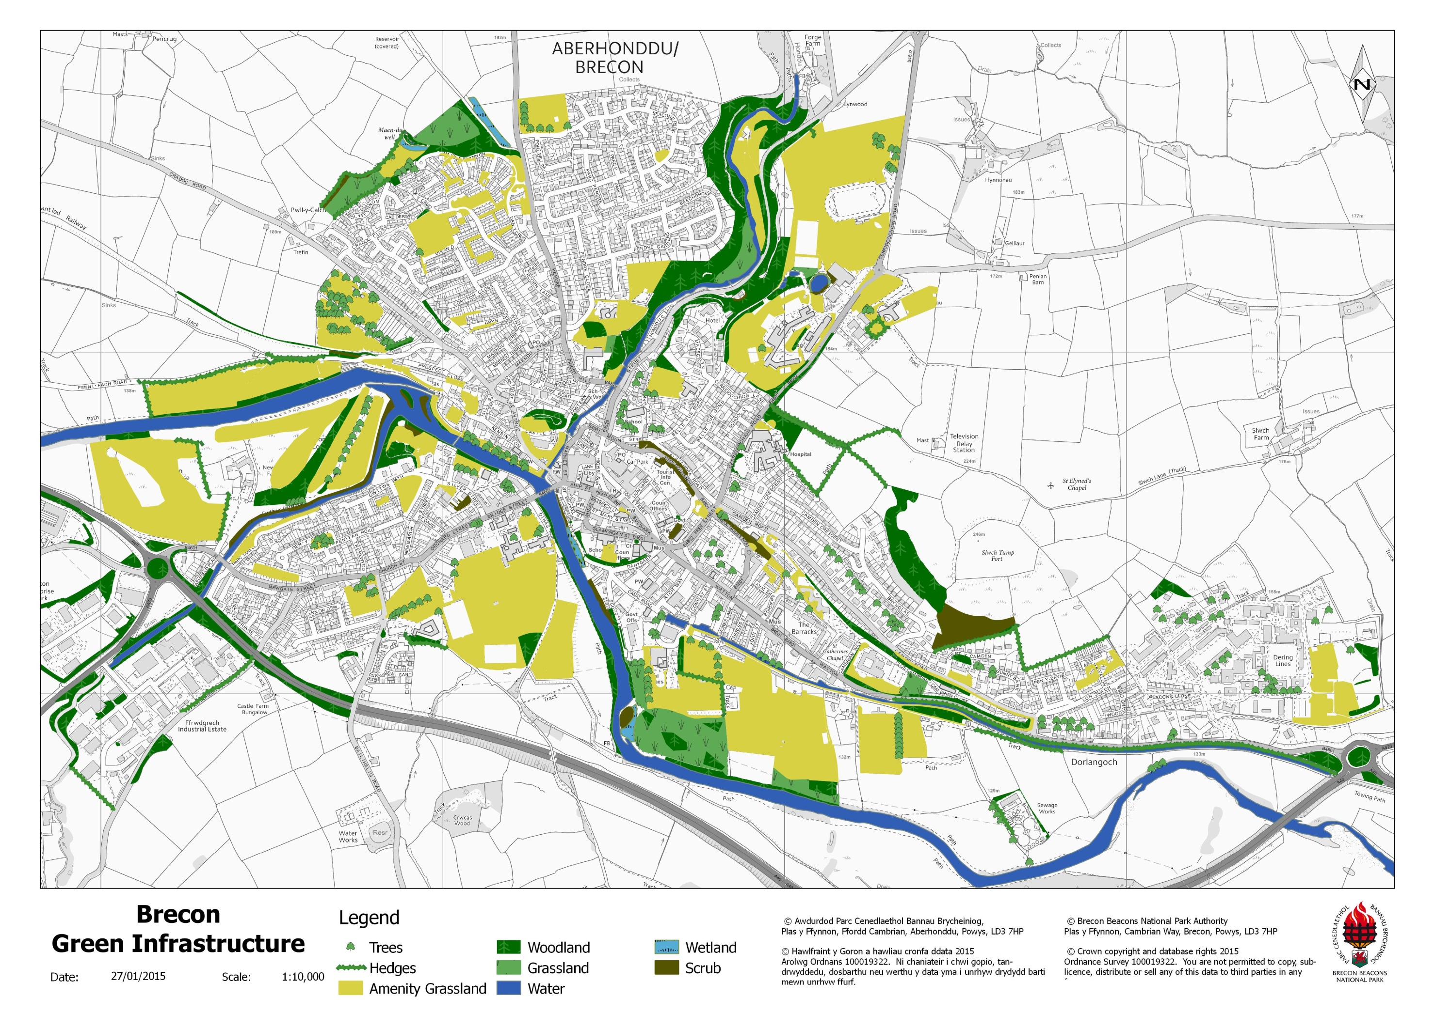

5.0 Biodiversity in and around Crickhowell

5.1 Overview
5.1.1 Crickhowell lies on the northern banks of the River Usk at the heart of the Usk Valley; the river is an important biodiversity feature, along with small tributaries flowing through the town including the Cwmbeth Brook. Tree cover is found along the watercourses as well as with scattered mature trees throughout the town, including at Alisby’s Castle. There are also some small areas of planted broad-leaf woodland as well as the Cefn Coed Woodland Trust Reserve to the east of Crickhowell. Large areas of amenity grassland are found at the school playing fields, the Bullpit recreation ground and the castle grounds as well as smaller areas throughout the town. The surrounding land is predominantly arable on the flatter areas of the floodplain and pasture on the steeper slopes to the north. The green infrastructure map for Crickhowell at the end of this section shows the distribution of green space and biodiversity features within and at the edge of the town.

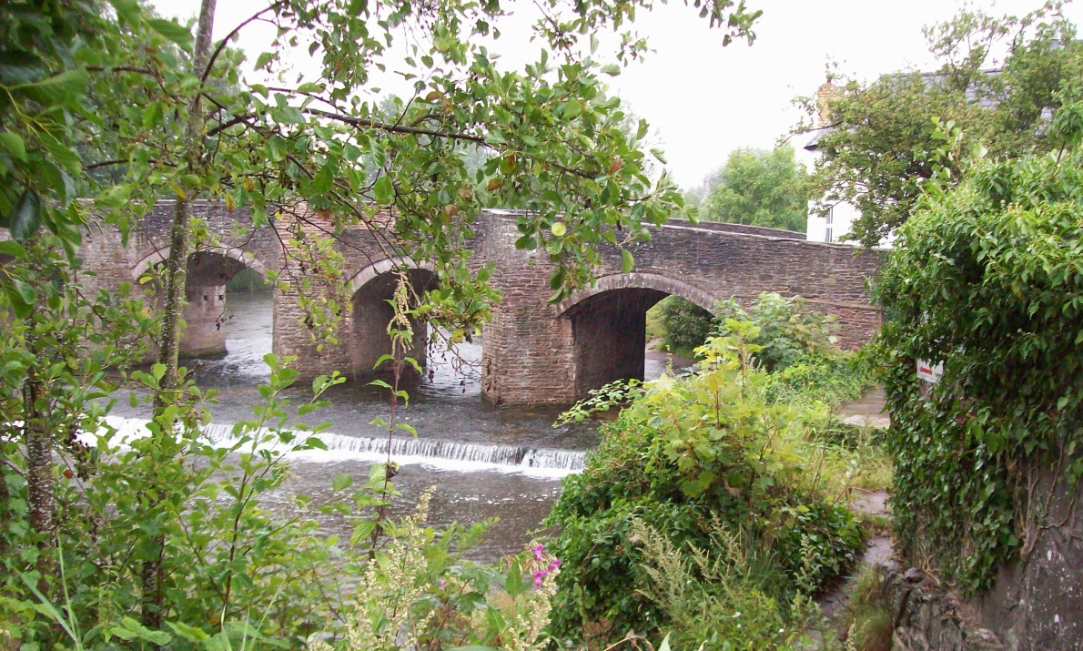
Photo 2: River Usk at Crickhowell

5.2 International and nationally designated sites (Special Areas of Conservation, SACs and Sites of Special Scientific Interest, SSSIs)
- River Usk SSSI and SAC

5.3 Locally important habitats and wildlife features
- Rivers and streams and their associated habitats are a key feature of the green infrastructure in Crickhowell, with the main rivers afforded international protection
  - River Usk
  - Cwmbeth Brook
  - Un-named brook flowing through Fffynnonau
- Woodland
  - Cefn Coed SINC (Woodland Trust Reserve)
  - Cwm Cwmbeth woodlands
- Grasslands (semi-improved)
  - North bank of River Usk (below the bridge)
- Amenity grassland
  - Bullpit Recreation Ground
  - Castle grounds
  - School playing fields
  - Patches throughout the town
- Allotments and gardens
  - Crickhowell Allotment Gardens
  - Llangattock Allotments
- Urban trees
  - Llanbedr Road
  - Beaufort Street Park
- Hedgerows

5.4 Protected and priority species
5.4.1 The presence of protected species is a material consideration in the planning process. Species that have been identified as qualifying features for the designation of SSSIs and SACs require particular consideration. For example, the otter is one of the qualifying features of the River Usk SAC. Many protected species are also included in the Section 7 list under the Environment (Wales) Act; that is, they have been identified as species of principal importance for conserving biodiversity in Wales. Habitat enhancement measures for these species should be incorporated into development proposals.

5.4.2 The following is a selection of the protected and/or priority species have been recorded in the Crickhowell area:

European protected species:
- Otter
- Bats (including lesser horseshoe, common and soprano pipistrelle, Brown long-eared, whiskered, Brandt’s, Natterer’s and noctule)

Nationally protected species:
- Kingfisher
- Barn owl
- Slow worm
- Adder
- Bluebell

Priority species:
- West European hedgehog
- Polecat
- Song thrush
- Lesser spotted woodpecker
- Tree sparrow
- Kestrel
- Bullfinch

5.5 Habitat protection and enhancement
The following are suggested actions for the protection and enhancement and creation of habitats that are appropriate to the Crickhowell area; the list is not exhaustive. The maps in Appendix 2 show the habitats in and around Crickhowell. Priority species recorded in the area that will benefit from the implementation of these actions are also included; other species not previously recorded may also benefit.

 | Priority habitats & biodiversity features | Actions | Species
1 | Rivers and streams | Retention of ‘buffer zones’ to protect water quality by reducing siltation  Sensitive management of trees and river banks e.g. pollarding of trees | Otter  Kingfisher  Fish species associated with the R. Usk SAC
2 | Street trees | Retain street trees & protect during development  Installation of bat and bird boxes on existing trees (where appropriate) | Bats  Nesting birds
3 | Amenity grasslands | Reduce cutting regimes where possible  Introduce locally-sourced wildflowers (seed or plants) | Insects
4 | Gardens & allotments | Promotion of wildlife-friendly gardening to new home owners and allotment tenants
5 | Hedgerows | Retention and enhancement of existing hedgerows (see maps in Appendix 2)  Planting of new native, mixed-species hedgerows, particularly to buffer and provide links between habitats | Nesting birds  Bats

5.6 Opportunities for habitat creation

 | Priority habitats & biodiversity features | Actions | Species
1 | Rivers and streams  Wet woodland | Construction of otter holts in undisturbed areas  Planting of alder and willow woodland | Otter  Nesting birds
2 | Hedgerows | Planting of mixed, native-species hedgerows with hedgerow trees | Bats  Birds  Insects
3 | Grasslands | Creation of new wildflower meadows, preferably using locally-sourced seed  Use of wildflower seed mixes in Sustainable Drainage Systems (SuDS) | Insects  Bats and birds feeding on insects
4 | Trees and woodlands | Planting of native-species trees in and around developments (individual trees as well as blocks of woodland) | Bats

5.7 Green Infrastructure map of Crickhowell
Please see following page

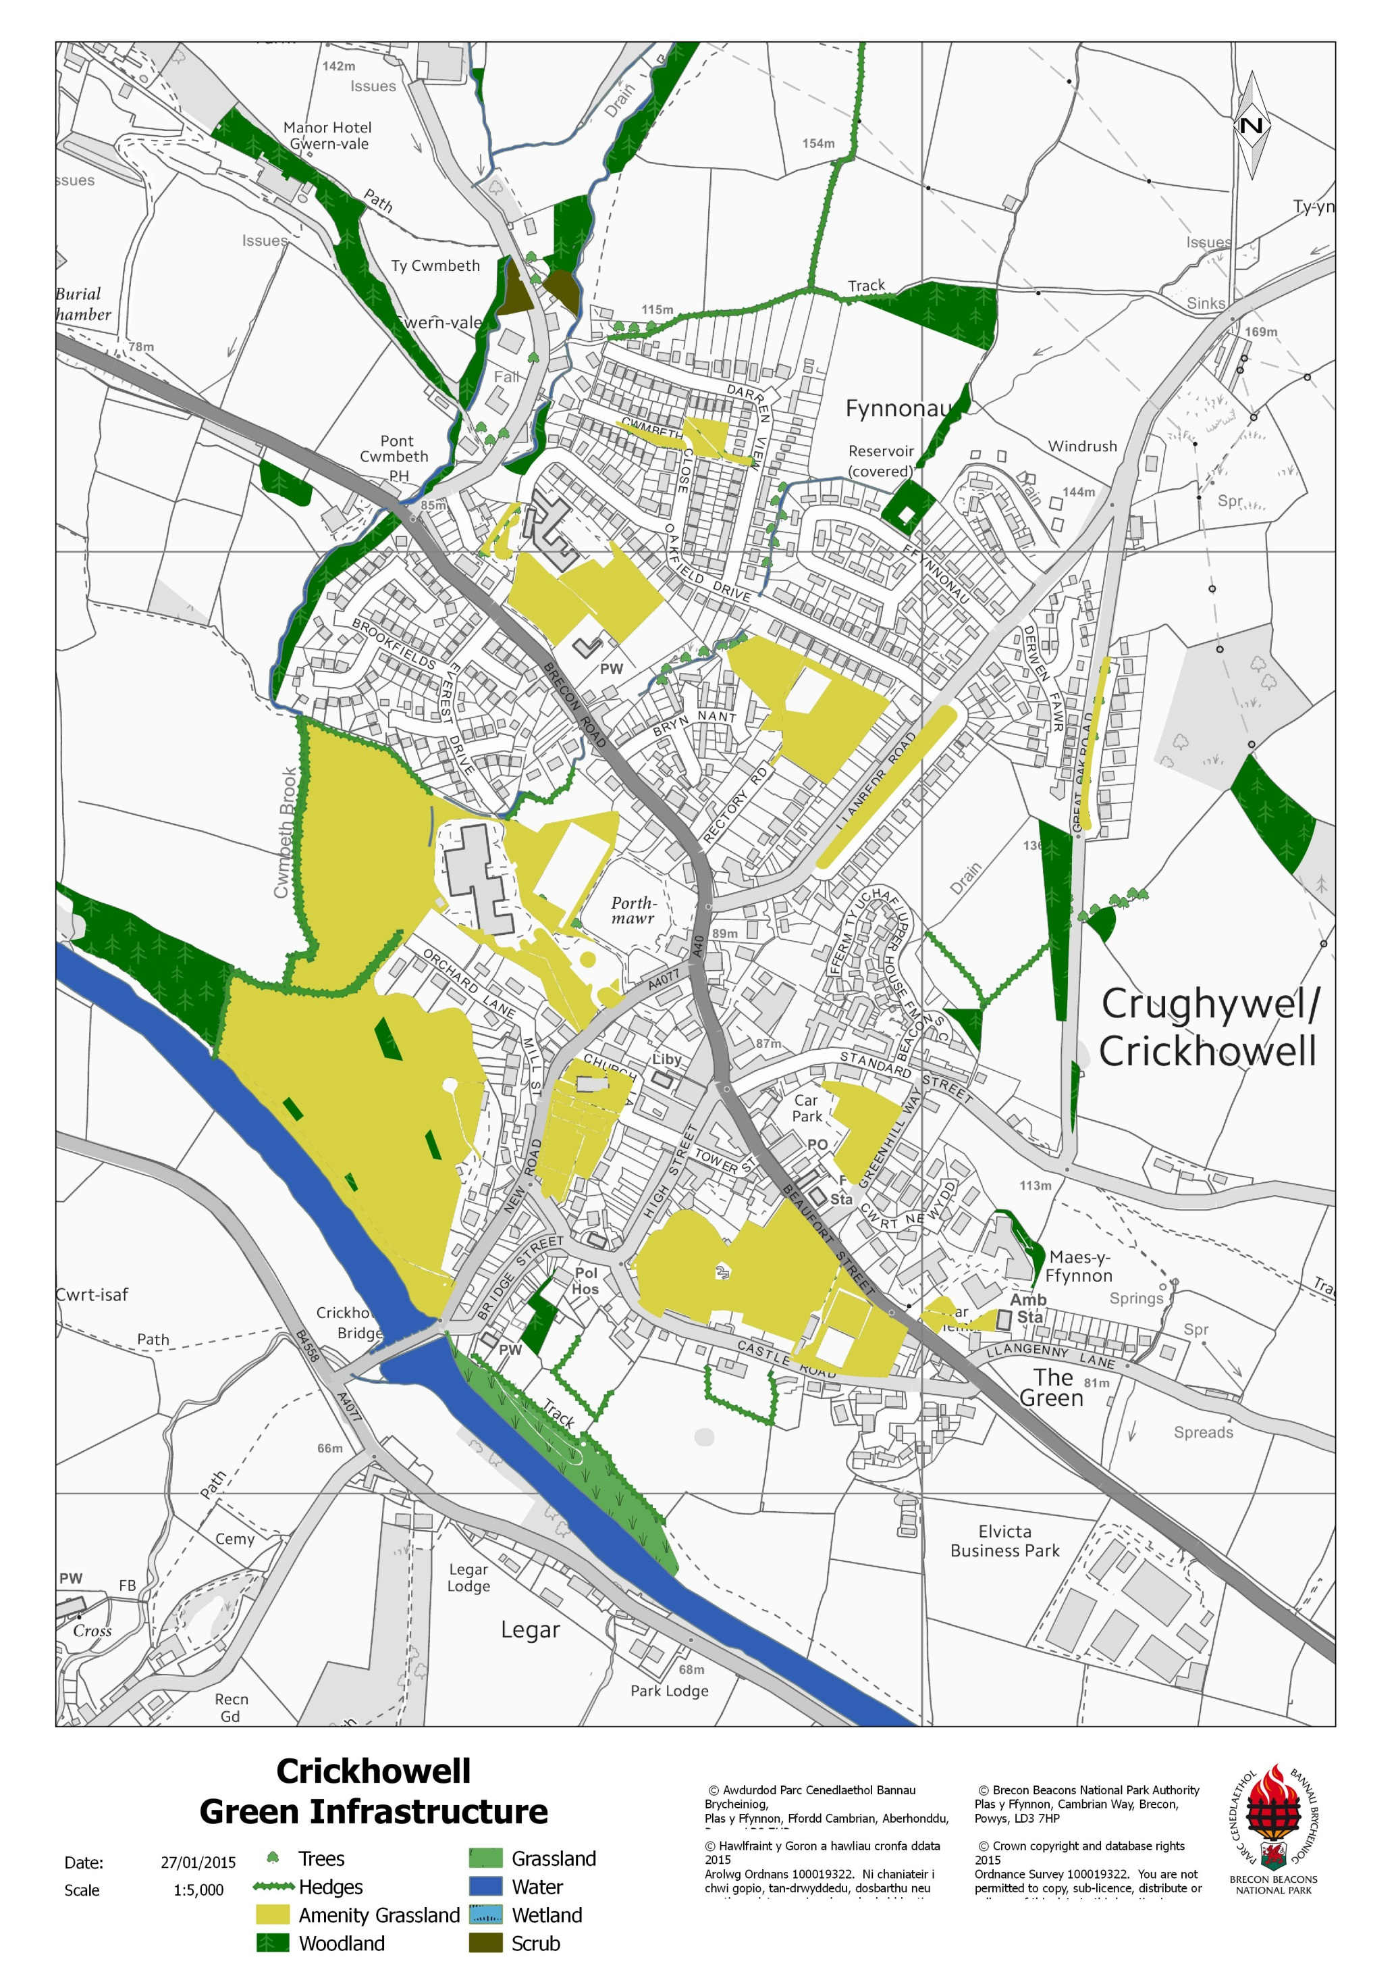

6.0 Biodiversity in and around Hay-on-Wye

6.1 Overview
6.1.1 Hay-on-Wye lies on the northern foothills of the Black Mountains. It is bounded to the north by the River Wye and to the east by Cusop Dingle, including the Dulas Brook, both forming the boundary to the National Park. There is a large bend in the river at The Warren with a shingle beach and open, semi-improved grassland on the higher ground to the south. Woodland along the river and the adjacent, disused tramway provides a valuable wildlife corridor for many species. The Castle also has mature trees as well as structures providing roosting features for bats. The land use to the south of Hay is predominantly pastureland with a good network of hedgerows. The green infrastructure map for Hay-on-Wye at the end of this section shows the distribution of green space and biodiversity features within and at the edge of the town.

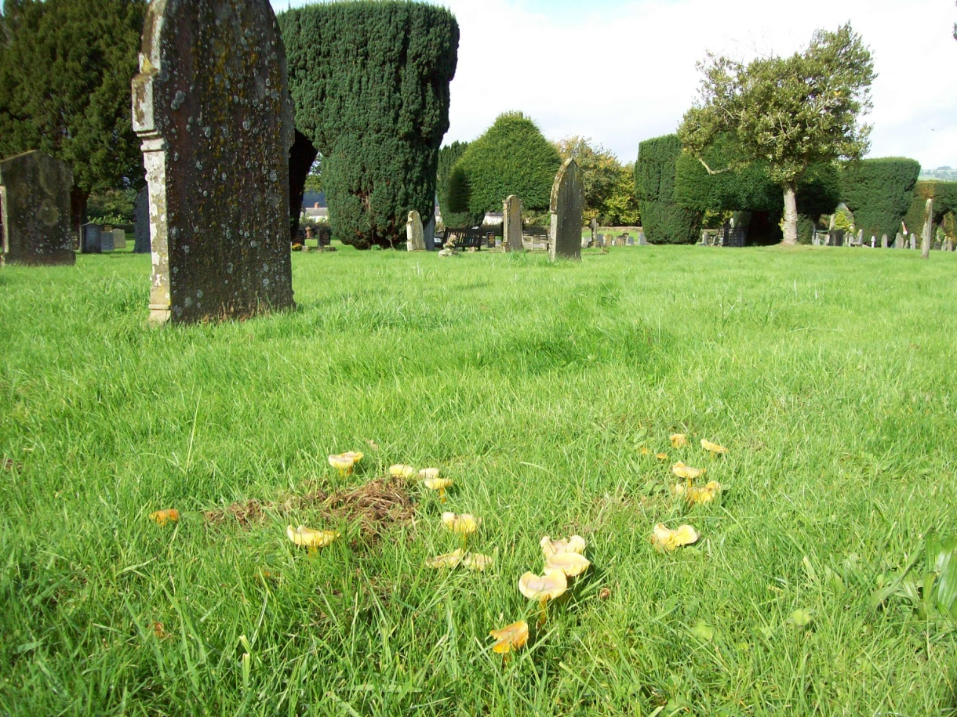
Photo 3: Hay-on-Wye Cemetery – grassland with wax cap fungi

6.2 International and nationally designated sites (Special Areas of Conservation, SACs and Sites of Special Scientific Interest, SSSIs)
- River Wye SSSI and SAC

6.3 Locally important habitats and wildlife features
- Rivers and streams and their associated habitats are a key feature of the green infrastructure in Hay-on-Wye, with the main river afforded international protection
  - River Wye
  - Dulas Brook
  - Login Brook
- Woodland
  - Cusop Dingle
  - Disused rail and tram way along the River Wye
  - Parts of The Warren
- Semi-improved grassland
  - The Warren
  - The cemetery
  - Fields to the south of the Surgery and the cricket pitch
  - The Motte
- Amenity grassland
  - The cemetery
  - Playing fields
  - Patches throughout town
- Orchards
  - Garibaldi Terrace
- Allotments and gardens
- Urban trees
  - The Castle
- Hedgerows

6.4 Protected and priority species
6.4.1 The presence of protected species is a material consideration in the planning process. Species that have been identified as qualifying features for the designation of SSSIs and SACs require particular consideration. For example, the otter is one of the qualifying features of the River Wye SAC. Many protected species are also included in the Section 7 list under the Environment (Wales) Act; that is, they have been identified as species of principal importance for conserving biodiversity in Wales. Habitat enhancement measures for these species should be incorporated into development proposals.

4.4.2 The following is a selection of the protected and/or priority species have been recorded in the Hay-on-Wye area:

European protected species:
- Otter
- Bats (including common and soprano pipistrelle, Brown long-eared, lesser horseshoe, greater horseshoe and noctule)
- Dormouse (records to the south of Hay-on-Wye)

Nationally protected species:
- Kingfisher
- Slow worm
- White-clawed crayfish
- Bluebell

Priority species:
- West European hedgehog
- Common Toad
- Dunnock

6.5 Habitat protection and enhancement
The following are suggested actions for the protection and enhancement and creation of habitats that are appropriate to the Hay-on-Wye area; the list is not exhaustive. The maps in Appendix 2 show the habitats in and around Hay-on-Wye. Priority species recorded in the area that will benefit from the implementation of these actions are also included; other species not previously recorded may also benefit.

 | Priority habitats & biodiversity features | Actions | Species
1 | Rivers and streams | Retention of ‘buffer zones’ to protect water quality by reducing siltation  Sensitive management of trees and river banks e.g. pollarding of trees | Otter  White-clawed crayfish  Fish species associated with the R. Wye SAC
2 | Grasslands | Retention and protection of existing semi-improved and unimproved grasslands | Slow worm  Insects
3 | Hedgerows | Retention and enhancement of existing hedgerows (see maps in Appendix 2)  Planting of new native, mixed-species hedgerows, particularly to buffer and provide links between habitats | Nesting birds  Bats
4 | Street trees | Retain street trees & protect during development  Installation of bat and bird boxes on existing trees (where appropriate) | Bats  Nesting birds

6.6 Opportunities for habitat creation
 | Priority habitats & biodiversity features | Actions | Species
1 | Rivers and streams  Wet woodland | Construction of otter holts in undisturbed areas  Planting of alder and willow woodland | Otter  Nesting birds
2 | Hedgerows | Planting of mixed, native-species hedgerows with hedgerow trees | Bats  Birds  Insects
3 | Grasslands | Creation of new wildflower meadows, preferably using locally-sourced seed  Use of wildflower seed mixes in Sustainable Drainage Systems (SuDS) | Insects  Bats and birds feeding on insects
4 | Orchards | Planting of new orchards as community areas, including on former orchard sites | Birds  Insects
5 | Trees | Planting of native-species trees in and around developments | Bats

6.7 Green Infrastructure map of Hay on Wye
Please see following page
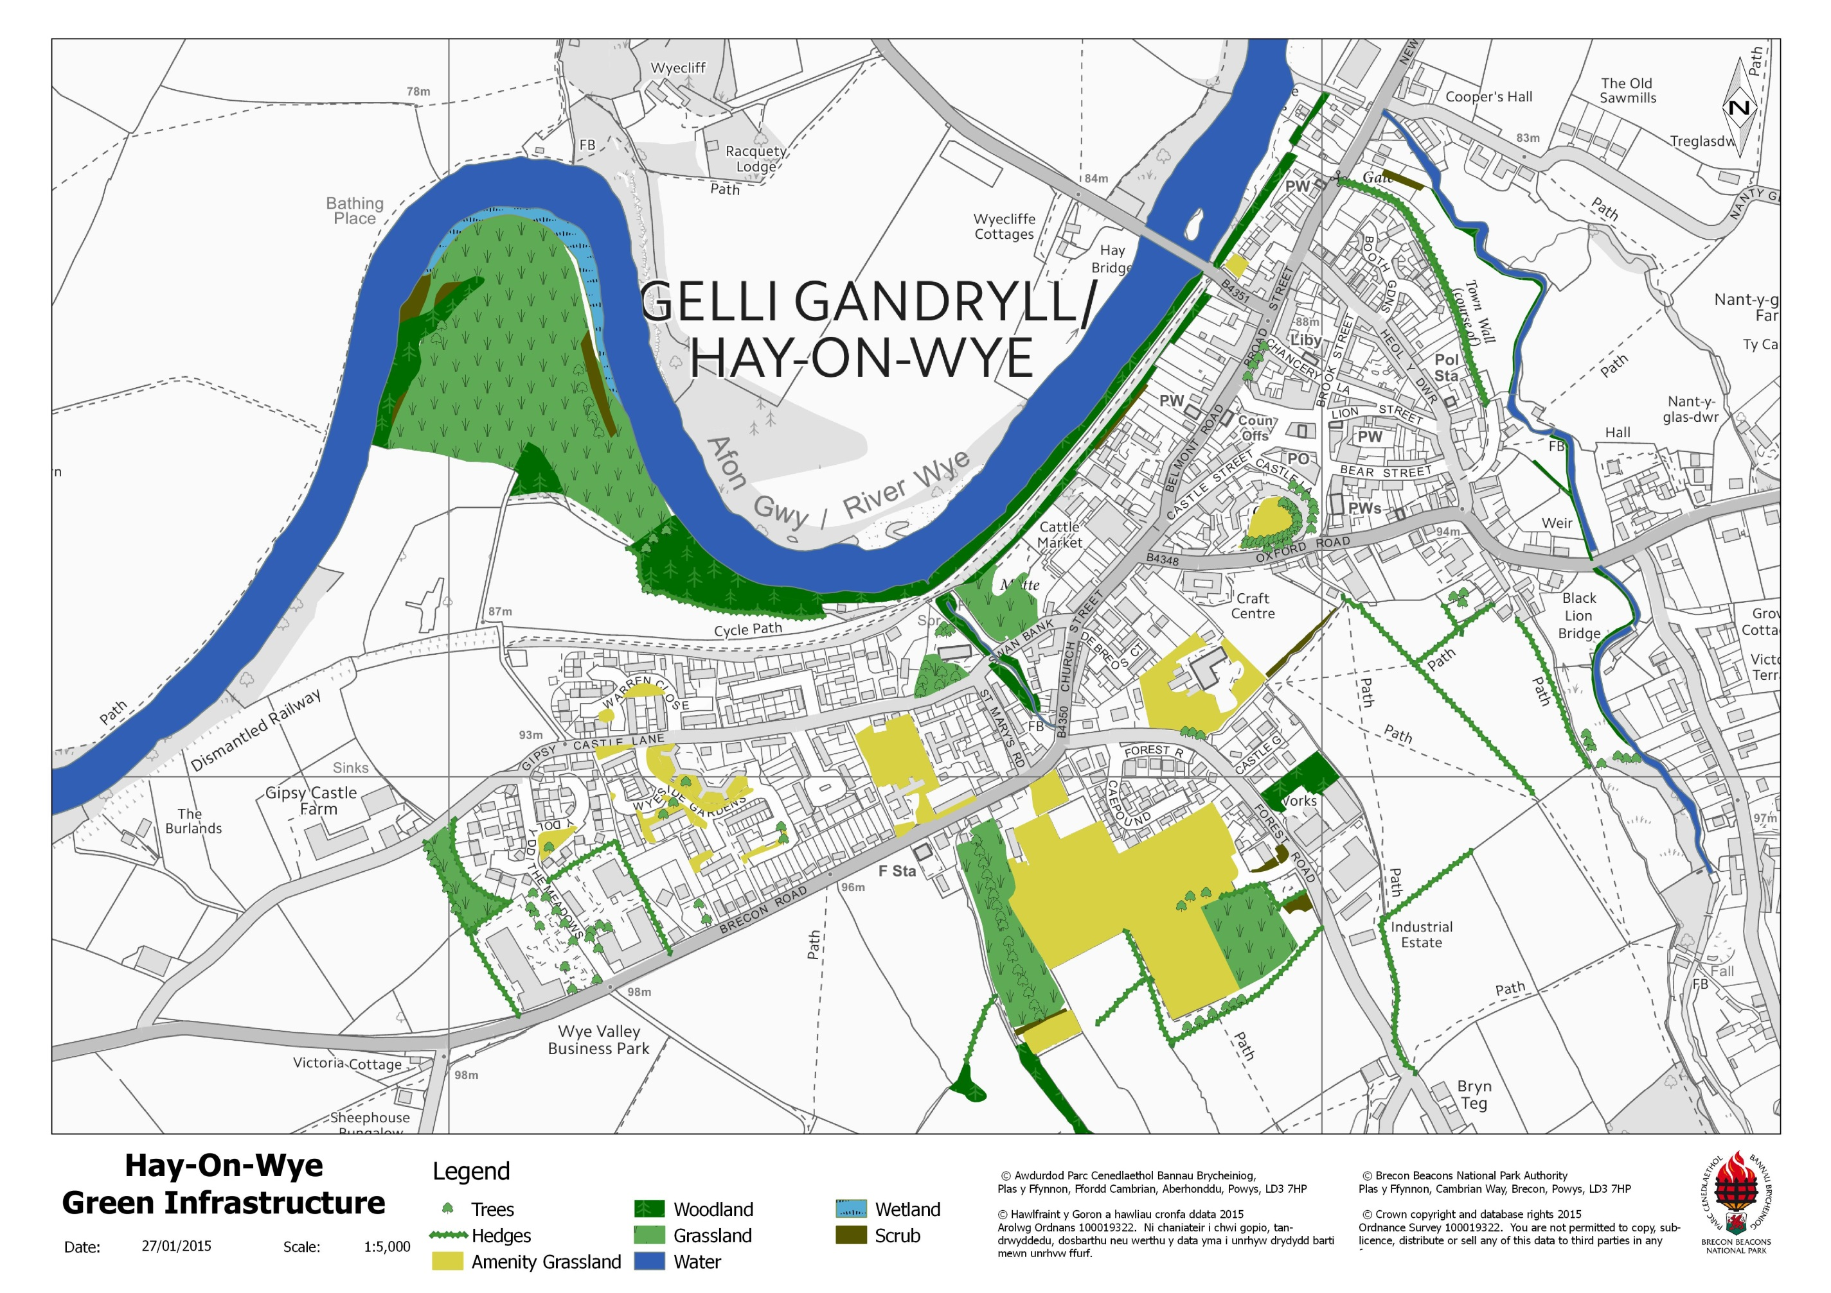

7.0 Biodiversity in and around Talgarth

7.1 Overview
7.1.1 The River Ennig flows through the town before joining the Rive Llynfi, which is a SSSI and part of the River Wye SAC; it is fast-flowing, with many waterfalls. The nearby woodlands of Pwll-y-Wrach and Park Wood provide valuable habitats for many species, particularly dormice, nesting birds and bats. The land use to the south and east has many small pastures with a strong hedgerow network; two roadside nature reserves have been designated by Powys County Council. Historic maps also show that Talgarth was surrounded by orchards in the past, a few of which remain. The green infrastructure map for Talgarth at the end of this section shows the distribution of green space and biodiversity features within and at the edge of the town.

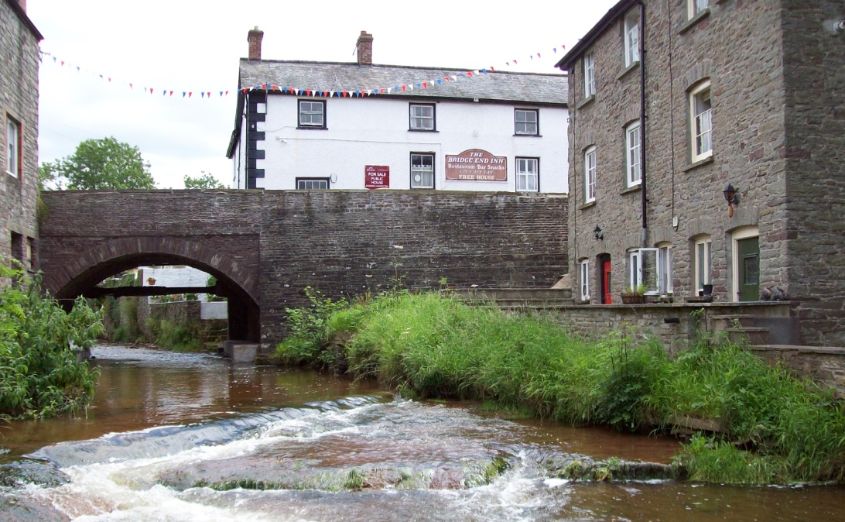
Photo 4: River Ennig, Talgarth

7.2 International and nationally designated sites (Special Areas of Conservation, SACs and Sites of Special Scientific Interest, SSSIs)
- Pwll y Wrach SSSI
- River Llynfi SSSI (500m north of Talgarth) and part of the River Wye SAC

7.3 Locally important habitats and wildlife features
- Rivers and streams and their associated habitats
  - River Ennig
  - Cwm Rhyd-Ellywe
- Woodland
  - Pwll y Wrach
  - Park Wood
- Amenity grassland
  - King George’s Playing Fields
  - Patches throughout town
- Gardens
- Urban trees
- Orchards
- Hedgerows
  - Lower Genffordd (Penbont Road) Roadside Nature Reserve
  - Pwll-y-Wrach Roadside Nature Reserve

7.4 Protected and priority species
7.4.1 The presence of protected species is a material consideration in the planning process. Species that have been identified as qualifying features for the designation of SSSIs and SACs require particular consideration. For example, the otter is one of the qualifying features of the River Wye SAC. Many protected species are also included in the Section 7 list under the Environment (Wales) Act; that is, they have been identified as species of principal importance for conserving biodiversity in Wales. Habitat enhancement measures for these species should be incorporated into development proposals.

7.4.2 The following is a selection of the protected and/or priority species have been recorded in the Talgarth area:

European protected species:
- Otter
- Bats (including common and soprano pipistrelle, Brown long-eared, lesser horseshoe, whiskered, Natterer’s and noctule)
- Dormouse
- Great crested newt

Nationally protected species:
- Kingfisher
- White-clawed crayfish
- Slow worm
- Goshawk

Priority species:
- West European hedgehog
- Tree sparrow
- Dunnock
- Song thrush
- Bullfinch
- Polecat

7.5 Habitat protection and enhancement
The following are suggested actions for the protection and enhancement and creation of habitats that are appropriate to the Talgarth area; the list is not exhaustive. The maps in Appendix 2 show the habitats in and around Talgarth. Priority species recorded in the area that will benefit from the implementation of these actions are also included; other species not previously recorded may also benefit.

 | Priority habitats & biodiversity features | Actions | Species
1 | Rivers and streams | Retention of ‘buffer zones’ to protect water quality by reducing siltation  Sensitive management of trees and river banks e.g. pollarding of trees | Otter  White-clawed crayfish  Kingfisher
2 | Grasslands | Retention and protection of existing “pockets” of unimproved grassland | Slow worm
3 | Hedgerows | Retention and enhancement of existing hedgerows (see maps in Appendix 2)  Planting of new native, mixed-species hedgerows, particularly to buffer and provide links between habitats | Nesting birds  Bats  Dormouse
4 | Street trees | Retain street trees & protect during development  Installation of bat and bird boxes on existing trees (where appropriate) | Bats  Nesting birds
5 | Orchards | Protect and enhance existing orchards | Nesting birds  Insects

7.6 Opportunities for habitat creation

 | Priority habitats & biodiversity features | Actions | Species
1 | Rivers and streams | Construction of otter holts in undisturbed areas | Otter
2 | Hedgerows | Planting of mixed, native-species hedgerows with hedgerow trees | Bats  Birds  Insects
3 | Grasslands | Creation of new wildflower meadows, preferably using locally-sourced seed  Use of wildflower seed mixes in Sustainable Drainage Systems (SuDS) | Insects  Bats and birds feeding on insects
4 | Trees | Planting of native-species trees in and around developments | Bats
5 | Orchards | Planting of new orchards, particularly on sites of former orchards | Nesting birds  Insects
6 | Ponds | Create new ponds | Great crested newt  Other amphibians

7.7 Green Infrastructure map of Talgarth
Please see following page.

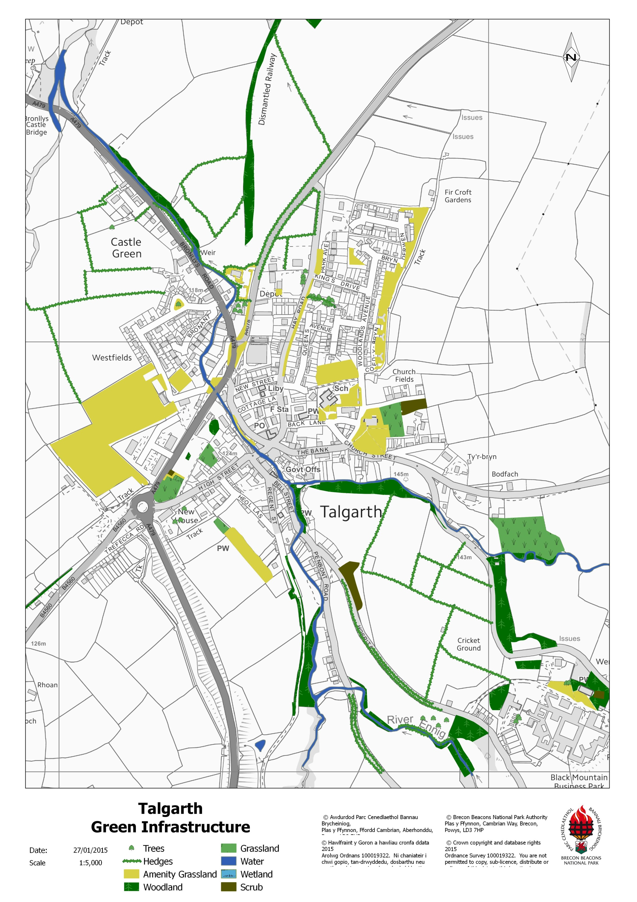

8.0 Biodiversity in and around Sennybridge & Defynnog

8.1 Overview
8.1.1 The River Usk is a dominant feature along the north-western boundary of Sennybridge and the Afon Senni flows from the south through Defynnog and into the Usk towards the middle of the town. There is almost continuous tree cover along the river corridors providing valuable cover and habitat for bats, birds and species such as otter. The disused railway corridor also provides a woodland corridor through the settlement. The surrounding land is predominantly pasture, much of it improved grassland, but there is a surprising amount of semi-improved grassland with a variety of flower and grass species present, for example the football field between Defynnog and Sennybridge. The ancient yew tree in Defynnog churchyard is also a valuable historical and biodiversity feature.

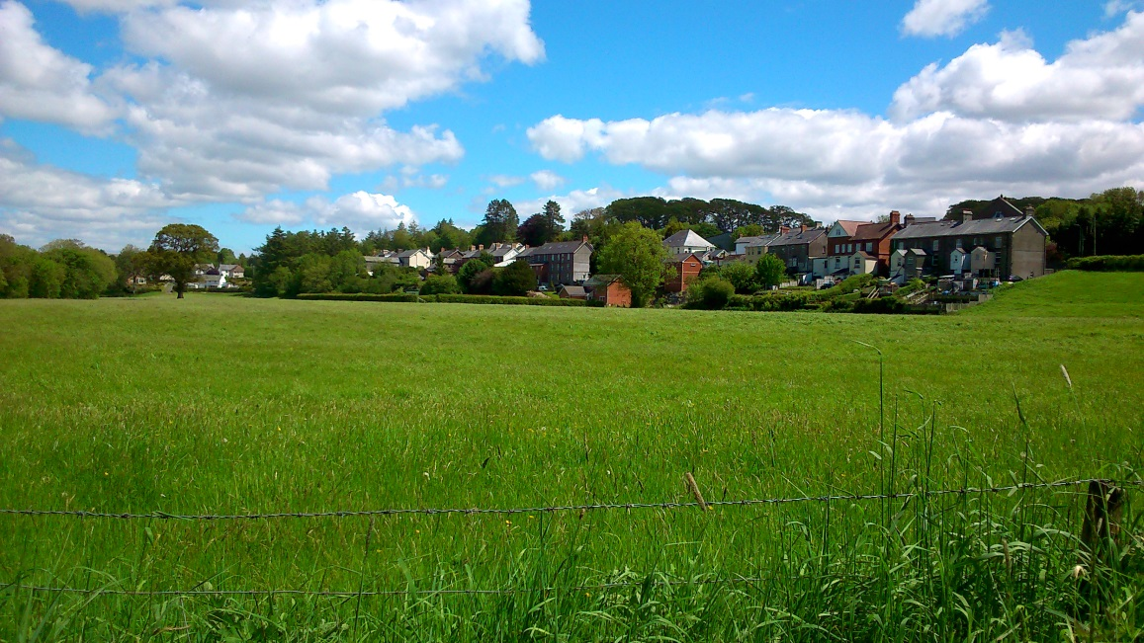
Photo 5: Sennybridge

8.2 International and nationally designated sites (Special Areas of Conservation, SACs and Sites of Special Scientific Interest, SSSIs)
- River Usk SSSI and SAC
- River Usk Tributaries SSSI
- Coed Mawr – Blaen-car SSSI

8.3 Locally important habitats and wildlife features (including Sites of Importance for Nature Conservation, SINCs)
- Rivers and streams and their associated habitats
  - River Usk
  - Afon Senni
  - Nant Car
- Woodland
  - Coed Mawr
  - Coed Waun-car
  - Disused railway corridor
  - Plantation woodland along the A4067
- Semi-improved grassland
  - Football field
  - Capel Sion burial ground
  - Meadow north of the Nant Car
- Amenity grassland
  - Roadside verges
  - School playing fields
- Hedgerows

8.4 Protected and priority species
8.4.1 The presence of protected species is a material consideration in the planning process. Species that have been identified as qualifying features for the designation of SSSIs and SACs require particular consideration. For example, the otter is one of the qualifying features of the River Usk SAC. Many protected species are also included in the Section 7 list under the Environment (Wales) Act; that is, they have been identified as species of principal importance for conserving biodiversity in Wales. Habitat enhancement measures for these species should be incorporated into development proposals.

8.4.2 The following is a selection of the protected and/or priority species that have been recorded in the Sennybridge area:

European protected species:
- Otter
- Bats (including common pipistrelle, Brown long-eared, Natterer’s and noctule)

Nationally protected species:
- Kingfisher
- Barn owl
- Red kite
- Bluebell
- Slow-worm

Priority species:
- West European hedgehog
- Polecat
- Song thrush
- Yellow wagtail
- House sparrow
- Spotted flycatcher
- Cuckoo

8.5 Habitat protection and enhancement

The following are suggested actions for the protection and enhancement and creation of habitats that are appropriate to the Sennybridge area; the list is not exhaustive. Priority species recorded in the area that will benefit from the implementation of these actions are also included; other species not previously recorded may also benefit.

 | Priority habitats & biodiversity features | Actions | Species
1 | Rivers and streams | Retention of ‘buffer zones’ to protect water quality by reducing siltation and to provide cover for some fauna  Sensitive management of trees and river banks e.g. pollarding of trees | Otter  Bats  Kingfisher  Fish species associated with the R. Usk SAC
2 | Grasslands | Retention and protection of existing areas of less-improved grassland | Barn owl  Reptiles
3 | Hedgerows | Retention and enhancement of existing hedgerows (see maps in Appendix 2)  Planting of new native, mixed-species hedgerows, particularly to buffer and provide links between habitats | Nesting birds  Bats  Reptiles
4 | Gardens | Promotion of wildlife-friendly gardening to new home owners | Hedgehog  Nesting birds
5 | Amenity grassland | Reduce cutting regimes where possible  Remove arisings following cutting  Introduce locally-sourced wildflower seed | Insects

8.6 Opportunities for habitat creation

 | Priority habitats & biodiversity features | Actions | Species
1 | Rivers and streams | Construction of otter holts in undisturbed areas  Creation of buffer zones along watercourses | Otter  Kingfisher
2 | Wet woodland | Planting of alder and willow woodland in floodplains/along watercourses | Otter  Nesting birds
3 | Hedgerows | Planting of mixed, native-species hedgerows with hedgerow trees | Bats  Birds  Insects
4 | Grasslands | Creation of new wildflower meadows, preferably using locally-sourced seed  Use of wildflower seed mixes in Sustainable Drainage Systems (SuDS) | Insects  Bats and birds feeding on insects  Barn owl
5 | Trees | Planting of native-species trees in and around developments | Bats  Nesting birds

8.7 Green Infrastructure map of Sennybridge and Defynnog

Please see following page.
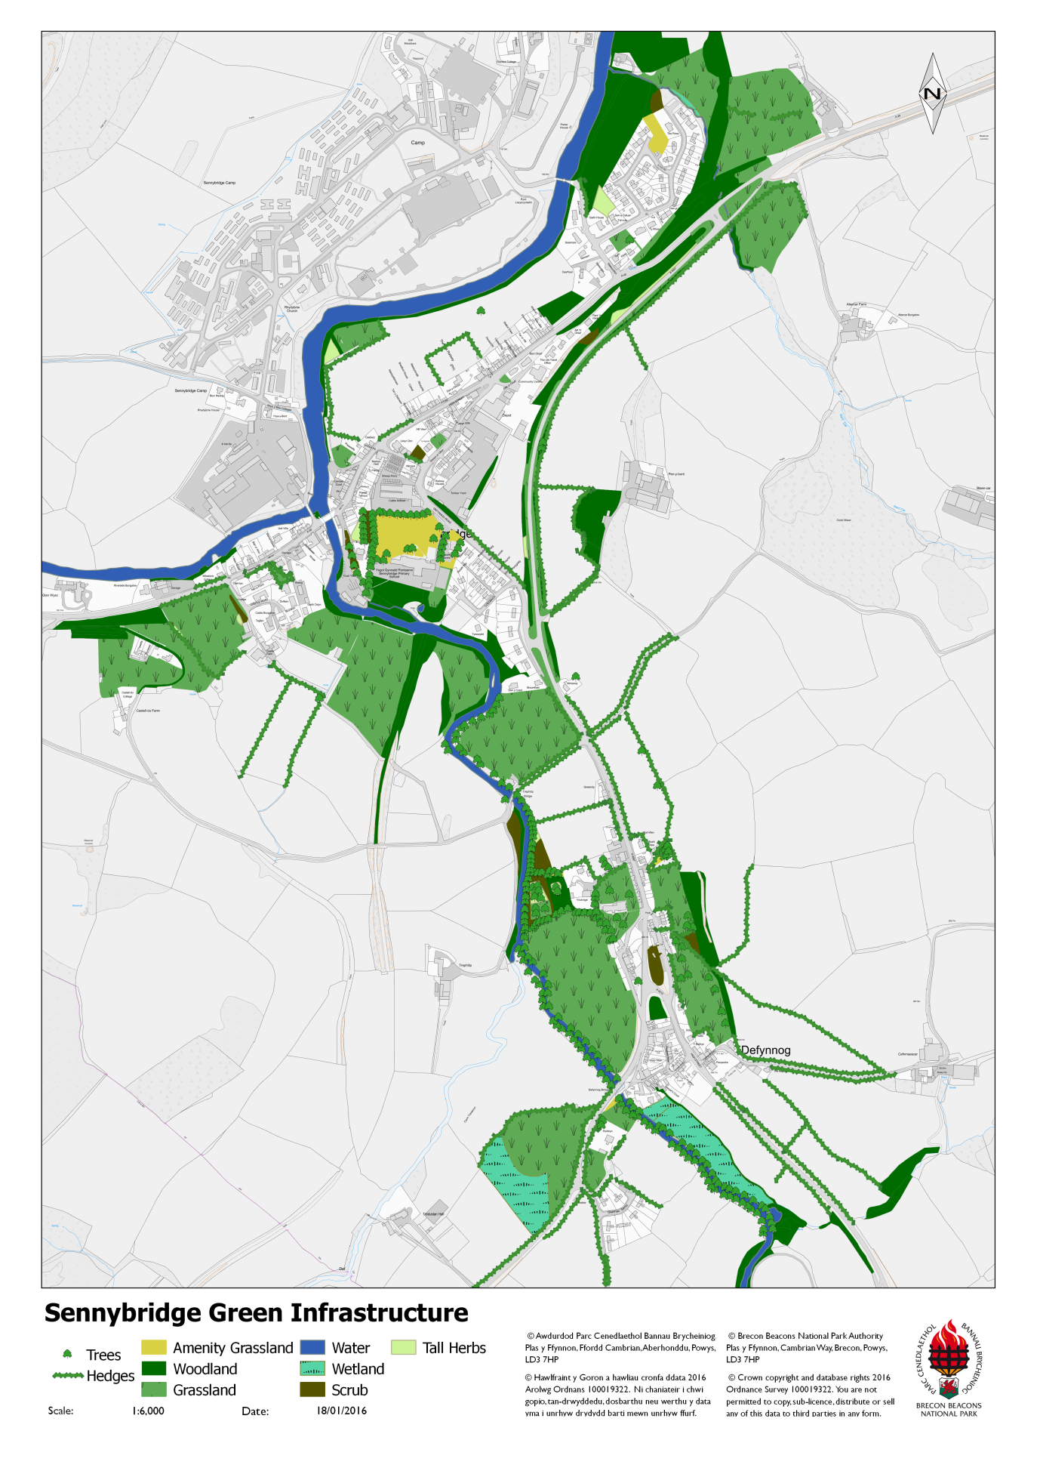

9.0 Further guidance and information

There is a huge amount of guidance and information available on biodiversity and green infrastructure. The following provides background information to the Green Infrastructure Approach as well as useful documents on practical ways of delivering biodiversity enhancement.

- Planning for a healthy environment – good practice guidance for green infrastructure and biodiversity, Town & Country Planning Association and The Wildlife Trusts (July 2012)

- Local Green Infrastructure - Helping communities make the most of their landscape, Landscape Institute (September 2011)

- Biodiversity by Design – a guide for sustainable communities, Town and Country Planning Association (September 2004)

Information on the Natural England website on green roofs and walls as well as wildlife-friendly gardening at: http://publications.naturalengland.org.uk/category/130041#content
including:

- NE20: Wildlife on Allotments (2007)
- Green walls: an introduction to the flora and fauna of walls (TIN030) (February 2009)
- Living roofs (NE30)( January 2007)

The Wales Biodiversity Partnership provides guidance on biodiversity issues in Wales, including the Section 7 Lists of Priority Habitats and Species in Wales at:
http://www.biodiversitywales.org.uk/1/en-GB/HOME
More information on records for species and habitats in your area is available from the Biodiversity Information Service for Powys and Brecon Beacons at: http://www.b-i-s.org/
A data search with BIS is recommended to provide information on species and habitats that are known present; however, it should be noted that absence of records does not mean that the species themselves are necessarily absent

The Wildlife Trusts operate a ‘Biodiversity Benchmark’ scheme, providing a framework for businesses to achieve continual biodiversity protection and enhancement. More information is available at:
http://www.wildlifetrusts.org/biodiversitybenchmark

More information and guidance on invasive species is provided by the GB Non-Native Species Secretariat at:
http://www.nonnativespecies.org/home/index.cfm

Appendices
Appendix 1 Biodiversity Audit Project – Extracts (please see separate document)

Appendix 2 Biodiversity Audit Maps (please see separate document)

Appendix 3 Section 7 List of Priority Habitats in Wales
The following table contains the Section 7 list of Priority Habitats identified by the Welsh Government under the Environment (Wales) Act 2016. The list here does not include marine habitats that are not relevant to the Brecon Beacons, although it does include a number of habitats that are unlikely to be threatened by development pressures.

ENVIRONMENT (WALES) ACT 2016:
SECTION 7 LIST OF HABITATS OF PRINCIPAL IMPORTANCE FOR CONSERVATION OF BIOLOGICAL DIVERSITY IN WALES
- Traditional orchards
- Wood pasture & parkland
- Upland oak woodland
- Lowland beech and yew woodland
- Upland mixed ash woodland
- Wet woodland
- Lowland mixed deciduous woodland
- Hedgerows
- Arable field margins
- Coastal and floodplain grazing marsh
- Lowland meadows
- Lowland calcareous grassland
- Upland calcareous grassland
- Lowland dry acid grassland
- Lowland heathland
- Upland heathland
- Upland flushes, fens and swamps
- Lowland fens
- Purple moorgrass and rush pastures
- Reedbeds
- Lowland raised bog
- Blanket bog
- Mountain heaths and willow scrub
- Rivers
- Oligotrophic and dystrophic lakes
- Ponds
- Mesotrophic lakes
- Eutrophic standing waters
- Aquifer-fed naturally fluctuating water bodies
- Inland rock outcrop and scree habitats
- Calaminarian grasslands
- Open mosaic habitats on previously developed land
- Limestone pavement

Appendix 4 Glossary of Terms
Biodiversity: “Biodiversity” (biological diversity) is the term applied to the variety of life on earth. It describes the richness and variety of all living things, from the tiniest microscopic organism to the largest tree.
Biodiversity Information Service (BIS): The Biodiversity Information Service for Powys and the Brecon Beacons National Park provides a mechanism for collating, sharing and utilising the wealth of biological data and knowledge, which exists in this part of Wales.
Geodiversity: Geodiversity (geological diversity) is the variety of geological environments, phenomena and active processes that make landscapes, rocks, minerals, fossils, soils and other superficial deposits that provide the substrate for life on earth. Geodiversity is important because it underpins biodiversity, with soils being the link between them.
Green Infrastructure: Green infrastructure relates to all green and blues spaces in and around our towns. The term refers to the collective value of all of these spaces together, rather than as individual elements. Component elements of green infrastructure include parks, private gardens (although these aren’t mapped in this document), agricultural fields, hedges, trees, woodland, green roofs, green walls, rivers and ponds. The term covers all land containing these features regardless of its ownership, condition or size.
Local Biodiversity Action Plan (LBAP): An LBAP is an action plan that is usually produced by a partnership of local organisations and people, which aims to protect and enhance the biodiversity of a local area.
Local Development Plan (LDP): Land use plan which will form the statutory development plan for a local authority area for the purposes of the Act. The Plan is subject to independent examination.
Local Wildlife Sites and Sites of Importance for Nature Conservation: Non-statutorily protected sites regarded to be of local importance for wildlife in the Brecon Beacons National Park.
National Park Management Plan (NPMP): The single most important policy document for the National Park. It is a plan for the geographic area of the Park and not for any one authority and, as a strategic over-arching document, it co-ordinates and integrates other plans, strategies and actions in the National Park, including the Local Development Plan.
Protected species: Particular animals, plants and other organisms protected under various pieces of wildlife legislation, principally the Wildlife and Countryside Act 1981 (as amended) and the Conservation of Habitats and Species Regulations 2010 (as amended), also known as the Habitats Regulations.
Supplementary Planning Guidance (SPG): Provides supplementary information in respect of the policies in a local development plan. They must be consistent with LDP policies and national planning policy.
Site of Special Scientific Interest (SSSI): Sites of Special Scientific Interest (SSSIs) conserve and protect the best of our wildlife, geological and physiographical heritage for the benefit of present and future generations.
Special Area of Conservation (SAC): Special Areas of Conservation (SACs) are strictly protected sites designated under the EC Habitats Directive.

