Brecon Beacons National Park Authority
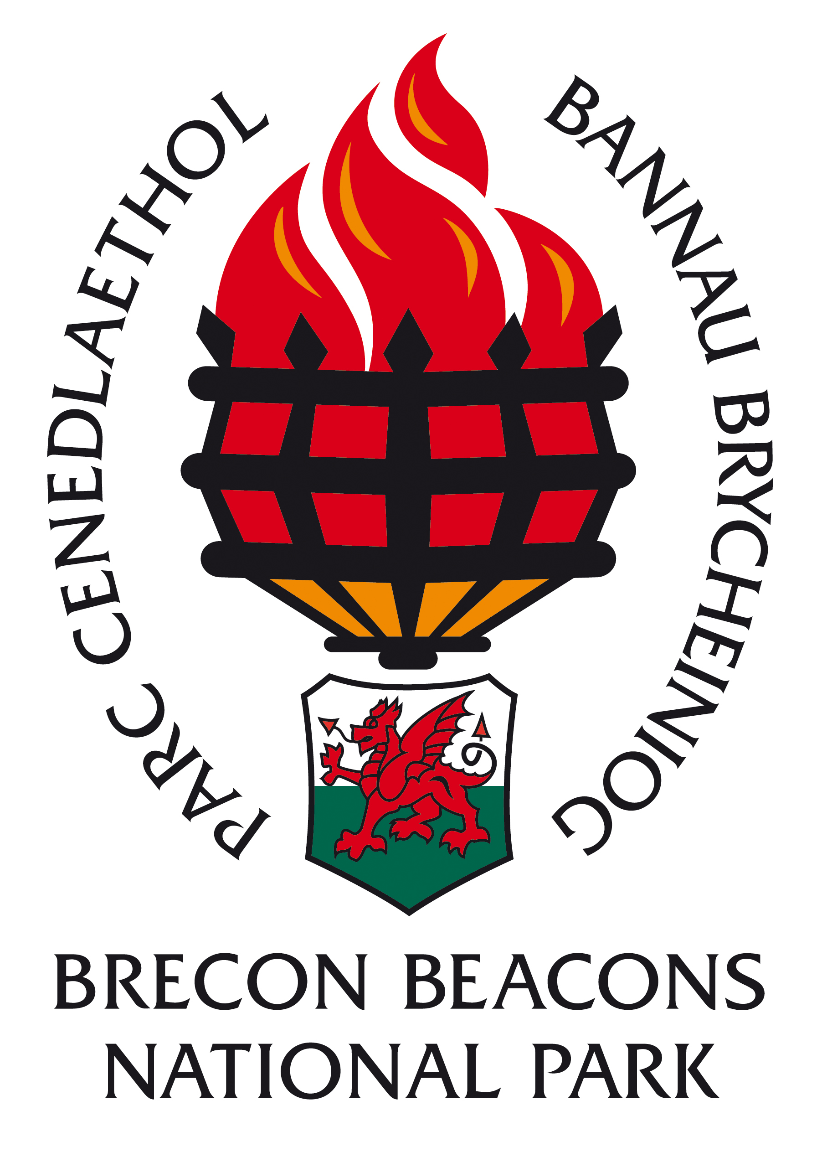
Equal Opportunities & Diversity Monitoring Form
The Brecon Beacons National Park Authority strives to operate a policy of equal opportunity and not discriminate against any person because of gender, age, disability, marital status, sexual orientation, religion or national origin. To enable us to monitor equal opportunities will you please provide the details below. This information will only be used for the monitoring of Equal Opportunities and the purposes of the Equality Act 2010.
Full Name
Post Applied for
Gender* |  | Male |  | Female
*If you are currently undergoing the process of gender reassignment, please indicate your future gender
Advertisement: where did you see this post advertised?

 | National Park Website |  | Local newspaper i.e. B&R, Abergavenny Chronicle
 | Regional newspaper i.e. Western Mail & Echo |  | National newspaper i.e. Guardian, Times
 | Specialist media i.e. Planning Magazine |  | Other websites i.e. CJS
Other - please specify

Welsh Language
Non speaker
No knowledge of any words or phrases
Basic
Able to speak and understand some words and phrases
Learner
Able to understand and converse in simple terms
Intermediate
Can converse in Welsh with reasonable confidence and occasional detailed terms
Fluent
Able to converse in Welsh with confidence using detailed and complex terms with ease.

Age |  |  | Marital Status
16-21 |  |  | Married
22-30 |  |  | Civil Partnership
31-40 |  |  | Co-habiting
41-50 |  |  | Other
51-60
60+

Ethnic Origin |  |  |  | Religious Belief / Faith
White | British |  |  | Muslim
 | Irish |  |  | Buddhist
 | Any other White background |  |  | Hindu
 |  |  |  | Sikh
Mixed | White & Black Caribbean |  |  | Jewish
 | White & Black African |  |  | Christian
 | White & Asian |  |  | Other
 | Any other Mixed background |  |  | Do not wish to disclose
 |  |  |  | None (Atheist)
Asian or Asian British | Indian
 | Pakistani |  |  | Sexual Orientation
 | Bangladeshi
 | Any other Asian background |  |  | Bisexual
 |  |  |  | Gay / Lesbian
Black or Black British | Caribbean |  |  | Heterosexual
 | African |  |  | Transgender
 | Any other Black background |  |  | Do not wish to disclose
Chinese or other ethnic | Chinese
group | Other

Disability Monitoring

The current Authority Equal Opportunities and Diversity Monitoring requirement has been extended in line with current guidance to include voluntary declarations of disability  What do we mean by a “disability”?  A person has a disability if s/he has a physical or mental impairment which has a substantial and long-term adverse effect on that person's ability to carry out normal day-to-day activities.  Examples of disabilities  The list to the right is of conditions of impairment that may cause somebody to describe themselves as “having a disability”. This list is not exhaustive and should be sued for guidance only. |  |  | Hearing, speech or visual impairment: (if you wear glasses or contact lenses this is not considered a disability)  Co-ordination, dexterity or mobility: e.g. polio, spinal cord injury, repetitive strain injury.  Mental health: e.g. schizophrenia, depression  Speech impairment: e.g. stammering  Learning disabilities: e.g. Down’s Syndrome  Other physical or mental conditions: e.g. diabetes, epilepsy, arthritis, cardiovascular conditions, haemophilia, asthma. Cancer, facia disfigurement, sickle cell dyslexia etc
Disability
Do you consider yourself to have a “disability”? |  |  | Yes |  | No
Disability Categories
Hearing, speech or visual impairment |  |  | Learning Disability
Co-ordination, dexterity or mobility |  |  | Other physical or mental condition
Mental health |  |  | Do not wish to disclose
Declaration: For the purposes of compliance with the Data Protection Act 1998, I understand that this information may be stored and processed as part of the Brecon Beacons National Park Authority monitoring of equal opportunities and i give my consent for my data to be used for this purpose.

