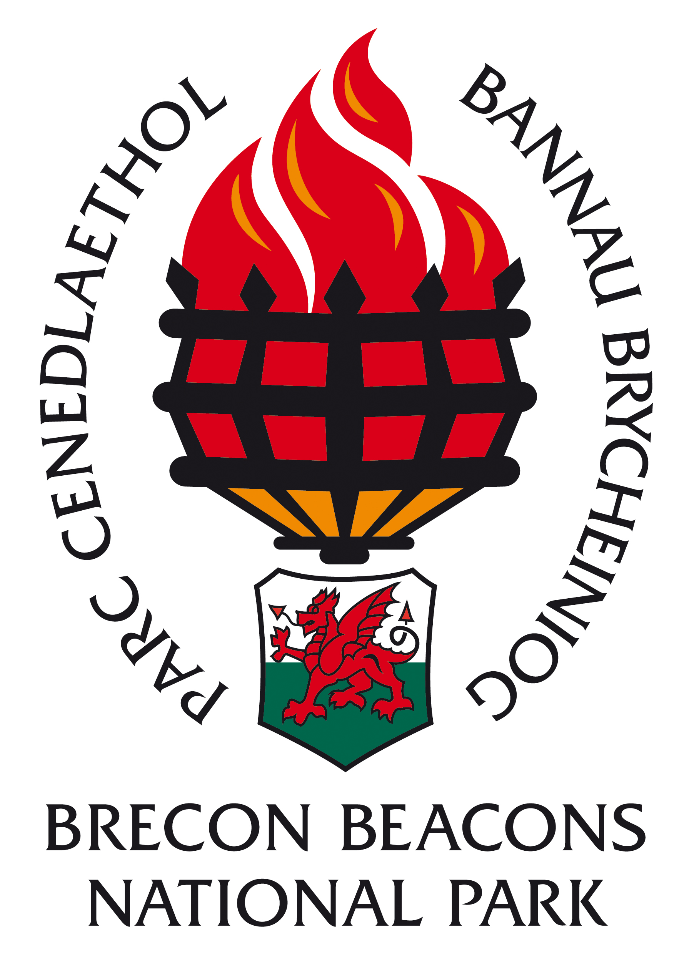

INFORMATION FOR CANDIDATES

Building Conservation Officer

Grade 12: £31,401 - £34,106 per annum, pro rata

22 hours per week

Permanent contract

CONTENTS

- Return details
- Brecon Beacons National Park Overview
- The Staff
- Organisational Chart
- Job Description
- Person Specification
- Guidance notes for appointees

CLOSING DATE: 19th November 2018
INTERVIEW DATE: 26th November 2018

COMPLETED APPLICATION FORMS SHOULD BE RETURNED TO:

(CONFIDENTIAL)

HUMAN RESOURCES DEPARTMENT
BRECON BEACONS NATIONAL PARK AUTHORITY
PLAS Y FFYNNON
CAMBRIAN WAY
BRECON

LD3 7HP

Thank you for your interest in the post of Building Conservation Officer in the Planning Directorate

Applications must be received by 11.00am on the morning of 19th November 2018. Unfortunately late applications will not be considered.

Would candidates please note that it is not the practice of the National Park Authority to acknowledge applications, nor to inform candidates of the outcome of their applications. Please assume that if you receive no further communication, your application has been unsuccessful.

If you have a disability please indicate this to us in a covering letter. Should you meet the essential criteria and be called to interview, please let us know of any special requirements needed.

Please note that all application forms and supporting information will be securely retained for six months and we may contact you should a suitable vacancy arise. After six months all application forms and supporting information will be destroyed. Should you object to your information being retained, please could you let us know and we will destroy your application form after the outcome of the recruitment process.

Where candidates are invited to interview, it is the Policy of the Authority to contact referees at that stage. Please could you identify any problems this may cause on your application form under the relevant section.
Please note that when completing your application form you must be able to demonstrate how you meet the essential criteria set out in the person specification relevant to this post. You should also demonstrate how you meet the desirable criteria set out in the person specification, but do not be deterred from applying if you do not meet all of the desirable criteria.

BRECON BEACONS NATIONAL PARK AUTHORITY

Background

National Parks were designated in order to protect beautiful areas for the benefit of the nation. They came about as a result of the 1949 National Parks and Access to the Countryside Act, which put a legislative framework in place for the establishment of National Parks in England and Wales.

The first two National Parks were designated in 1951 and in 1957 the Brecon Beacons National Park was designated covering an area of some 520 square miles (1346 sq. kilometres). Until 1995 the Brecon Beacons National Park Authority was a joint committee of the then local County Councils until the Environment Act of that year laid down legislation to establish National Park Authorities as independent, special purpose Local Authorities.

What do National Parks do?

National Parks have two purposes: Firstly to conserve and enhance the natural and cultural environment of the park, and secondly to promote awareness and understanding and enjoyment of its special qualities. These special qualities have been described as:

- the landscape and natural beauty
- the peace and tranquility
- opportunities for walking and access to open countryside
- open spaces and qualities of remoteness
- traditionally managed farm land and
- wildlife

In so doing the National Parks also have a duty to foster the social and economic well being of the communities within the Park.

In delivering on their purposes and duty there are five key functions of National Park Authorities. These are to:

- act as Local Planning Authority
- act as relevant Authority for access to open countryside under the CROW Act
- facilitate environmental programmes
- provide public information, interpretation and education services
- deliver the sustainable development fund on behalf of the Welsh Assembly Government.

The Brecon Beacons National Park Authority

The National Park Authority consists of 24 members, 16 nominated by the seven Local Authorities in the area and the other eight nominated by the Minister for Environment, Sustainability & Housing of the Welsh Assembly Government. The Authority’s total budget is £6.1 million of which £4.6 million is funded by the National Park Grant and Levy and £1.5 million from Income activities.

This split helps to ensure that the local and national interests are represented at National Park Authority level. There is a range of key committees responsible for managing the business of the Authority. In addition, working and advisory groups, both internal and external, have been established to help in the decision-making process. Some 110 full-time staff equivalents are employed in two Directorates – Countryside and Land Management & Planning, as well as the Chief Executive’s Department – PR & Communications, Finance, IT, Legal, Democratic Services and HR. Staff and Members cover a wide range of activities and services and it is the key role of officers to provide advice and guidance to Members of the Authority to help them make decisions and set the vision and strategies for the Authority.

The Authority’s key strategic document is the National Park Management Plan, which sets our aims, strategic objectives and Priorities for Action for the Authority (see http://www.breconbeacons.org/the-authority/planning/strategy-and-policy/npmp). In addition to this, we have an approved Unitary Development Plan (see http://www.breconbeacons.org/the-authority/planning/strategy-and-policy/udp) which provides the framework for future development within the National Park and are developing the Local Development Plan (see http://www.breconbeacons.org/the-authority/planning/strategy-and-policy/deposit-local-development-plan/useful-deposit-information). The Authority is also developing its State of the Park Report, which will summarise the changing status of environmental, social and cultural assets in the Park. With delegated responsibility for Rights of Way maintenance and management we are implementing the Authority’s Rights of Way Improvement Plan.

National Parks in England and Wales are Category V protected landscapes as defined by the World Conservation Union (IUCN). This recognises the involvement of people in shaping the landscapes. Like all National Parks in England and Wales, agriculture is very influential in how the landscape is managed. A viable, profitable, broadminded and innovative farming sector, working in close collaboration with the Park’s communities, local businesses and public and voluntary bodies is fundamental to the landscape’s future management. Flexibility and adaptability will be important qualities to address the challenges of climate change, energy descent pathways and demographic and social changes ahead.

Brecon Beacons National Park Authority

Job Description

Post Title: Building Conservation Officer

Date: 1st January 2010

Grade: 12

Responsible to: Planning & Heritage Manager

Responsible for: N/A

Job Purpose
To be responsible for the day-to-day delivery of a first class building conservation service; To raise the profile of the building conservation service to ensure that appropriate high quality development is achieved in accordance with National Park Authority policies; To ensure the service meets the needs of its users and performance targets are met; To promote the conservation of the historic environment of the National Park and to contribute to the quality and design of new buildings.
Main Duties.
- To act as an internal consultee on Listed Building Consent and Conservation Consent applications, liaising with Cadw as necessary.

- To advise the Head of Development Control, Development Control officers, the Enforcement Manager and Members on technical, legal and professional aspects of applications, appeals, enforcement issues and related matters. To contribute to Appeal Statements and represent the Authority at Informal Hearings and Public Inquiries where necessary.

- To provide pre-application and general advice to applicant, agents and the public on the appropriate conservation of historic buildings.

- To oversee the maintenance of a register of Buildings at Risk and to give advice in relation to those buildings.

- To initiate and implement the preparation of Conservation Area Appraisals and Management Plans. To implement the designation of new Conservation Areas where appropriate and contribute to other design guidance.

- To liaise with the Enforcement Manager to ensure that there is appropriate investigation of alleged unauthorised works to listed buildings.

- To develop and maintain data bases on Listed Buildings, including a local list, Buildings at Risk and Scheduled Ancient Monuments and to give advice in relation to those buildings. To develop, with the IT Manager, public access to Listed Buildings information.

- To increase public awareness of, and create a high profile for, the built heritage service by, for example, the preparation of informative and interpretive material. Develop and facilitate effective partnerships with statutory, non-statutory and community groups.

- Any other duty appropriate to the grade and nature of the post, as required by the Director of Planning or the Chief Executive.

Brecon Beacons National Park Authority

Building Conservation Officer

Person Specification

Essential Criteria Method of Assessment
A degree or diploma in Planning, Architecture, Conservation or Civic Design or other relevant qualification and. | Application form, interview and certificates
Be a Member of or working towards Membership of the Institute of Historic Building Conservation and evidence of continuing professional development | Application form and certificates
A minimum of 3 years experience in a Local Authority planning or conservation environment related to Listed Buildings and Conservation areas or similar direct work. | Application form and interview
The ability to assess a wide range of historic buildings and advise on their merit, appropriate methods of conservation and repair. | Interview, presentation and examples of work
A commitment to the principles and aims of building conservation. | Application form and interview
Proven experience of managing a varied and complex caseload and working to tight deadlines. | Application form, interview, presentation and examples of work
‘A thorough working knowledge of Listed Building and Conservation Area legislation’ | Application form, interview and Test
An effective team member and partnership or consultative working with other organizations. | Application form and interview
Effective and efficient communication skills both written and verbal with experience of dealing courteously with the public and Members both face to face and by telephone. | Application form, interviews, presentation and examples of work
The ability to write clear and concise letters and reports. | Application form, presentation and examples of work
Practical experience of GIS, Word processing and Database packages. | Application form and interview

Desirable Criteria Method of Assessment

A working knowledge of rural Welsh historic architecture and decoration | Application form and interview
Ability to communicate in Welsh | Application form and interview
Knowledge of the UK’s National Parks and the Brecon Beacons National Park in particular | Application form and interview

NOTES FOR GUIDANCE FOR PERSONS TAKING UP AN APPOINTMENT WITH THE BRECON BEACONS NATIONAL PARK AUTHORITY AS

Building Conservation Officer

Salary

The salary is £31,401 - £34,106 per annum, pro rata.

Period of employment

Permanent contract

Working hours

22 hours per week.

Salary is paid monthly (last day of month) into bank/building society account.

Annual leave entitlement

21 days per annum, plus 8 public holidays and 2 extra statutory days. Leave entitlement rises annually to 25 days per annum after 5 years service.

If you transfer from the service of an outside Authority to the Brecon Beacons National Park Authority, you are able to bring with you your accrued leave entitlement (accrued due to length of service) up to a maximum of 25 days.

Pension

The pension scheme in place is a standard Local Government one; the employee contributes 5.5% (up to £14,100) which rises to 5.8% (£14,101) of their contractual hours worked and the employer currently contributes 22%.

Location

The position will be based in the National Park Headquarters in Brecon.

Brecon Beacons National Park Authority

Privacy Statement: | We process personal data relating to those we employ for employment purposes, to assist in the running of the authority and/or to enable individuals to be paid. The collection of this information will also be of benefit in:  - improving the management of workforce data  - enabling development of a comprehensive picture of the workforce and how it is deployed  - informing the development of recruitment and retention policies  - allowing better financial modelling and planning  - enabling monitoring of selected protected characteristics  The personal data includes identifiers such as name, date of birth, payroll (SAP) number, personal characteristics such as gender, disability and ethnic group, plus qualifications, performance and absence/occupational health information.  We will not share information about you with third parties without your consent unless the law allows or requires us to or we are required to share it to manage your employment contract with us. When we do share your data it will be via encrypted email software or password protected files. We are required to share some of your personal data with:  - HMRC  - Outsourced HR and Payroll Services (currently with Cardiff City Council and Carmarthenshire County Council)  - Powys County Council pensions who administer the Authority’s pension scheme  - Local Government Audit and fraud detection teams  We store information relating to job applicants for 6 months and for employees for 7 years post-employment. Data is stored electronically on BBNPA servers. The employee records have access restrictions meaning only HR staff are able to view and process it. Physical records are stored in the HR office which is locked and within locked filing cabinets.  If you require more information about how we store and use your personal data or would like to request that your details be removed, please contact the HR Officer.

Data controller: Brecon Beacon National Park Authority, Plas Y FFynnon, Cambrian Way, Brecon, LD3 7HP
Contact : Elizabeth Lewis, HR Officer
Telephone : 01874 60426
Data protection officer: Paul Funnell
As part of any recruitment process, the Authority collects and processes personal data relating to job applicants. The Authority is committed to being transparent about how it collects and uses that data and to meeting its data protection obligations.
What information does the Authority collect?
The Authority collects a range of information about you. This includes:-
- your name, address and contact details, including email address and telephone number;
- details of your qualifications, skills, experience and employment history;
- information about your current level of remuneration;
- whether or not you have a disability for which the Authority needs to make reasonable adjustments during the recruitment process;
- information about your entitlement to work in the UK; and
- equal opportunities monitoring information, including information about your ethnic origin, sexual orientation, health, and religion or belief
The Authority collects this information in a variety of ways. For example, data might be contained in application forms, CVs or resumes, obtained from your passport or other identity documents, or collected through interviews or other forms of assessment, including online tests.
The Authority will also collect personal data about you from third parties, such as references supplied by former employers and information from criminal records checks. The Authority will seek information from third parties only once a job offer to you has been made and will inform you that it is doing so.
Data will be stored in a range of different places, including on your application record, in HR management systems and on other IT systems (including email).

Why does the Authority process personal data?
The Authority needs to process data to take steps at your request prior to entering into a contract with you. It also needs to process your data to enter into a contract with you.
In some cases, the Authority needs to process data to ensure that it is complying with its legal obligations. For example, it is required to check a successful applicant's eligibility to work in the UK before employment starts.
The Authority has a legitimate interest in processing personal data during the recruitment process and for keeping records of the process. Processing data from job applicants allows the Authority to manage the recruitment process, assess and confirm a candidate's suitability for employment and decide to whom to offer a job. The Authority may also need to process data from job applicants to respond to and defend against legal claims.
The Authority processes health information if it needs to make reasonable adjustments to the recruitment process for candidates who have a disability. This is to carry out its obligations and exercise specific rights in relation to employment.
Where the Authority processes other special categories of data, such as information about ethnic origin, sexual orientation, health or religion or belief, this is for equal opportunities monitoring purposes.
For some roles, the Authority is obliged to seek information about criminal convictions and offences. Where the Authority seeks this information, it does so because it is necessary for it to carry out its obligations and exercise specific rights in relation to employment.
The Authority will not use your data for any purpose other than the recruitment exercise for which you have applied.
Who has access to data?
Your information will be shared internally for the purposes of the recruitment exercise. This includes members of the HR and recruitment team, interviewers involved in the recruitment process, managers in the business area with a vacancy and IT staff if access to the data is necessary for the performance of their roles.
The Authority will not share your data with third parties, unless your application for employment is successful and it makes you an offer of employment, or it is required to in law. If you are successful in your application subject to references Authority will then share your data with former employers to obtain references for you and, if the nature of the role requires it, the Disclosure and Barring Service to obtain necessary criminal records checks.
The Authority will not transfer your data outside the European Economic Area.
How does the Authority protect data?
The Authority takes the security of your data seriously. It has internal policies and controls in place to ensure that your data is not lost, accidentally destroyed, misused or disclosed, and is not accessed except by our employees in the proper performance of their duties.
For how long does the Authority keep data?
If your application for employment is unsuccessful, the Authority will hold your data on file for six months after the end of the relevant recruitment process and employment opportunities. At the end of that period your data is deleted or destroyed.
If your application for employment is successful, personal data gathered during the recruitment process will be transferred to your personnel file and retained during your employment. The periods for which your data will be held will be provided to you in a new privacy notice.
Your rights
As a data subject, you have a number of rights. You can:
- access and obtain a copy of your data on request;
- require the Authority to change incorrect or incomplete data;
- require the Authority to delete or stop processing your data where the data is no longer necessary for the purposes for which it was originally obtained;
- object to the processing of your data where the Authority is relying on its legitimate interests as the legal ground for processing; and
- ask the Authority to stop processing data for a period if data is inaccurate or there is a dispute about whether or not your interests override the Authority's legitimate grounds for processing data.
If you would like to exercise any of these rights, please contact Elizabeth Lewis, HR Officer. Email: elizabeth.lewis@beacon-npa.gov.uk . You can make a subject access request by contacting the Authority’s, Corporate Services Officer, Marcia Zurian. Email: marcia.zurian@bacons-npa.gov.uk
If you believe that the Authority has not complied with your data protection rights, you can complain to the Information Commissioner.
What if you do not provide personal data?
You are under no statutory or contractual obligation to provide data to the Authority during the recruitment process. However, if you do not provide the information, the Authority may not be able to process your application properly or at all.
You are under no obligation to provide information for equal opportunities monitoring purposes and there are no consequences for your application if you choose not to provide such information.

