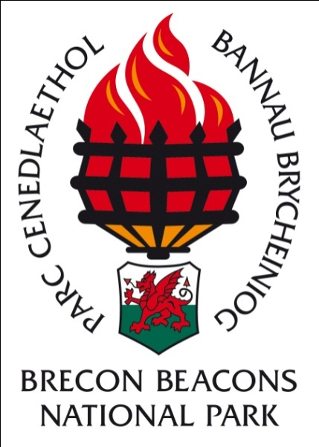

Brecon Beacons National Park Authority
Welsh Language Promotion Strategy
2017
The Welsh Language Standards
Under the Welsh Language Measure (2011) the Welsh Language Commissioner has introduced a range of standards, with which, the Authority must comply.
Standard 145 places a duty on the Authority to develop and publish a five year strategy for the Promotion of the Welsh Language.
The Situation of the Welsh Language in the Park
According to the 2011 census 10.3% of the Park’s residents are able to speak Welsh against the National average of 19%. The majority of Welsh speakers reside in the West of the National Park.
The Brecon Beacons National Park Authority is committed to promoting the use of the Welsh Language wherever possible and aims to ensure that residents and visitors are able to receive the service in Welsh if they so choose to do.
The statutory framework for the Welsh language in the Brecon Beacons National Park which gives strength to this strategy is as follows:
- The Welsh Language (Wales) Measure 2011
- The Well Being of Future Generations Act 2011:
The latter sets a clear well-being goal of
- A Wales of a vibrant culture and a thriving Welsh Language.
- A society that promotes and protects culture, heritage and the Welsh Language
- One million speakers by 2050 – The Welsh Government target announced at the National Eisteddfod in August 2016.

Methods of Promotion
- The appointment of Welsh speaking staff in posts which have been identified as Welsh essential will ensure that the public is aware that the Authority welcomes the use of the Language, is able to deliver its services in Welsh and that the Authority provides opportunities for locally educated people to work through the medium of Welsh. Welsh speakers from further afield may also be attracted to jobs within the Authority.
- Public Service Boards of Local Authorities which we are involved in. During discussions with the Public Service Board’s joint promotion of the Welsh Language will be discussed and developed.
- The Authority has a working relationship with local tourism providers. The Authority, working in conjunction with the local Menter Iaith (Brycheiniog a Maesyfed) will run Welsh Language awareness training courses each year with the view of developing at least five Welsh Ambassadors a year.
- Staff
- Work with the Menter Iaith on Welsh Language awareness. All staff will be encouraged to attend a course and to comment on opportunities to increase the use of the language within and outside the Authority
- Encourage staff to follow language courses. Details of courses available will be circulated to staff annually.
- Consider a buddy/mentoring system for learners – in order to increase the confidence of Welsh learners within the Authority, speakers and learners will be paired up and will meet periodically to practise using the language.
- Guided walks for Welsh learners – Although the Authority does not now offer an official guided walks programme we offer guided walks as part of some of the events each year and we will run at least one Guided walk for learners each year.
- Promote Welsh open learning course to our communities. This is a four hour on-line introduction to Welsh.
- Promote environmental education courses to schools through the medium of Welsh.
- Encourage Welsh language projects to apply to the Sustainable Development Fund.
- The Authority will support Welsh events. For example the Urdd Eisteddfod in Builth Wells in 2018.
- Activities available in Welsh within the Brecon Beacons National Park will be publicised through articles in local Welsh newspapers e.g. Papur Bro/Llais.
- The Authority will promote its Welsh language social media feeds with the intention of improving the number of followers to these feeds by 10% a year.
- The Authority will undertake other promotion activities wherever possible over the next 5 years.

Standard 145 requires the Authority to set a target to maintain or increase the number of Welsh Speakers in the area. The Authority believes that the methods of promotion outlined above will help to maintain the level as measured in the next census data at 10.3%. However it is recognised by the Commissioner that education is the most important driver of residents’ ability to speak Welsh and factors outside the control of the Authority will have a greater impact on the number of speakers than any positive intervention undertaken by the Authority.

