Equality Act Consultation questionnaire
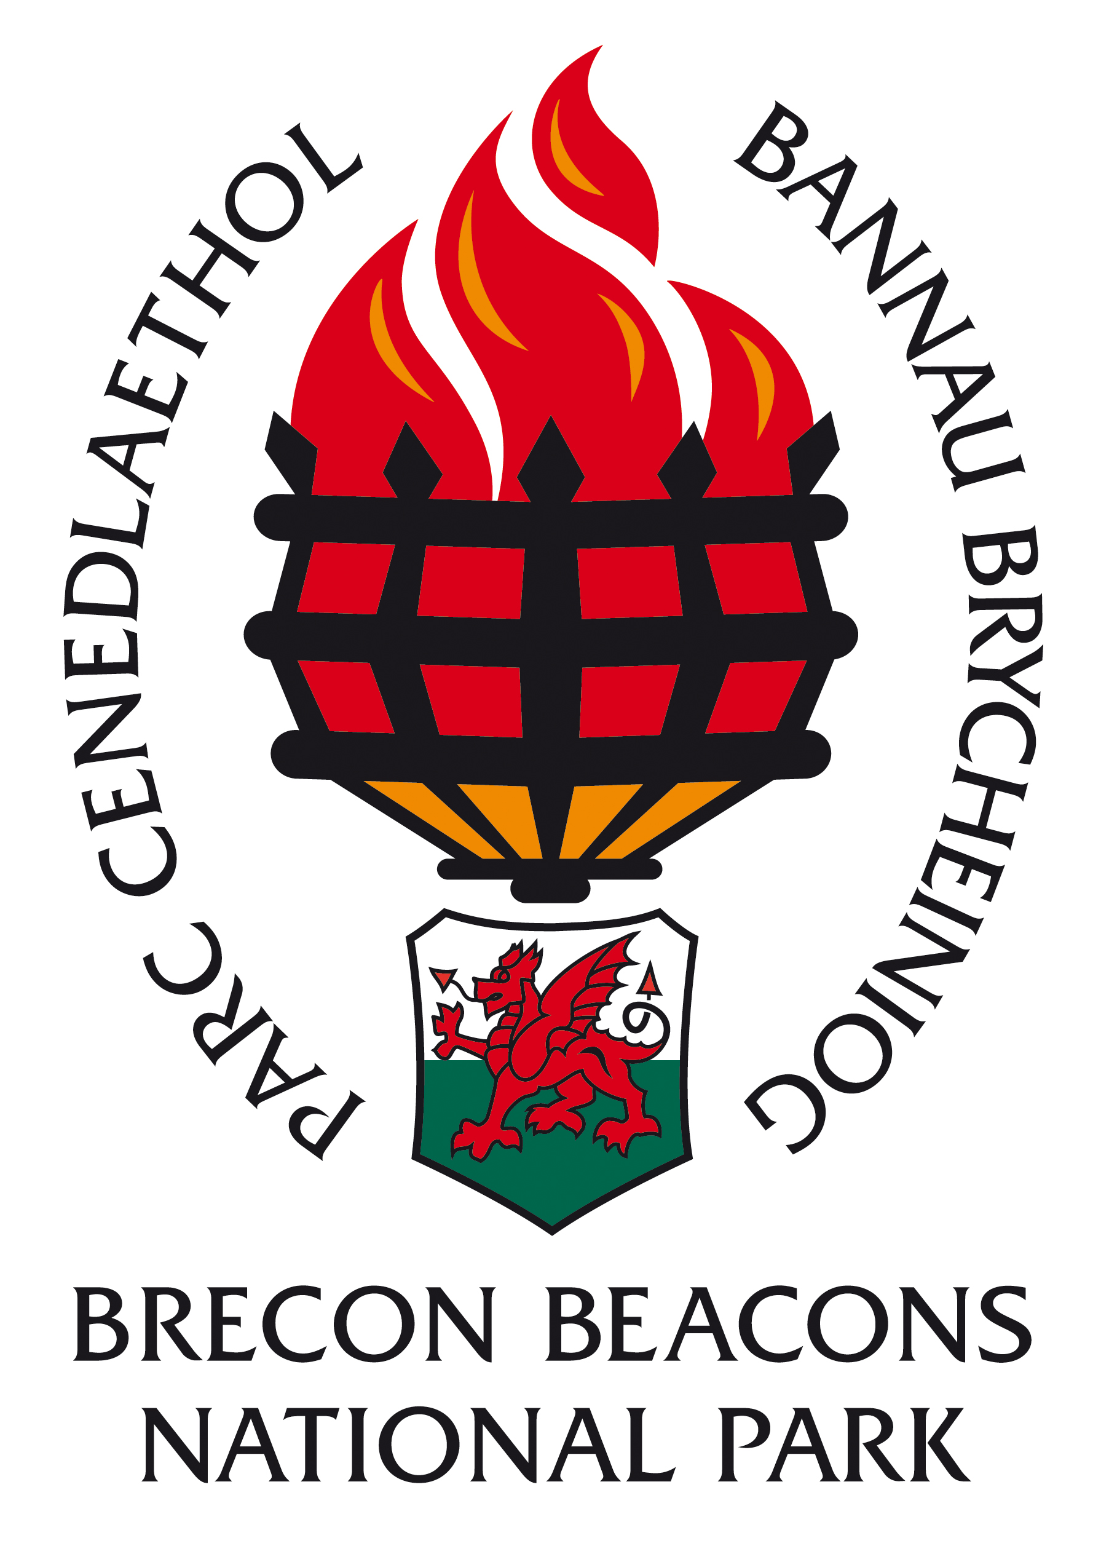
The Brecon Beacons National Park Authority is determined to promote diversity, inclusiveness, and equality of access and eliminate inequality in everything we do, as such we are seeking your views to help gather information about inequality of access to the Brecon Beacon National Park and its services. This information will allow us to plan and deliver our services in a way that increases access.
The questionnaire below seeks your views about our two main activities of work, Promoting Access and Promoting Understanding and Enjoyment, although comments about any other aspects of our work relating to reducing inequality are welcomed.

- Promoting understanding and enjoyment
Promoting understanding and enjoyment. Please add your comments in the space below

- Promoting access to services or to the countryside:
Promoting access (to services) or the countryside: Please add your comments in the space below

- Other comments.
Other comments: Please add your comments in the space below

Thank you for taking the time to complete the form.
Please either email to HR@beacons-npa.gov.uk or post to Elizabeth Lewis, HR Officer Brecon Beacons National Park Authority, Plas Y Ffynnon, Cambrian Way, Brecon, Powys LD3 7HP

