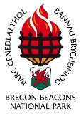

Key Visitor attractions in the Brecon Beacons National Park 2010/11
Waterfalls Country 154,189
National Park Visitor Centre 142,167
Garwnant Visitor Centre 111,000
Pen y Fan (National Trust) 110,000
Craig-y-nos Country Park 97,808
Dan-yr-Ogof Showcaves 82,000
Llangorse Common 75,000
Carreg Cennen castle 19,650

Visitor numbers 2010/11

