Brecon Beacons National Park Authority

Local Development Plan Policy 27
Householder Design Guide

April 2017

Supplementary Planning Guidance

Document Contents
1. Introduction | Page 2

2. General Guidance | Page 3
2.1 Permitted Development Rights | Page 3
2.2 Pre Application Advice | Page 3
2.3 The application Process  2.3.1 Planning Applications  2.3.2 How do I submit a valid application?  2.3.3 What happens to my application?  2.3.4 Who makes the decision?  2.3.5 What if I don’t like the decision? | Page 3
2.4 Other Application types | Page 5
2.5 Demolition | Page 6
2.6 Building Regulations | Page 6
2.7 The party Wall Act 1996 | Page 6
3. Design Guidance for your proposal Page 7
3.1 Principles of Good Design Page 7
3.2 Understanding where you live Page 8
3.3 Extending your house Page 9
3.3.1 Two storey extensions
3.3.2 Single storey extensions
3.3.3 Dormer windows
3.3.4 Porches
3.3.5 Extensions in countryside locations
3.4 Out Buildings and Garages Page 15
3.5 Ancillary residential accommodation and annexes Page 17
3.6 Roof lights Page 18
3.7 Boundary treatments Page 18
3.8 Balconies and terraces Page 20
3.9 Alterations to a converted agricultural building Page 21
3.10 External Materials Page 21
3.11 Neighbour Amenity Page 25
3.12 Parking and Highway Safety Page 26
3.13 Trees Page 26
3.14 Ecology Page 28
3.15 Archaeology Page 29
3.16 Flood Risk Page 30
3.17 Householder Checklist Page 31

4. Further information Page 32
4.1 List of Relevant Local Development Plan (2013) Policies Page 32
4.2 Contact Information and useful websites Page 38
4.3 Glossary of Planning Terms Page 39

- Introduction

Householder Development involves works carried out within the curtilage of a house, including the extension or alteration to the dwelling house, the construction or alterations to outbuildings, the erection of boundary treatments and other works within the residential curtilage.

Good design is essential in maintaining and enhancing the built environment around us. The Brecon Beacons National Park Authority encourages appropriate design in householder developments to ensure the character and appearance of the towns, villages and countryside is conserved and enhanced. Places are shaped by the built environment, it is therefore essential to ensure that all alterations and extensions, no matter how small, are appropriately designed to incorporate the surrounding areas characteristics and appearance.

Appropriate design is a requirement for all new development within Wales. Ensuring that alterations to a property are well-designed can increase the overall value of the dwelling, enhance the local area and meet the changing needs of the residents.

This guide has been produced to illustrate, in principle, what the Brecon Beacons National Park Authority would consider appropriate householder design. It gives general guidance on design to householders who wish to undertake alterations and extensions to their properties. It is recommended to follow this guidance whether planning permission is required or not.

Section 2 of this document provides general information to consider before applying for planning permission and designing your proposals.
Section 3 sets out design guidance for householders in relation to various types of alterations and extensions. Also drawing upon the issues of which need to be considered when planning your proposals, such as the impact an extension or alteration could have on a neighbouring property.
Section 4 provides further information to ensure that your development is appropriate in terms of design, size and scale within the National Park.

The content of this Householder Design Guide, once adopted, would be a consideration when determining householder planning applications. Application may be refused if proposals are contrary to the information within this document. All development within the Brecon Beacons National Park should also comply with the relevant Local Development Plan (December 2013) policies and further Supplementary Planning Guidance.

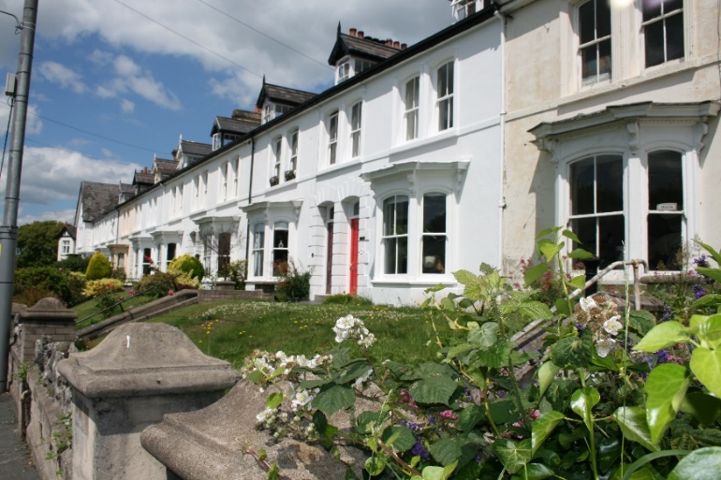

A Brecon street scene

- General Guidance

2.1 Permitted Development Rights

Under the Part 1 of the Town and County Planning (General Permitted Development) Order 1995, as amended in 2013, certain alterations and extensions do not require planning permission. These certain alterations and extensions can be carried out using your householder permitted development rights. An advice note has been prepared by Welsh Government providing guidance on the householder permitted development rights and whether planning permission is required for certain householder developments. This advice note can be found at the link below, please ensure you refer to the protected areas section of the guidebook, which applies to development in a National Park:
http://www.beacons-npa.gov.uk/planning/applications/before-you-apply/

It is your responsibility to check whether your permitted development rights are not restricted due to one of the following points:
- The property is within a Conservation Area;
- The property is subject to an Article 4 Direction;
- The property is a Listed Building, or
- The property has a planning condition on the original application for the construction of the house or any subsequent permissions that may restrict or remove your permitted development rights.

2.2 Pre-application advice

The National Park Authority encourages pre-application negotiations with prospective applicants as the first step towards gaining planning permission. This process can identify and provide applicants with an opportunity to resolve possible issues before the submission of an application.

We offer pre-application advice to householders and the public contemplating minor householder developments through our weekly planning surgeries. We hold two surgeries, one every Wednesday at our offices in Brecon and one every second and fourth Tuesday between 2pm and 3pm at the One-Stop Shop, Town Hall, Abergavenny.

When attending a planning surgery you will need to bring with you as much information as possible. Information such as the description of development, photographs, sketches and plans are very helpful. The more information you can bring the better informed our designated planning officer will be to assess your proposal against current planning policy. For more information regarding planning surgeries please consult our Planning Advice Note 6 which is available at www.beacons-npa.gov.uk.

2.3 The Application Process

2.3.1 Planning Applications

As the statutory planning authority for the Brecon Beacons National Park area we receive around 800 planning applications each year and we have to determine them in accordance with the adopted Development Plan: the Local Development Plan (December 2013) along with any other material planning considerations.

2.3.2 How do I submit a valid application?

To ensure your application is capable of being registered as valid you will need to consider your project carefully in order to ensure you know what information is required. The National Park adopts the national validation requirements (under the Town and Country Planning (Development Management Procedure) (Wales) Order 2012).

The basic validation requirements for a householder planning application are as follows:

- Householder application form – Ensuring all sections of the application form are completed.
- Site Location Plan – To a scale of 1:1250 or 1:2500, with a red outline to illustrate the curtilage of the property.
- Site Layout Plan – To a scale of 1:200 or 1:500
- Existing and Proposed Elevations – To a scale of 1:100 or 1:50
- Existing and Proposed Floor Plans – To a scale of 1:100 or 1:50
- Application Fee of £190
- Any additional information required – i.e. Initial Bat Scoping Survey, Full Bat Survey, Tree Survey, Landscaping details (this list is not exhaustive).

If, following an opportunity to provide any outstanding information, you fail to provide the required information your application will not be registered and will be made invalid. In order to ensure that your application is valid please consult our Local Validation Requirements document which lists the details and documents that are needed for different applications. These documents are available on our website along with our Planning Advice Notes (PANs) which give a range of advice from planning fees to our enforcement procedures.

It is also possible to submit planning applications online through the Planning Portal and pay the planning application fee using a debit or credit card. Alternatively, you can complete the nationwide standard 1APP application forms and hand or post them to our office, along with all the supporting documents. The forms are available to download from our website (www.beacons-npa.gov.uk).

2.3.3 What happens to my application?

Once the application is received, the information is initially registered and passed to our Principal Planning Officers who allocate your application to one of our Planning Officers. The allocated Planning Officer will validate the application against the Local Validation Requirements.

Once valid, the allocated Planning Officer will process the application in accordance with Planning Legislation. Officers will consult with statutory and non-statutory consultees (e.g. Town/Community Councils, Highway Authorities) and organisations, such as Natural Resources Wales and Dwr Cymru/Welsh Water for their views on the proposed development. These organisations can provide comments and suggest conditions which will be taken into account when making the decision. The Planning Officer assigned to your application will also undertake a site visit.

Neighbours of the development site are notified of the application by letter and the erection of a site notice and are given 21 days to respond and comment on the proposal. Details of all applications are published on our website and updated daily. Plans and consultee comments can also be viewed online. A paper copy of the file can be viewed at our headquarters in Brecon on an appointment basis by contacting the Planning Administration team on 01874 620431.

When considering the application the Officer must have regard to the relevant policies of the Adopted Development Plan and will take into account all aspects of the proposed development, including any comments from consultees and neighbours.

2.3.4 Who makes the decision?

Most applications are determined by authorised Officers (e.g. Director of Planning) under powers delegated to them by the National Park Authority under the approved Scheme of Delegation. The assigned planning officer will write a report which includes a recommendation as to whether planning permission should be granted or not. All reports and recommendations are reviewed by a Principal Planning Officer, before being formally determined by an authorised Officer.

Applications for major developments, departures from development plan policy, or applications which are the subject of objections from consultees or raise significant issues can be referred to our Planning, Access and Rights of Way Committee (PAROW) for determination. Applications which Members or Officers have a personal interest in will also be referred to our PAROW committee. PAROW runs on a 6 week cycle and committee agendas are available to view on our website (www.beacons-npa.gov.uk).

If an application you are interested in appears on the agenda for PAROW you may attend the meeting to witness the debate or access the live webcast of the meeting via the National Park Authorities’s website. In certain circumstances you can take part in public speaking at the PAROW meeting. The Public Speaking Procedure to address PAROW is available on our website.

2.3.5 What if I don’t like the decision?

If you are not satisfied with the decision or conditions imposed on your planning permission you have the right to appeal to the Planning Inspectorate at the Welsh Assembly. An applicant has six months from the date of the decision to lodge an appeal. There are no third party rights of appeal. Planning Advice Note 13 (PAN13) regarding planning appeals is available on our website (www.beacons-npa.gov.uk).

2.4 Other application types

If your property is a Listed Building or within a Conservation Area you may also be required to make an application for the following consents:
Conservation Area Consent – If your proposals include the demolition of a building or a wall within a conservation area you may require conservation area consent. If you have any queries regarding this, you should contact the National Park’s Senior Heritage Officer (Building Conservation) for advice.
Listed Building Consent – If your proposals include internal or external alterations/extension to a Listed Building or are within the curtilage of the Listed Building you would need Listed Building Consent. If the alterations are considered to be a repair or a like for like replacement the works may be exempt, but advice should be sought from the National Park’s Senior Heritage Officer (Building Conservation).

If amendments are proposed to a permitted application there are methods of altering the approved plans without the requirement of a whole new planning application. There are two formal methods to make changes to an approved application and the appropriate process to take is dependent on the site constraints and the type of amendments which are proposed.
Application for the variation of a condition (Section 73) – If the proposed amendments are considered to be material to the planning permission then an application to vary the appropriate condition would be required. This application has similar validation requirements to a householder application for planning permission, with a fee of £190 and an 8 week determination period.
Non-material minor amendment application – If the proposed alterations or amendments to the scheme are considered to be minor and non-material to the planning permission then a non-material minor amendment application could be submitted. This application has a form and requires the relevant plans and information to enable a decision to be made. There is a fee of £30 for a non-material minor amendment to a householder application with a 28 day determination period.

Application forms are available on our website at http://www.beacons-npa.gov.uk/planning/application-forms-1 or via the planning portal at http://www.planningportal.gov.uk/
For further information on a particular type of application please do not hesitate to contact us or visit the Brecon Beacons National Park Authority website: www.beacons-npa.gov.uk

2.5 Demolition
The demolition of a building is generally not classed as ‘development’ and therefore planning permission is not usually required. In certain instances the demolition of certain buildings will need approval from the Local Planning Authority prior to the commencement of the demolition works. In these cases you must apply to the planning authority for a determination as to whether prior approval will be required for the method of demolition and any proposed restoration of the site. The purpose of this control is to give Local Planning Authorities the opportunity to regulate the details of demolition in order to minimise the impact of that activity on local amenity. The Authority will also ensure that the applicant has undertaken appropriate species surveys to ensure that no protected species are affected by the demolition of a building.
Although the demolition of a structure may not need planning permission, other consents may be required (please see section 2.4).

2.6 Building Regulations
Both planning permission and, in most cases, Building Regulations approval are required before building works can commence on site. Building Control is not a function that is carried out by the National Park Authority as it is administered by the relevant Unitary Authority. You will find a list of the Unitary Authorities together with contact details at the end of this guide.

2.7 The Party Wall Act 1996
If the works you propose to carry out are on the boundary of your property or access is required from the neighbouring property you will need to check your responsibilities and rights under the Party Wall Act 1996. Details can be found on the government website as follows:
https://www.gov.uk/party-wall-etc-act-1996-guidance

3. Design Guidance for your proposal

3.1 Principles of Good Design

Design is defined in paragraph 4.11.1 of Planning Policy Wales (Edition 8, January 2016) as “the relationship between all elements of the natural and built environment. To create sustainable development, design must go beyond aesthetics and include the social, environmental and economic aspects of the development, including its construction, operation and management, and its relationship to its surroundings”.

Good design is a process of careful understanding of a place and its context. Whilst design is subjective there are a number of key principles which can be followed that raise the standard of proposed householder development, and should result in the enhancement of the Brecon Beacons National Park as a whole.
Design is not just about the appearance of a building, structure or space; Bad design can have a detrimental impact on the way in which we live our lives and function in the environments around us. Good design constitutes as alterations and extensions to a property which enhance the local area, relate well to the original dwelling, and are well conceived in their own right. They must also make use of quality materials while meeting the requirements of the householder. Good design can also help to reduce energy bills, avoid wasting natural resources and make more efficient use of land.
Your proposal should normally be acceptable if it does not:
- Harm the character or appearance of the area;
- Harm the character of the existing dwelling;
- Unreasonably affect your neighbours by causing overlooking or overshadowing of their property, by having an overbearing effect on them, or effecting their right to light;
- Cause problems with highway safety, such as by making access to your property dangerous or by the loss of on-site parking in an area where on street parking would be dangerous;
- Conflict with adopted policies of the Local Development Plan
In considering planning applications, the Council cannot take into account:
- The effect on the value of neighbouring properties;
- Private boundary disputes and private rights of way;
- Private legal covenants;
- Private views.
These guidelines are not exhaustive and each case must be considered on its individual merits. In some cases there may be good reasons why they should not be followed. There may be imaginative design solutions which can help to overcome any problems encountered. However, it is important that planning decisions are made on a consistent basis, and therefore clear justification would be required to defer from the guidelines set out above.

Size, Scale and Mass
The overall size, scale and mass of extensions and alterations are critical when determining its acceptability. An extension or additional structure should normally be subservient to the original house (in height, depth and width) except in exceptional circumstances. Extensions should have similar proportions to the original building, although on a smaller scale, and should not significantly reduce the outdoor amenity space at the property.
In terms of new roofs, the style and scale should always complement that of the original building, for example, hipped roofs should generally only be used if the original building is fitted with hips. The pitch of a proposed roof should match that of the original building. Where flat roofs are proposed they must be sensitively designed, and are more likely to be considered acceptable with contemporary proposals rather than traditional schemes.
Any extensions or alterations should be in keeping with the existing character, design/materials, scale and proportions of the main dwelling and must not unbalance any other attached dwellings. The following general rules should be taken into account when designing an extension:
- Front extensions beyond the building line will not normally be permitted
- Corner plots are very prominent, buildings on corner plots may be difficult to extend and special design skill will be required
- The siting, scale and orientation of extensions should avoid unacceptable levels of overlooking and overshadowing of private areas of neighbouring houses and gardens
- New development should not overbear its neighbours, and therefore should be set back from all site boundaries and be of an appropriate scale
- No part of an extension should overhang a boundary (e.g. rainwater goods, balconies) unless there is a good reason for doing so (notice will need to be served on the other landowner(s))
- Extensions, where possible, should be sited to preserve existing trees and hedges
- Extensions should be of a scale and sited appropriately to ensure sufficient garden is retained
- Extensions should not result in the loss of off-street parking behind the building line to preserve the street scene / character of the area where appropriate
- Extensions should not prevent the natural surveillance of the street, and in particular front doors should be visible from the street

3.2 Understanding where you live
Your property will contribute to the overall character and appearance of the area of which it is in. When considering extending or altering your house, you should reflect on the impact any proposal may have on the overall surroundings. It is important that an extension or alteration is suitably designed to fit in with the appearance of your house and the street scene. Below are some points to consider when designing your proposal:
- The building line and topography of your street, recognised the height and spacing of buildings;
- The roof styles and shapes that can be seen in your street;
- The patterns of external materials used on your house and on the surrounding properties (i.e. slate, stone, brick, timber);
- Any consistencies in the arrangements of the door and windows openings;
- Any repetitive building forms which exist in your street scene and considering whether your proposal reflect this form;
- Any existing trees, hedges, walls and garden patterns are considered when designing your proposal, to ensure that any new development contributes positively to the character of the street scene and wider landscape of the National Park.

Photographs illustrating the contrasting street scenes within the National Park

3.3 Extending your house
Minor extensions to dwellings might not require an application for planning permission, section 2.1 provides further information on permitted development rights.
Whether or not planning permission is required an improvement to a house should not only make it easier to live but also maintain or improve the character and appearance of the property. Large extensions to the side or rear of the dwelling might have considerable effect on neighbouring properties as well as on the main building. Good planning and careful design could provide advantages by creating privacy, screening or reflecting sunlight and daylight into existing rooms. The main elements of roof, wall and windows should combine in such a way that the overall effect is in scale with, and does not adversely affect, the architectural balance of the existing building. Simply by setting back the extension wall 150 mm from the main building line of the original building line, the character of both old and new can be expressed.
Pitched roofs are a traditional and practical feature of houses in Wales and give a visual sense of soundness and finish to the building. Pitched roofs not only look better, but with felt under slate or tile provide a double line of defence against weather penetration. To be in keeping with the main house, the roof of a proposed extension should be of the same slope and materials; and unless there are unusual ground levels, the roof line of the extension should be lower than that of the main building. Flat roofed extensions can generally be considered as unacceptable, however there are certain instances where a flat roof would be considered appropriate due to the particular site or alternative design.

3.3.1Two Storey extensions
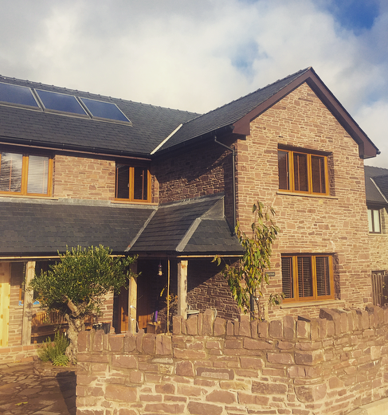
Two storey extensions are larger and more prominent than single storey extensions; they therefore can have a larger impact upon the overall appearance and character on the host dwelling and surrounding area. Any two storey extensions must be proportionate in terms of size and scale of the host property and its roof structure; it must not be overbearing to any neighbouring properties and should allow for the retention of sufficient outdoor amenity space. They can have a larger impact upon the overall appearance and character on the host dwelling and surrounding area. It is therefore crucial to ensure your proposal is appropriate.
Example of a pitched roof two storey extension
Two storey front extensions
Front extensions should not detract or alter the wider street scene. Extensions to the front are not generally acceptable where there is an obvious building line which would be disrupted by a front extension.
If an extension to the front of your property is to be considered acceptable, it would need to be well designed to ensure that the proposal does not have a detrimental impact on the character and appearance of the property and greater street scene. An extension to the front of a property may alter the character of the original dwelling and interrupt the building line on that street; Acceptable additions to the front elevation would usually include a porch or small extension, however every case is considered on its own merits.
The principal elevation of a residential dwelling usually faces the highway and includes the door used to access the property; any proposed extensions to this elevation would require planning permission.

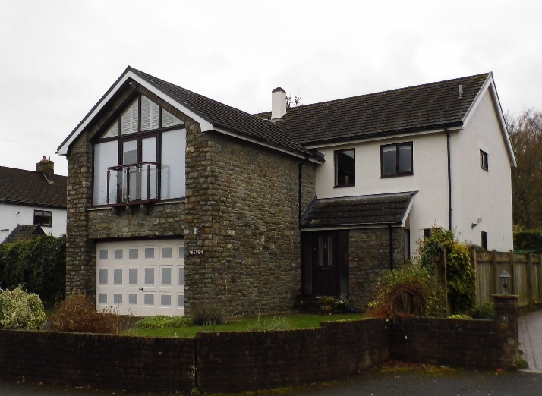

Example of a two storey front extension

Please see sections 3.6.4 for further details on porch extensions.
Two storey side extensions
Extensions to the side of a detached or semi-detached property should follow the criteria below:
- The extension must be set back from the front elevation to allow for a visible break between the existing and proposed extension, usually a 150mm set back is considered acceptable;
- The ridge and eaves height of the extension must be set down at a lower level than the main ridge and eaves to avoid a terracing effect;
- Any two storey extension must have a hipped or pitched roof to match original in terms of pitch and shape;
- The extension should match the host dwelling in terms of scale, design and finish;
- Characteristics of the main property should be reflected within a proposed extension, including elements such as the style and size of the openings, the wall finish, eaves and ridge.
- The extension should be away from the side boundary of the property;
- A side extension to a property on a corner plot must remain subordinate to the main dwelling. They should include sufficient openings to ensure that highly visible elevations are not blank and do not have a detrimental impact on the appearance of the area.
- If your property is semi-detached, a side extension must be appropriate in size to ensure that the host property does not look out of balance with the adjoining dwelling.
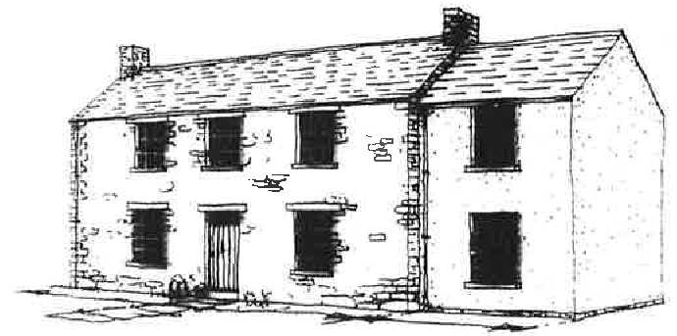

Example of a two storey side extension
Two storey rear extensions
Extensions to the rear of a detached or semi-detached property should follow the criteria below:
- The ridge and eaves height of the extension must be set down at a lower level than the main ridge and eaves in order to remain subordinate to the original property;
- Any two storey extension must have a hipped or pitched roof to match the original in terms of pitch and shape;
- The extension should match the host dwelling in terms of scale, design and finish;
- The extension must be subordinate and appropriate in terms of size and scale of the original property;
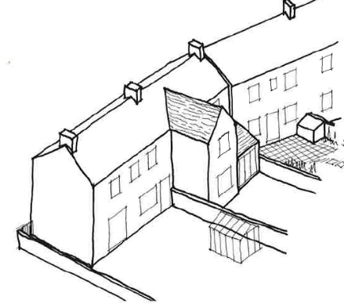
- Consideration must be given to the proximity between the proposed windows and the adjacent properties to ensure that the proposal does not have a detrimental impact on the amenity and privacy of your neighbour;
Example of a two storey rear extension
- Characteristics of the main property should be reflected within a proposed extension, including elements such as the style and size of the openings, the wall finish, eaves and ridge;
- The extension should be set away from the boundary of the property;
- Sufficient garden and outdoor amenity space should be retained at the property;
- The proposed extension must not negatively impact protected species.
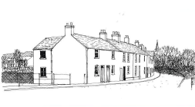

Example of a two storey rear extension
3.3.2 Single storey extensions
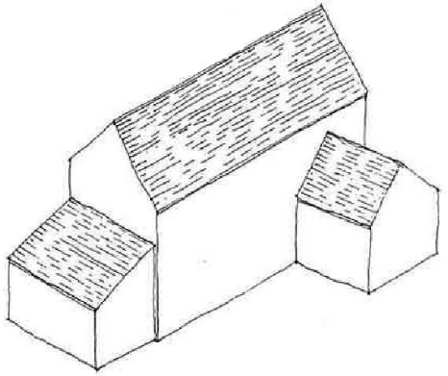
Well-designed single storey extensions provide additional living space whilst usually having minimal impact on the host property, neighbouring dwellings and surrounding area. Single storey extensions must be appropriate in terms of size and scale to ensure that they do not have a detrimental impact on the character and appearance of the main dwelling; with the use of matching or appropriate materials. If your proposed extension encroaches upon an existing parking area you should consider relocating the parking provision within the curtilage of your property to ensure that sufficient parking is retained (2-3 spaces dependent on the size of your property).
Examples of single storey side and rear extensions
Single storey front extensions
Extensions to the front elevation of a property are not usually supported and can be difficult to accommodate. However, small extensions functioning as an entrance hall or porch may be considered acceptable subject to the overall design of the proposal. The front of a property is usually the most prominent and visible within a street and can include the main characteristics of the house; therefore large extensions are unlikely to be acceptable, particularly within a row of uniform dwellings.
Single storey extensions to the front elevation may be acceptable if:
- There is a lack of uniformity within the street scene;
- The proposal will not have a detrimental impact on the character of the host property or general area; and
- The dwelling is positioned well set back from the front boundary of the curtilage;
- The proposal would match the host dwelling in terms of scale, design and finish.
For further information regarding porches, please see section 3.6.4.
Single storey side extensions
Single storey side extensions are a popular method of increasing the residential floor space of a property. In instances where the extension is to be located on the boundary with a neighbour, consideration of the amenity of the neighbour must be given when designing the extension. As a general rule extensions to the side should not exceed the width of the host property to ensure it remains subservient and appropriate in terms of size.
A single storey side extension would be generally acceptable where:
- Materials which match the existing dwelling are used;
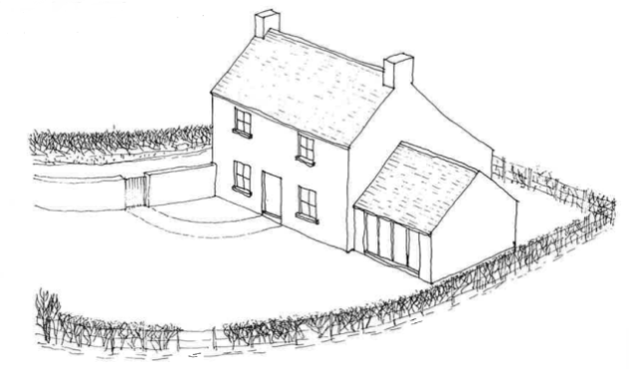
- The extension would not have a detrimental impact on the amenity or privacy of a neighbouring property;
Example of a single storey side extension
- The extension is appropriate in terms of size, scale and design of the original property and plot;
- The roof pitch of the extension matches (where possible) the roof pitch of the original property;
- The extension would be set back from the principal elevation of the main house to allow for a visual break between the existing dwelling and the proposed extension.
Single storey rear extensions
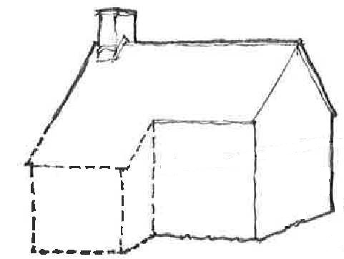
Single storey extensions to the rear of a property are a very common method of increasing the residential floor space of a house. In instances where the extension is to be located on the boundary with a neighbour, consideration of the privacy and amenity of the neighbour must be given when designing the extension. The depth of the extension depends on the relationship the property has with the neighbouring dwelling: If the extension is stepped away from the boundary a greater projection from the rear wall may be more acceptable.
A rear single storey extension would be generally acceptable where:
- The use of materials to match the existing dwelling;
- The extension would not have a detrimental impact on the amenity or privacy of a neighbouring property;
- The extension is appropriate in terms of size, scale and design of the original property and plot.
See section 3.11 for more information on neighbour amenity and the 45 degree rule.
Example of a single storey rear cat slide extension 1
3.3.3 Dormer windows
Where there is inadequate headroom within an existing roof space, it may be possible to create additional space through the insertion of dormer windows. Dormer windows are generally considered acceptable if:
- They are modest in size;
- They are finished in materials to match the host property;
- They are appropriate in terms of scale and appearance;
- They are in proportion with the windows below and are of a traditional style which matches the character of the building.
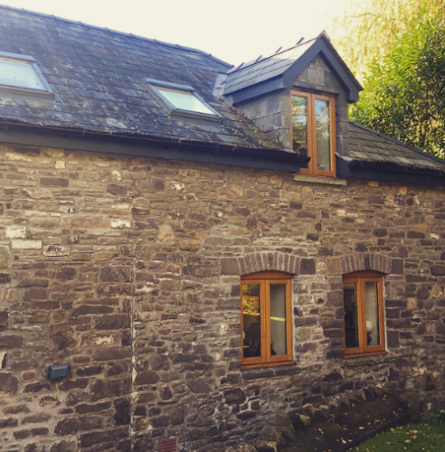
The examples below illustrate a gabled dormer (left) and lidded dormer (right):
Examples of dormer windows
3.3.4 Porches
Entrance lobbies are much cheaper to provide if they can be formed within the existing building, but where it is necessary to build on externally, a porch should be of traditional shape and with simple, uncluttered detail. When designing a porch it is important that the proposal:
- Reflects the character of the house and surrounding area;
- Should be proportion to the scale of the house and should avoid being over-dominant;
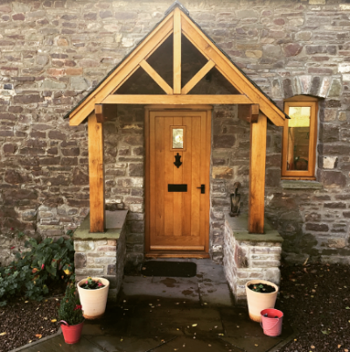
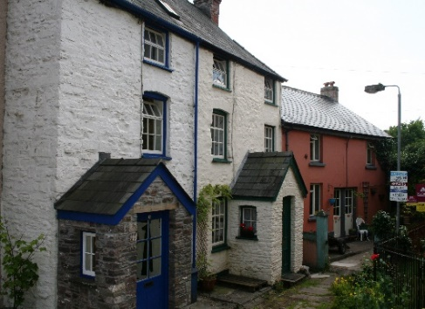
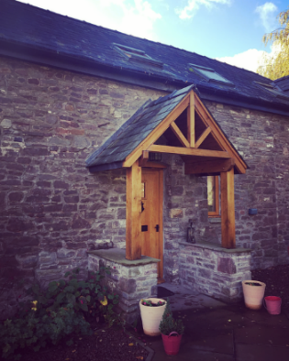
Should be designed so that the details and roofs reflect the shape and style of the existing
Examples of porches

3.3.5 Extensions in countryside locations
Development within countryside is strictly controlled by virtue of policy CYD LP1 of the Local Development Plan (2013). This stipulates that proposals for development within countryside locations will be required to contribute positively to their countryside setting and enhance the quality of the landscape without adverse impact on the wildlife, natural beauty, cultural heritage, environmental assets or biodiversity of the area.
CYD LP1 (1) (a) looks at extensions to dwellings in open countryside. Proposals for an extension to a dwelling in the open countryside that would increase the size of the original dwelling by more than 30% will be considered to be contrary to Policy CYD LP1. The Local Development Plan defines the original dwelling as the dwelling as existing on 1st July 1948 if it was built before that date, and as it was built if built after that date.
Therefore if your house is located outside of the settlement boundaries displayed within the Local Development Plan inset maps (which are available to view on our website: http://www.beacons-npa.gov.uk/planning/draft-strategy-and-policy/brecon-beacons-national-park-local-development-plan/) an extension to the property should not exceed a volume increase of over 30% of the original dwelling. The original dwelling being as it was on the 1st July 1948 if it was built before that date, and as it was built after that date.
The primary consideration in assessing proposals to extend dwellings in the countryside is that its character and appearance is retained. In practice, this means that to conform to policies 27 and CYD LP1 of the Local Development Plan, all proposals to extend dwellings in the countryside must therefore:
- Be considerably smaller than the existing dwelling;
- Be lower than the existing dwelling in relation to ridge and eaves height; and
- Be subordinate to the existing dwelling with the original form of the dwelling being clearly recognizable when the new works are completed.
If your property is located within the countryside, further information in relation to extending your house and policy CYD LP1 of the Local Development Plan (2013) can be found in Supplementary Planning Guidance ‘Enabling Appropriate Development in the Countryside’ (Endorsed by NPA on May 22nd 2015), which is available on our website: http://www.beacons-npa.gov.uk/planning/draft-strategy-and-policy/supplementary-planning-guidance/
If a planning application is to be submitted which represents a new increase of more than 30% but is considered acceptable and recommended for approval, it must be reported to the Planning Access and Rights of Way Committee (PAROW) for determination as a departure from Policy CYD LP1 set out within the Local Development Plan (2013).

3.4 Out Buildings and Garages
Domestic garages and outbuildings must be used for purposes incidental to the enjoyment of your house, not for commercial or residential accommodation purposes. The positioning and design of the proposed structure should complement the character of the property and appearance of the surrounding area.
The key principle when designing your proposed garage or outbuilding is to consider the overall size and position of the structure. It is essential that the building is subservient to the host dwelling in terms of scale, ensuring that the roof style and pitch relates to the main house. Pitched roofs are preferable to flat roofed structures as long as they do not dominate or increase the massing of the building.
Generally, the outbuilding or garage should not be positioned forward of the principal elevation and should be set away from the neighbouring boundary if considered to adversely affect your neighbours amenity.
If your proposal is for a residential garage, it is crucial to consider the parking and turning provisions at the site, and any potential impact the development would have on highway safety. If an access to the highway is proposed, we would encourage you to contact the highways department within the relevant Local Authority prior to the submission of the application. This allows you to discuss your proposal and the issues dealt with directly by the highway department, such as lowering of a curb.
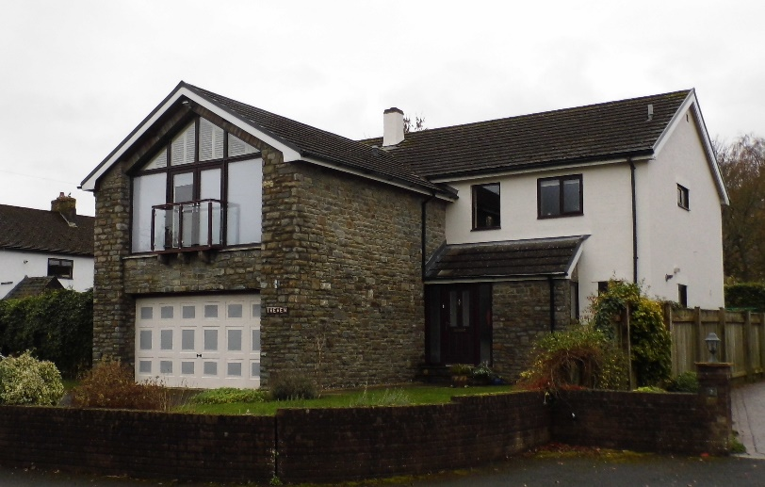
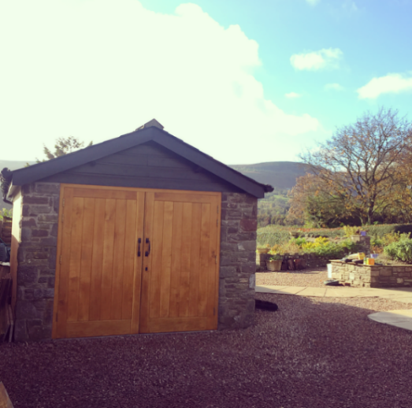
Below are examples of garages which are generally considered acceptable subject to the constraints of the individual site.
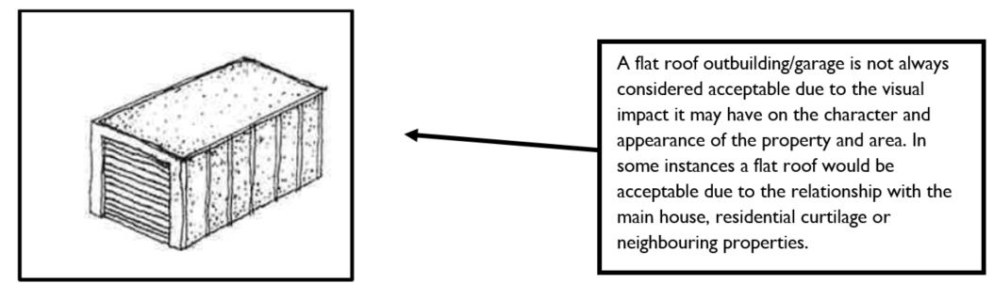

Detached, single or double garages can be acceptable however are usually associated with properties which benefit from large areas of amenity space. Detached garages should be subservient in terms of size and scale of the host dwelling within the site and in most cases should be set back from the principal elevation. It is essential that the roof pitch and openings are proportional to the size and scale of the building, with the use of appropriate materials.

3.5 Ancillary residential accommodation and annexes
Residential annexes generally provide accommodation which offers a certain degree of separation from the main dwelling, while remaining linked and dependent on the host property. In considering a residential annex the Authority must be satisfied that the accommodation cannot exist without reliance on the main dwelling and is seen not to create a separate unit of living accommodation within the curtilage of the property. The Authority will expect that any proposals for annexes follow the following requirements:
- Comply with the Authority’s standards for extensions to a dwelling in terms of size, scale, design and neighbour amenity.
- Remain subordinate to the main dwelling
- Be within the curtilage of the host dwelling
- Rely on a common shared access with the main dwelling
- Be in the same ownership as the main dwelling
- Have a functional connection with the main dwelling (e.g. the occupant should be a dependent relative of the residents of the main dwelling)
- Have no boundary separation or sub division of the garden areas between the curtilage of the main dwelling and the annexe
- Have adequate parking to serve the main dwelling and the associated annexe.
If planning permission is granted for ancillary residential accommodation, planning conditions would be attached to the decision to control the occupants of the accommodation and the connection with the host property. In certain instances it may be required for the development to be controlled by a section 106 legal agreement.

3.6 Roof lights
Roof lights provide natural light into the roof space of properties and are simpler, less intrusive than inserting a dormer window. The insertion of roof lights should following the following guidelines:
- When more than one roof light is inserted into a roof plane, they should be located at similar positions and match one another in terms of design and size;
- Roof lights should be fitted flush with the roof covering to ensure they do not have an unacceptable impact on the character of the property;
- If your property is located within a Conservation Area, ‘conservation’ style roof lights will be expected to be used.
Alterations to any part of the roof may require ecological surveys to ensure that the proposal would not impact any protected species, namely bats. Refer to section 3.14 (Ecology) for further information regarding ecological surveys.
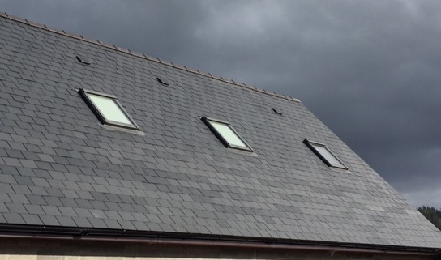
Example of roof lights within the roof plane

3.7 Boundary treatments
Boundary treatments, particularly front boundaries, have a significant impact on the character of an area and the street scene. Any alterations to walls, fences or railings should be carefully considered in terms of appearance, siting and security.
Front enclosures should be low enough to see over. The height of all enclosures should ensure that public areas, such as footpaths, are not unduly enclosed so as to compromise pedestrian safety. High walls and fences of 1.8 metres provide good security at the rear. Side entrances should be lockable.
The design and type of materials used for means of enclosure and boundary separation depends on the function of the structure and the traditions and character of the particular locality. As a general rule local natural stone used in the local traditional manner, either mortared or dry-stone walling, will make an appropriate boundary in open country, village or town.
Examples of stone walling
Examples of boundary fencing which is generally acceptable within the National Park include:
- Simple, stained post-and-rail fencing is suitable for many countryside or village sites;
- Well maintained white or dark stained palisade fencing is traditional and could suit a village location;
- Black painted iron railings, with or without a stone wall base, are suitable for villages or towns.
Boundary treatments which should be avoided are:
- Overly detailed artificial stone or concrete screen walling
- Chain link fencing on concrete posts
Fences or walls on steep sloping sites should not be stepped. The top of the fence or enclosure should match the slope of the ground.

3.8 Balconies and terraces
Proposals which create an elevated platform will only be acceptable where they do not directly overlook neighbouring gardens and are in keeping with the character of the host property. Strategically placed screens may sometimes help where it is not otherwise possible to avoid overlooking. In densely populated areas it can be difficult to construct these features without causing problems regarding privacy to others in the locality.
Planning permission is normally required when using an existing flat roof as a balcony or terrace. The use of a flat roof extension as outdoor residential amenity space would be considered in the same manner as an application for a new balcony or raised terrace area.
If you are considering incorporating a balcony or decking at your property it is strongly advised to discuss this with all neighbours who may be affected prior to the submission of a planning application.
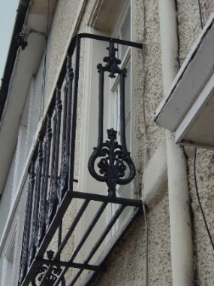
Example of a Juliet balcony

3.9 Alterations to a converted agricultural building
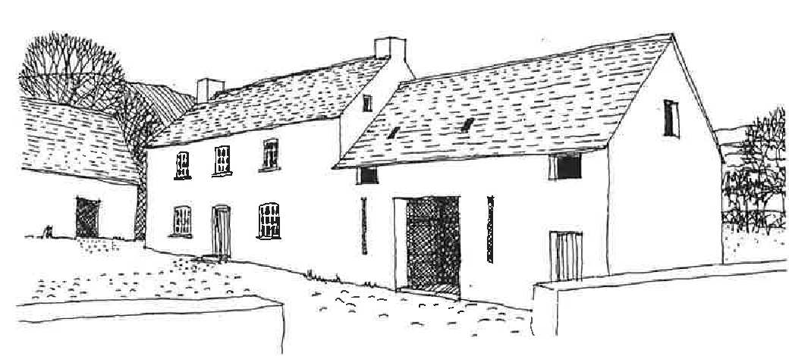
Example of an attached converted agricultural building
When consent is granted for the initial conversion of rural buildings to residential use it is normal practice to impose conditions removing the normal permitted development rights in relation to extending or altering the building structure. Generally, this means that any alterations to a converted rural building will require planning permission.
Alterations and extensions to convert agricultural buildings must be sensitive to the rural and agricultural nature of the property. Proposals regarding such properties are usually considered more sensitively than an alteration or extension to an ordinary dwelling. Conservatories and porches are very unlikely to be supported as these are very domestic in appearance. Equally, alterations which remove or conceal key features, such as the original openings, are not likely to be considered favourably.
It is essential that converted buildings retain their overall appearance and character, keeping a similar form, the use of appropriate materials and the use of existing openings and fixtures. It may be considered acceptable to extend a converted rural building in some instances, however, any alterations must not significantly alter the original character and form of the property, and positively contribute to the appearance of the overall building. It a building is not large enough to contain all the accommodation required, additional space may be added in appropriate form which would match the existing style, materials and detailing. Exceptionally, an extension may contrast with one or more of these elements, provided that the overall effect is harmonious and the development does not cause detriment to the character of the building.

3.10 External Materials
The choice of building and finished materials should reflect the character of the property and area. Generally, the materials should match those of the house in order to achieve a degree of coherence between original building and extension. The materials used in an extension or alteration often decide its appearance and impact on the street scene. Poorly matched bricks, stone, slate, tiles and even mortar can ruin a good design and stand out in the street. The roof is an important element because it is often the most visible. Where the roof of the original dwelling is covered in natural slate, it is not appropriate to use imitation slate on the extension roof, though it is acknowledged that some materials are no longer made. Reusing existing slates or second-hand supplies can be a solution.
If your property is located within a Conservation Area, please see the Conservation Area Appraisal for your area on our website for further details on appropriate external alterations to buildings:
http://www.beacons-npa.gov.uk/planning/heritage2/built-heritage-draft/conservation-areas/
External wall finishes
The materials and finishes chosen for an extension are very important and should be related as closely as possible to the materials used in the original building. In many cases it is likely that the best match of bricks or stone is obtained, both in terms of colour, texture and tone. If materials can be salvaged and reused, this can assist in blending old and new. In some cases high-quality modern materials which positively contrast with the finish of the existing property may be acceptable. The use of materials should integrate with the desirable features of the traditional, remembering that traditions vary in different areas of the National Park, with the functional requirements of modern living.

Example of the use of smooth render
Example of the use of natural stone

Doors and windows
Inappropriate window detailing can spoil an otherwise acceptable extension and make the addition appear out of character. All new windows and doors should respect the character and appearance of the original house. Particular attention should be paid to the side and front elevations. Details which should be considered are:

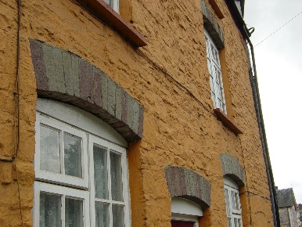
- The size, materials and overall design;
- The positioning of windows and doors within the building;
- Cill and head details.
Windows and detailing vary from house to house. It is critical to ensure that those chosen for an extension reflect the host dwelling.
Example of window detailing
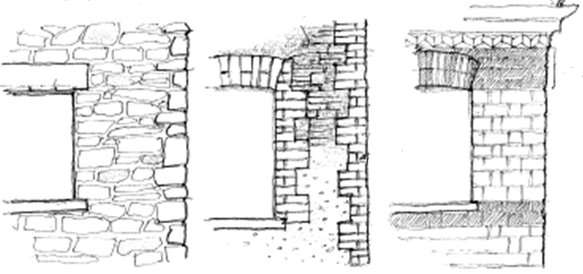
Examples of window detailing
Consideration of the historic characteristics of a building should also be accounted for when undertaking works to existing windows and doors. Architectural features such as former shop fronted windows should be preserved in order to protect the historical fabric of the property and street scene.
Examples of acceptable windows
The design, style and materials of any windows proposed in an extension should match those within the host property when possible, or offer an improvement to the existing openings. The layout of the proposed windows should also reflect the character of the existing dwelling, with similar sized openings and design of glazing bars where appropriate. There are various types of windows which would usually be considered acceptable, below are examples of appropriate styles:
Older and historic window styles:
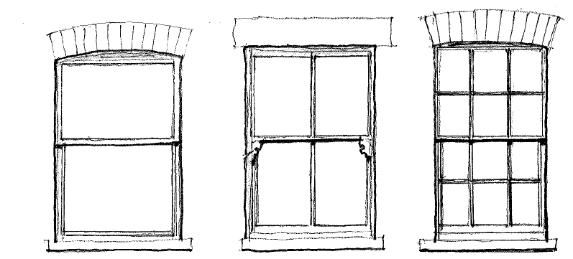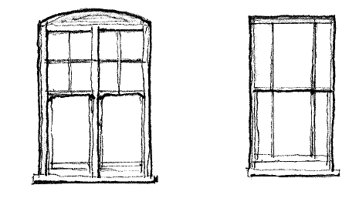
Modern window styles:
Examples of acceptable door types
The design, style and materials of any doors proposed in an extension should match those within the host property when possible, or offer an improvement to the existing openings. There are various door types which would usually be considered acceptable throughout the National Park and these vary dependent on the characteristics of the main property. Below are some examples of various door types throughout the Brecon Beacons National Park:
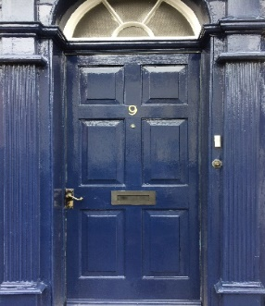
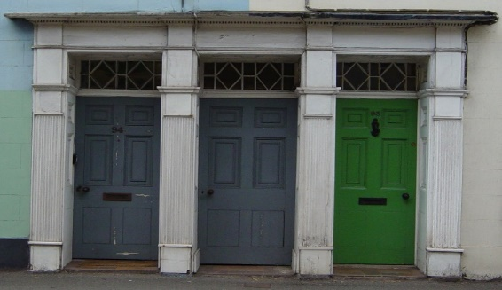
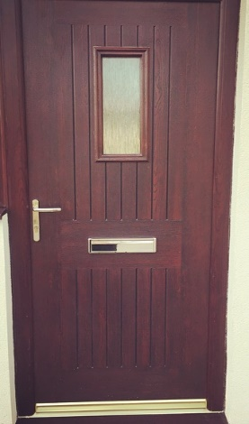
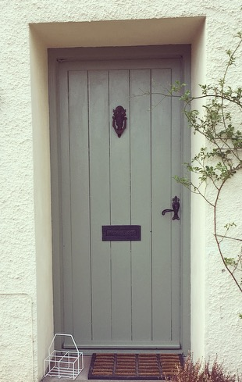
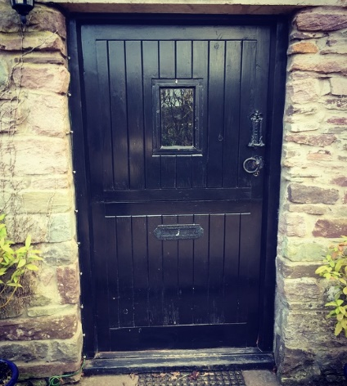
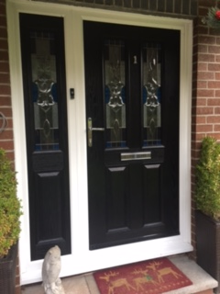
Examples of various door styles

Roof finishes
Roofs should match the main roof of the host dwelling in terms of shape, pitch and materials. Generally roof details including fascias, soffits and rainwater goods, along with verges should be uniform with the details of the existing dwelling. If the roof of the original house is finished in natural slate, it would not be appropriate to use artificial slates on the roof of an extension, however it is recognised that certain materials are no longer manufactured.
The roof finish and building materials should reflect the character of the host dwelling and area. Poorly matched slates and tiles can be detrimental to the overall appearance of the property.
Chimneys
Although they have a practical function, chimney stacks and pots can enhance the character and appearance of your existing property. If the proposals include the provision of additional chimneys, it is suggested that they match any existing stacks/pots in terms of design and finish in order to retain the character of the dwelling. If your proposal includes the insertion of a chimney into a roof which does not currently benefit from a stack/pot, ensure that the addition is appropriate in size and scale of the roof plane and dwelling and is either located at the end of the ridge or in the centre of the roof ridge (see example images below). Within the National Park, planning permission is required for the installation, alteration or replacement of any chimney.
When considering the installation of a flue into the roof plane it is important to ensure that the stack is located in an appropriate location, preferably on the rear elevation, to reduce the overall impact on the house. If a stainless steel flue pipe is proposed, these can have a detrimental impact on the character of a property and street scene, therefore you should consider painting the flue a dark colour (e.g. matte black) to reduce its impact.
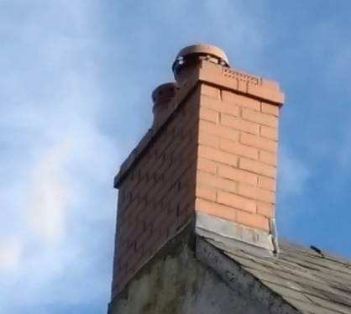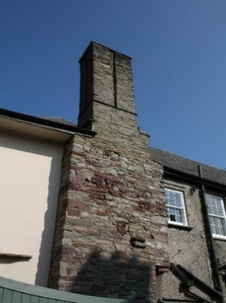
Examples of chimney styles

3.11 Neighbour Amenity
The design of all extensions should take into account the impact on neighbouring properties. Extensions to a property should maintain a reasonable distance from the neighbouring property, ensuring that the proposal does not overlook or overbear the adjacent dwelling.
Two storey extensions should be at a distance of 10.5 metres between the rear wall of a property and its rear boundary; and 21 metres should remain between the rear habitable room windows of houses which directly back on to each other. This is normally required to avoid overlooking and to protect neighbour amenity. Where there is an established development pattern or in the case of larger houses, the above guidelines may not be appropriate.
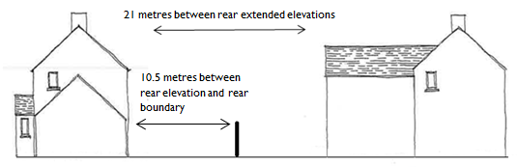
Extensions should not be overbearing to your neighbours or result in an unacceptable loss of light to neighbouring properties. As a general rule, two-storey extensions should not be positioned very close to the boundary adjacent to the garden of a neighbour’s property. Two storey extensions if appropriate should be subservient to the main dwelling and be limited in size as to avoid an overbearing appearance, significant overshadowing and loss of privacy in order to avoid a detrimental impact on the neighbour.
The potential loss of sunlight to neighbouring properties is a material planning consideration. Generally, two storey extensions should not encroach beyond a 45 degree line taken from the edge of the nearest first floor window of a habitable room of a neighbouring property.
If your proposal includes a two storey extension, you must consider the impacts it may have on the neighbouring property in terms of over shadowing or their right to daylight. The 45 degree rule can be used to illustrate the maximum acceptable size of an extension. This rule can be used to measure the acceptability of the depth, width and height of a proposal; however please note that an extension may fall within the 45 degree rule but still be considered unacceptable.
The diagram below illustrates how to use the 45 degree rule:
Any side facing upper floor windows to habitable rooms needs to be carefully located or designed to ensure they do not cause overlooking problems for neighbouring properties.

3.12 Parking and Highway Safety
An extension should not have an adverse impact on highway safety or car parking provision. It should not restrict or affect any existing access, turning area or parking space or the visibility of highway users. Where an extension would be built over an existing car parking space, this may have to be replaced within the boundary of your property to a standard acceptable to your Local Authority’s Highways Department.

3.13 Trees
Consideration should be given to whether an extension will affect any trees, particularly those that are protected by a Tree Preservation Order. The siting of a structure and all associated hard surfaces should avoid the removal of or damage to any significant trees and tree rooting.
Policy 8 (Trees and Development) of the Local Development Plan (2013) states that proposals for development on sites containing trees will be required to provide a Tree Survey and a Tree Protection Plan in support of the proposal.
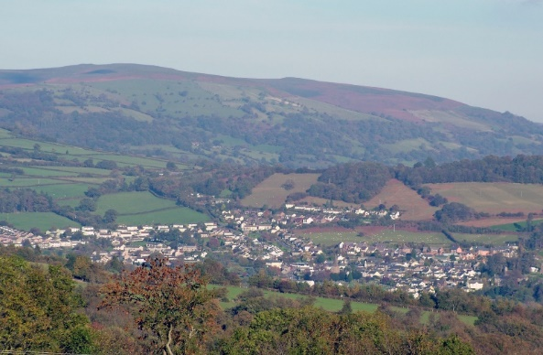

3.14 Ecology
The Brecon Beacons National Park Authority has a responsibility to protect, conserve and enhance wildlife and the natural environment when considering development proposals. Vulnerable species and habitats can be adversely affected as a result of development and it is essential to consider the potential impacts of proposals on wildlife at development sites. Extensions must avoid harm to protected species, such as bats and nesting birds (e.g. swifts, house martins and house sparrows), as this can constitute a legal offence. If there is any potential for any adverse impacts, mitigation or compensation measures will need to be incorporated.
The planning and development process therefore has an important role to play in controlling and relieving the pressure that development can put on biodiversity. As protected species are a ‘material consideration’, Brecon Beacons National Park Authority cannot determine an application of this nature until all the necessary survey, mitigation, compensation and enhancement information are received. Failure to address ecological issues may cause a planning application to be refused.
Many householder applications involve only minor alterations and will not necessarily have an impact on protected species. However, if the proposal includes the insertion of roof lights or a proposed extension which interferes with the existing roof or eaves of the property, or concerns are raised by the National Park Planning Ecologist or Natural Resources Wales during the application process, the applicant would need to commission a preliminary ecological survey to establish whether the proposed development will have impacts on protected species. If no evidence of or potential for presence or impacts is found, a report detailing these findings should be submitted, along with any suitable biodiversity enhancement measures. This can be in the form of a letter-style report if desired.
If evidence of or potential for protected species is found, further ecological surveys must be undertaken at an appropriate time of year to establish species present, numbers and details such as exact roosting sites and access points for bats. The methodology of the surveys should follow the latest best practice guidelines for the species concerned. A final report must detail mitigation, compensation and enhancement measures (including landscaping if appropriate).
In summary, if surveys are required, the applicant will need to submit a report to the BBNPA detailing the following:
- A full visual assessment of the site for the presence of protected species (bats, nesting birds etc.)
- If necessary, results of further surveys to establish species present.
- Mitigation and compensation strategies for any species found to be present – these will also need to be shown on architectural drawings
- Biodiversity enhancement measures that can be incorporated.
Please note that the biological records provided in the ecological report will be forwarded to the Biodiversity Information Service for Powys and Brecon Beacons.’
Biodiversity Enhancement Measures
When a proposed extension or alteration impacts the roof and/or eaves of a property the National Park Planning Ecologist would be consulted on the planning application. Regardless of whether any ecological surveys are required at the site, the provision of at least two biodiversity enhancement measures would be requested to be installed. Details of the enhancements are usually secured through a planning condition which ensures that the Authority receive information on the type of enhancement (bat box, bird box etc.) and its proposed location prior to the commencement of the development. These details can be provided and considered as part of the planning application process; this can avoid additional costs and timescales. The provision of biodiversity enhancement measures through the planning application process complies with policies SP3, 6 and 7 of the Brecon Beacons National Park Authority Local Development Plan (2013) and the biodiversity duty under Section 6 of the Environment (Wales) Act 2016.

3.15 Archaeology
The landscape of the Brecon Beacons National Park has been shaped and changed by humans for thousands of years, from prehistoric times to the present day. The people, down the ages, who called this landscape their home, lived, worked and died here, and the physical traces they behind can tell us about their lives. The wealth of archaeological heritage left to us by our ancestors makes an important contribution to the National Park’s special qualities.
The Welsh Government recognises the potential threat to archaeological remains posed by development, and preserving archaeological remains and their setting is a material consideration in determining a planning application, allowing the planning system to manage and conserve the archaeology within the National Park. There is always a presumption in favour of the physical preservation, in situ, of nationally important archaeological remains. However, the case for the preservation of archaeological remains is assessed on the individual merits of each case, taking into account all planning policy considerations, the intrinsic importance of the archaeological remains weighed against other factors, including the need for the proposed development. Most planning applications and developments will not have a significant impact on archaeological remains.
In order to make fully informed and reasonable decisions, planning authorities need to be fully informed about the nature and importance of the archaeological remains and their setting, and the potential impact of the development upon them. Early consultation and discussions between the Brecon Beacons National Park Authority and developers is very important in order to ensure that the needs of archaeology are taken fully into account as early as possible in the development processes.
Where there is insufficient information available, or where development is proposed in an archaeological sensitive area (such as within the cores of our historic settlements, near nationally designated heritage assets including listed buildings and scheduled ancient monuments or near other known archaeological sites) applicants may be required to provide additional information, prior to the determination of an application, on the likely archaeological implications of the development, by commissioning a Desk-Based Assessment or a Field Evaluation. Applicants may also be required to make provisions for reducing or removing the impact of the development on the archaeological remains. Positive planning and management can help to manage archaeological risk, ensure that any pre-application or pre-determination archaeological assessments required can be arranged, and bring about sensible solutions to the treatment of archaeological remains where there is a conflict between preservation and development.
Archaeological works can also be required as a condition following the determination of a planning application to ensure that archaeological remains are protected or are carefully investigated, recorded and the results appropriately published. The Brecon Beacons National Park Authority needs to be satisfied that the applicant has made appropriate and satisfactory provision for this work.
Cof Cymru and Archwilio provide a map based search across Wales for sites that are of Archaeological Interest. Prior to the submission of a planning application, it is suggested that householders check whether there are any archaeological constraints in close proximity to their property on the following websites:
www.cadw.gov.wales/historicenvironment/recordsv1/cof-cymru/?lang=en www.cofiadurcahcymru.org.uk/arch/
For further information regarding these please visit our website: www.beacons-npa.gov.uk/planning/heritage2/heritage-and-planning/archaeology-and-planning/ or contact the National Park’s Archaeologist on 01874 624437.

3.16 Flood Risk
Where the property to be extended is located within a designated flood risk zone, it is expected that the issue of flood risk is adequately addressed through the design of the proposal.
Further advice and guidance is available on the UK Government’s website:
https://www.gov.uk/prepare-for-a-flood/improve-your-propertys-flood-protection

3.17 Householder Application Checklist
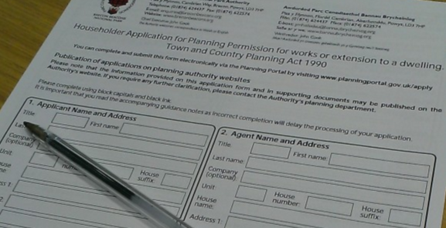
Please ensure that the following points are undertaken and included with the submission of your householder application for planning permission in order to satisfy the relevant criteria set out in the Welsh Government validation document: Applying for Planning Permission and Other Related Consents:
- Complete the ‘Householder application for planning permission’ form, ensuring you have signed and dated the declaration on all required copies;
- Ensure the appropriate Certificate and Agricultural Holding Certificate has been completed, signed and dated correctly (If any part of the proposed development is on land outside of your ownership you should complete section B of the certificate and serve notice on the owners);
- Pay the fee of £190;
- Provide a site location plan drawn to the recognised scale of 1:1250 or 1:2500, illustrating the scale on the plan. The application site should be edged clearly in red (the application site for a householder development usually would be the boundary of the garden of the property, however would not include adjoining paddocks or fields).
- Provide existing and proposed elevations of the property drawn to a recognised scale of 1:50 or 1:100. You should include all elevations affected by the proposal.
- Provide existing and proposed floor plans of the property drawn to a recognised scale of 1:50 or 1:100. If the proposal is for a two storey extension, floor plans should be provided for the ground floor and first floor.
- If any alterations are proposed to the ground levels of the site, provide existing and proposed sections to a recognised scale of 1:50 or 1:100.
- If your proposal is going to interfere with the roof of your property, a preliminary ecological survey may be required, along with any subsequent surveys needed.
- If your property is within a flood zone, a flood risk assessment may be required.
- If the proposal is in close proximity or has an impact on any trees within the site, a tree survey may be required.

4. Further Information

4.1 List of Relevant Local Development Plan (2013) Policies
The list of policies below is not exhaustive. They include those most relevant policies to householder development within the National Park. All Local Development Plan Policies can be viewed on our website at the following link: http://www.beacons-npa.gov.uk/planning/draft-strategy-and-policy/brecon-beacons-national-park-local-development-plan/
SP1 National Park Policy
Development in the National Park will be required to comply with the purposes and statutory duty set out in legislation, and will be permitted where it:
a) conserves and enhances the Natural Beauty, wildlife and cultural heritage of the Park; and/or
b) provides for, or supports, the understanding and enjoyment of the special qualities of the National Park in a way that does not harm those qualities; and
c) fulfils the two purposes above and assists the economic and social well being of local communities.

Policy 1 Appropriate Development in the National Park
All proposals for development or change of use of land or buildings in the National Park must comply with the following criteria, where they are relevant to the proposal:
- the scale, form, design, layout, density, intensity of use and use of materials will be appropriate to the surroundings and will maintain or enhance the quality and character of the Park’s Natural Beauty, wildlife, cultural heritage and built environment;
- the proposed development is integrated into the landscape to the satisfaction of the NPA through planting and appropriate management of native species or through the construction of appropriate boundary features;
- the proposed development does not have an unacceptable impact on the economic, social, cultural and linguistic vitality and identity of any community, either in its own right or through cumulative impact.
- the proposed development promotes opportunities for the conservation and enhancement of bio/geodiversity through appropriate design and landscaping.
- the proposed development is within 400m of an area of accessible natural greenspace.

Policy 6 Biodiversity and Development
Development will only be permitted where;
- the developer proves to the satisfaction of the NPA that there is no unacceptable loss or fragmentation or other impact of a habitat or landscape feature and/or increased isolation on important species as listed under Section 42 of the NERC act (habitats and species of principal importance to Wales), OR
- A the developer identifies habitats and landscape features of importance for wildlife within the site and provides for the further creation, positive management, restoration, enhancement or compensation for these habitats and features to ensure that the site maintains its nature conservation importance; and
B full provision is made for the future management of the site's habitats and features of nature conservation value. This will be secured either through Planning Obligations or the imposition of Planning Conditions; and
C there is no unacceptable loss/breaching of linear features (e.g. hedgerows, woodland belts). Development should seek to enhance linear habitat features (e.g. hedgerow, woodland belts) ‘dark corridors’ and roosts used by bats
The NPA will require all development being judged against this policy to provide biodiversity enhancement through the scheme in accordance with the direction of the Planning Obligation Strategy.

Policy 7 Protected and Important Wild Species
Proposals on land or buildings that support protected or important species will only be permitted where:
- the need for the development outweighs the nature conservation importance of the site, and in the case of European protected species, the criteria for derogation under the Habitats Regulations are met; and
- positive measures are provided to contribute to species and habitat conservation targets; and
- the developer proves to the satisfaction of the NPA that
a) the disturbance of the species and habitat in terms of the effect on species survival and reproductive potential or habitat function will be kept to a minimum; or
b) alternative areas are provided to sustain at least the current levels of populations or size of habitat affected by the proposal.

Policy 8 Trees and Development
Proposals for development on sites containing trees will be required to provide a Tree Survey and a Tree Protection Plan in support of the proposal. Permission will be granted where the NPA is satisfied that:-
a) Trees and their root systems (including associated soil) are retained and adequately protected prior to, during and after development; and/or
b) Where the NPA agrees to the removal of trees as part of the development scheme, appropriate replacement must be provided on site utilising native trees of local provenance. A scheme for tree replacement, including details of planting and aftercare, shall be agreed with the NPA prior to the commencement of development.
The NPA will use Planning Conditions and/or Planning Obligations to secure any necessary mitigation / compensation / enhancement measures in relation to trees and development proposals.

Policy 12 Light Pollution
Proposals where lighting is required shall include a full lighting scheme and will be permitted:-
a) where the lighting proposed is appropriate to its purpose; and,
b) where there is not a significant adverse effect individually or cumulatively on
i) the character of the area;
ii) local residents;
iii) vehicle users;
iv) pedestrians;
v) biodiversity;
vi) the visibility of the night sky; and
vii) 'dark corridors' for bats and light sensitive species.

Policy 15 Listed Buildings

All listed building consent application will be determined in accordance with National Policy as set out in Circular 61/96.
Proposals for planning permission which impact on a listed building or its curtilage including the alteration, extension or change of use, whether internally or externally, will only be supported where it can be shown that there will be no significant harm to the special historic or architectural character and setting of the building or historic features.
- Conversion / Alteration / Extension / Change of Use of a listed building
The conversion, alteration, extension or change of use of a listed building will only be permitted where the following criteria are satisfied:
a) The proposal conserves the contribution made by the building to the character of the National Park.
b) The materials and finishes used in the building works are compatible in all respects with those of the existing structure.
c) The proposal conforms with all other relevant policies of this plan and national guidance
d) The development would not have a detrimental effect on the setting of a listed building or a building of local importance.

An independent structural survey will be required to prove the structural stability of the building or if it is considered that the proposed works would result in major or substantial reconstruction.
Planning Applications requiring works to listed buildings should include details of all alterations and other works to demonstrate the effect of the proposal on the appearance, character, historic fabric and setting of the building and include where relevant species surveys and any proposed mitigation details.

Policy 16 Demolition of Listed Buildings

The demolition, or partial demolition, of a listed building will only be permitted in the rarest of circumstances where the Authority is convinced that the building, or part thereof, cannot be retained, or is not worthy of retention and where convincing evidence has been provided that:-
- real efforts both to sustain existing uses for the building and to find viable new uses have failed;
- preservation in some form of charitable or community ownership is not possible or suitable; and
- redevelopment would produce substantial planning benefits for the community which would outweigh the loss of the listed building.

The National Park Authority must be wholly satisfied that the proposed re-use of the site will bring benefits to the character or amenity of the locality or the wider National Park that outweigh the loss of the building. In the case of deliberate neglect to Listed Buildings at risk the National Park Authority will take action to safeguard the building(s).

Where such a building is to be replaced, a contract of redevelopment will be required to be finalised and entered into between the developer and the NPA.

Policy 17 The Settings of Listed Buildings

Development proposals which would adversely affect the setting of a listed building will not be permitted.

Policy 18 Protection of Buildings of Local Importance

Development affecting buildings which make an important contribution to the character and interest of the local area as set out on the local list will be permitted where the distinctive appearance, architectural integrity or their settings would not be significantly adversely affected.

Policy 19 Development affecting Conservation Areas

New development and alterations to existing buildings within or affecting the setting of a Conservation Area will only be permitted where it will preserve or enhance the character or appearance of the area and where the design, all building materials, proportions and detailing are appropriate to the Conservation Area.

The demolition or substantial demolition of any unlisted building or structure within a Conservation Area that is subject to Conservation Area consent will only be permitted where there is the strongest justification. Where such a building is to be replaced, a contract of redevelopment will be required to be finalised and entered into prior to the granting of conservation area consent.

SP11 Sustainable Design

All proposals for development will be required to address the principles of sustainable design by demonstrating that they:

a) meet National and where defined local requirements for sustainable design or higher
b) are able to demonstrate consideration of the use and where appropriate the application of, renewable energy sources.

CYD LP1 Enabling Appropriate Development

Proposals for development within countryside locations will be required to contribute positively to their countryside setting and enhance the quality of the landscape without adverse impact on the wildlife, natural beauty, cultural heritage, environmental assets or biodiversity of the area.

All proposals for development within countryside locations must demonstrate how they respond to the identified issues set out at 4.9.2 and how the scheme will contribute to achieving the Countryside 15 year Future Vision.

Outside of defined settlements within the LDP the following forms of development will be: permitted subject to all other relevant LDP Policies:-

1. Proposals that capitalise on improving the existing building stock and/or utilises previously developed land and/or re-uses redundant buildings, including:-

a) Proposals for the extension of residential dwellings appropriate in scale and design to the countryside location where this would result in a net increase of no more than 30% of the original dwelling size (see Policy 27).
b) Proposals to re-instate redundant buildings to the following beneficial uses i) Commercial, Sport, Tourism or Recreation use OR ii) Affordable Housing to serve an identified need OR iii) The proposal will provide a Rural Enterprise Dwelling to serve an evidenced essential need

Only in cases where evidence can be provided to the NPA that the need for conversion to the above uses does not exist within the locality will the NPA consider proposals to reinstate redundant buildings for use as open market housing.

c) Proposals for the appropriate demolition and replacement of buildings, where this action:-

- would result in a net increase of no more than 30% of the original dwelling size
- would result in a replacement building with a lower environmental impact,
- would result in no loss of community services and/or commercial activity within the settlement; and
- the replacement building is intended to serve the identified housing need within the community.

2. Proposals that strengthen and enhance the provision of community facilities and services serving the area and its locality and resisting proposals which would result in the loss of community service / facility (see Policy 50).

3. Proposals to enable residential accommodation to serve an essential Rural Enterprise need.

4. Proposals to enable Rural Enterprise and farm diversification (see also Policy 38 and Policy 43).

5. Proposals for tourist attractions or recreational activity which by evidenced necessity require a countryside location as essential to their function (see Policy 48).

6. Low Impact development schemes, in keeping with One Planet Development set out in TAN 6 (see also Policy 46).

7. Proposals relating to the provision of local food production of a scale and character in keeping with the countryside location, including the provision of new farm buildings where agricultural need can be proven as essential.

8. Proposals relating to the provision of renewable energy of a scale, type and impact in keeping with the countryside location (see also SP9).

Policy 27 House Extensions and Ancillary Buildings

Extensions and ancillary buildings to dwellings will be permitted where:
a) the proposal is appropriate to the scale and design and setting of the original dwelling;
b) no loss of on-site parking space will result, and adequate on-site parking provision can be provided for the extended dwelling;
c) an area of private amenity space is retained that is reasonably proportionate to the proposed size of the dwelling; and
d) there is no significant loss of privacy to an adjoining property.

In the Countryside, new buildings ancillary to domestic use of a dwelling shall be grouped with the dwelling.

4.2 Useful Contact Information and Web Addresses
Brecon Beacons National Park Authority Planning Department contact details:
Address: Brecon Beacons National Park Authority, Plas Y Ffynnon, Cambrian Way, Brecon, Powys, LD3 7HP
Telephone: 01874 620431
Email Address: planning.enquiries@beacons-npa.gov.uk
Website: www.beacons-npa.gov.uk

Other useful contacts and websites:
- Powys County Council 01874 612009 www.powys.gov.uk
- Carmarthenshire County Council 01267 234567 www.carmarthenshire.gov.uk
- Monmouthshire County Council 01633 644644 www.monmouthshire.gov.uk
- Blaenau Gwent County Borough Council 01495 350555 www.blaenau-gwent.gov.uk
- Rhondda Cynon Taff County Borough Council 01443 442100 www.rhondda-cynon-taff.gov.uk
- Torfaen Borough Council 01495 762200 www.torfaen.gov.uk
- Merthyr Tydfil Borough Council 01685 725000 www.merthyr.gov.uk
- Planning Portal www.planningportal.gov.uk
- Welsh Government – Planning Division http://wales.gov.uk/topics/planning/?lang=en
- Planning Inspectorate 02920 823889 www.planning-inspectorate.gov.uk
- Land Registry 01792 355000 www.landregistry.gov.uk
- Natural Resources Wales 0300 065 3000 www.naturalresourceswales.gov.uk
- Cadw 01443336000 www.cadw.gov.wales

4.3 Glossary of Planning Terms

This section is designed to help you understand the words and terms used in this guide and the planning system generally.

Adopted/Adopted Development Plan - The development plan has been completed, it has been examined by the Welsh Government Inspector and has been agreed by the Authority, and can be used for development control purposes.

Appeal/Appellant - An applicant for planning permission can appeal against the decision of the Local Planning Authority. Appeals can also be lodged if a planning authority does not decide an application within a set time and against the imposition of a condition attached to a consent. The person who makes an appeal is the appellant. Appeals are decided by the Planning Inspectorate.

Applicant - The person who signs and submits the planning application forms. An agent can submit applications on behalf of the applicant.

Building Regulations - Building regulations set standards for the design and construction of buildings. They are designed to keep people in and around buildings safe and healthy. They also deal with energy saving measures and provide disabled access into and around buildings.

Certificate of Lawfulness of a Proposed or Existing Use or Development – People can apply to find out whether a proposed development does not require Planning permission or an existing development is lawful in planning terms. If it is, the Certificate is issued by the local planning authority, meaning that the proposed development will not require separate planning permission and cannot be the subject of enforcement action.

Committee Report/Report to Committee - Before an application goes to planning committee, the officer dealing with the application compiles a report to explain the issues and the reasons for the recommendation. It usually includes a summary of consultee and third party (public) responses to the application, provides an analysis of the issues and relevant policies, and makes a recommendation to approve or refuse. Conditions, or reasons for refusal, are also added to the recommendation.

Community and Town Councils - The local administrative body in a ward, town or community area. Usually consulted about planning issues. Known as parishes in England.

Conditions - Attached to a planning permission, conditions control how different parts of a development should be carried out. Conditions can be used to control many things - building materials, landscaping and access are just a few examples.They can be:
Statement conditions e.g. - The development shall be carried out in all respects strictly in accordance with the approved plans (drawing nos. NP1v1, NP2v1, NP5v1 and NP6v1), unless otherwise agreed in writing by the Local Planning Authority or;
Pre-commencement conditions e.g. - Prior to the commencement of development details of all new joinery at a scale of 1:20 shall be submitted to and approved in writing by the Local Planning Authority. The development shall be carried out in accordance with the approved details or;
Pre-occupation or beneficial use conditions e.g. - Prior to the use or occupation of the dwelling hereby permitted, and at all times thereafter, the window*s+ marked “X” on the approved plans shall be glazed with obscure glass only. Reason: In order to protect the residential amenity of adjacent properties or;
Ongoing/restrictive conditions e.g. – The occupation of the dwelling shall be limited to a person solely or mainly working or last working, in the locality in agriculture or in forestry, or a widow or widower of such a person, and to any resident dependants.

Conservation Areas - Conservation areas are parts of villages or towns which are special because of their architecture or history. LPA’s designate conservation areas to preserve or enhance their special qualities. A higher standard of design is expected in the area, and any demolition of buildings or felling of trees is controlled.

Consult/Consultation - Asking people or organisations what they think about something. Comments are usually asked for on a particular matter (such as a planning application), or a set of issues, or a draft document (such as public participation in preparing a plan). Consultation can be formal or informal. It can involve everybody in an area, or a small selection of people or groups.

Contamination/Contaminated land - Land that has been polluted or harmed in some way, making it unfit for safe development. Development can only happen after it has been decontaminated.

County Councillors - A locally elected politician. Often known as a Member of the authority. The National Park Authority is composed of 24 members, 16 councillors appointed by the local authorities who have land in the National Park i.e. Powys (8 members), Monmouthshire (2 members), Carmarthenshire (2 members), Merthyr Tydfil (1 member), Torfaen (1 member), Blaenau Gwent (1 member) and Rhondda Cynon Taff (1 member). In addition, the Welsh Government appoints 8 members who may have experience or specialist knowledge of a particular area, such as environment, tourism, farming or community work. Terms of office for local authority members are usually for 4 years, until the next local government elections, and 4 years for Welsh Government appointed members (up to a maximum of three terms).

Curtilage - Land surrounding, and ancillary to, a building which is necessary for its function and enjoyment, for example, the domestic garden of a dwelling or the storage yard of a factory. The curtilage of a house is usually shown in the title deeds and is referred to as the Residential Curtilage of the dwelling.

Decision Notice - The formal letter that gives the decision on a planning application.

Delegated Powers - A power given to certain planning officers (usually the Director of Planning, the Head of Development Control or Principal Planning Officers) to determine applications without having to refer them to the planning committee in line with a clear Scheme of Delegation.

Departure/Departures - A proposed development which is not in line with the policies contained in an adopted development plan. In these cases the application is advertised as such on site and in the local press.

Design and Access Statement - A short report accompanying and supporting a planning application to illustrate the process that has led to the development proposal, and to explain and justify the proposal in a structured way.

Development – The legal definition of development is "the carrying out of building, mining, engineering or other operations in, on, under or over land, and the making of any material change in the use of buildings or other land" (Sec 55 of 1990 Act); this covers virtually all construction activities and changes of use.

Development Control - The process by which a local planning authority receives, considers the merits of, and determines planning applications. Development control decisions are based on the development plan and other material considerations.

Development Plan - The document which uses words and proposals maps to set out the local planning authority’s policies and proposals for future development in its planning area. Usually looking fifteen years forward, it contains policies for specific sites and for different types of development. Development plans include Local Development Plans, Unitary Development Plans, Structure Plans and Local Plans. Most planning authorities in Wales have now adopted their Local Development Plan.

Development Plan Polices - Policies are usually contained in the development plan. They set out how different types of development and land uses should be controlled. Policies can be for a small area, for a type of development, or apply over the whole plan area.

Drainage - The way water (foul and surface) moves around and off a site. Foul water can either be directed to the mains system or a private treatment works (e.g. septic tank). Surface water is usually directed into streams, rivers or lakes following the attenuation of flow using Sustainable Drainage Systems, soakaways, attenuation tanks, balancing ponds etc.

Enforcement/Enforcement Notice - A local planning authority uses its enforcement powers to make sure all the terms and conditions of a planning decision are carried out. Enforcement is also used to control development which has not got a planning permission, but which needs it. An enforcement notice sets out what needs to be done to put something right, or to control an activity which has not got planning permission.

Freedom of Information Act - Gives any person the legal right to ask for, and be given, most of the information which is held by public authorities.

Full Application - A planning application with all the details of a development proposal. Sometimes referred to as a detailed application, it can be given a full planning permission. There are no matters which are reserved for discussion and approval at a later date (see ‘Outline Permission’).

Habitable Room - Any room used for sleeping, cooking, living or eating purposes. Enclosed spaces such as bath or toilet facilities, service rooms, corridors, laundries, hallways, utility rooms or similar spaces are excluded from this definition.

Hearing - A planning appeal hearing which is carried out in a structured way, but which is not as formal as a local inquiry.

Highway Authority - The department which is responsible for maintaining public roads and access onto them, pavements and verges.

Human Rights Act - The Human Rights Act protects people’s human rights. Human rights are the basic freedoms and values which all people have a right to. It also limits some individual rights, to protect protected characteristics and the rights of others and the wider community.

Judicial Review - Where the High Court looks at whether a decision made by a planning authority is reasonable. Some planning decisions are tested by a Judicial Review.

Landscaping/Landscaping Proposals - Includes plants, trees, paths and structures. A landscaping proposal should be prepared for areas of land which will not be built on. Often forming part of a planning application, it might include garden layouts, walls and fencing, trees and planting areas, and ‘hard’ road and pavement surfaces.

Late Representations - A letter of objection or support which is received after a set legal period for consultation. The comments can sometimes still be considered.

Listed Building Consent - Required to alter or extend a listed building, where the work would affect the building’s character or special interest. Consent is also needed for any work to other buildings in the grounds of a listed building – these buildings are referred to as curtilage buildings.

Listed Building - A building which is protected from development because of its special historic interest or architecture. LPA’s hold a list of the listed buildings in its area, which the public can access.

Local Development Plan - A type of plan which has replaced the Unitary Development Plan system. All LPA’s in Wales have prepared, examined or adopted their LDPs. It will be the statutory development plan for a local planning authority area. It should include a vision and a broad strategy, as well as policies for different areas and types of development. It will identify land suitable for new development, and set out proposals for key areas of change and protection. Policies and development land will be shown on a map base, called the Proposals Map.

Local Planning Authority - The local authority or council that is responsible for preparing plans and for making planning decisions for that area. In Wales, there are currently twenty five planning authorities, including the three National Parks. The planning authorities also deal with waste and minerals matters.

Local Plan - An old-style development plan which sets out detailed policies and proposals for the development and use of land. In some authorities, local plans are still used to guide decisions on planning applications.

Material/Material Considerations - If something is material, it is relevant and needs to be taken into account before a decision is made. Whether or not something is material often depends on the individual case.

National Park Management Plan (NPMP) - The single most important policy document for the National Park. It is a plan for the geographic area of the Park and not for any one authority and, as a strategic overarching document, it co-ordinates and integrates other plans, strategies and actions in the National Park, including the Local Development Plan.

National Resources Wales (NRW) - undertakes the functions of the now disbanded Countryside Council for Wales, Environment Agency Wales and Forestry Commission Wales. They are the statutory body for the protection of the Environment in Wales.

Outline Planning Application - Planning applications can be submitted in Outline to find out if the principle of a development on a site is acceptable. If a proposal obtains Outline consent, details of the development will need to be approved at a later date. Usually only used for larger applications.

Permitted Development/Permitted Development Rights - There are certain types of development which do not need planning permission. These include small works, and things which will not have much of an effect on other people. The General Permitted Development Order sets out those things which can be done without needing to apply for planning permission.

Planning Inspector - An experienced planner appointed by the Planning Inspectorate. The Inspector makes independent planning decisions on behalf of the Welsh Government. Inspectors consider appeal cases, and test the ‘soundness’ of development plans at examination. They also make decisions at public inquiries into larger proposals. Inspectors write reports considering all the planning evidence, and decide cases.

Planning Inspectorate - An independent agency which acts for the Welsh Government. It is responsible for processing planning and enforcement appeals, and holds inquiries into local development plans. It also deals with listed building and advertisement appeals, as well as reporting on applications which are ‘called in’ by the WG.

Planning Permission - Formal approval from a local planning authority that a proposed development can go ahead. It is often granted with conditions. Usually, the development needs to be started within a given time of permission being granted. Planning Permission can be full or in outline.

Planning Policy Wales - Sets out the national policy framework for land use planning in Wales, and includes many different areas of planning. Prepared and updated by the Welsh Government to give LPA’s and others a clear understanding of how the system should work.

Pre-application Discussions - Discussions which happen before a planning application is submitted. Usually between LPA Officers and the person thinking of developing a proposal. They can improve the quality of an application and are usually seen as good practice.

Public Consultation - Informing members of the public about a planning application, or about future plans for an area. Usually involves asking people to make comments within a set time. Comments received are taken into account before a decision is made.

Public Inquiry - A formal hearing held by a planning inspector into a planning matter. It might be into a local development plan, or an appeal. Members of the public can attend public inquiries as observers, and can also be invited to comment on an issue.

Recommendation - A planning officer makes a recommendation to the planning committee. It is usually set out towards the end of the committee report on the planning application. The recommendation is the professional opinion of the planning officer, but the committee do not have to accept the recommended decision provided that they have robust reasons to go against it. Recommendations are usually to refuse, to approve, or to defer.

Representations - Comments which are submitted to a local planning authority. They can either be in support of something, or they can object to something. Representations are usually made in connection with a planning application, or a proposed policy in a development plan for the area.

Reserved Matters - Things to do with a proposed development which will need to be decided at a later date. The reserved maters are Appearance, Scale, Access, Landscaping and Layout. These are reserved matters because they still need to be approved.

Section 106 Agreement - A legal agreement under section 106 of the 1990 Town & Country Planning Act. Section 106 agreements are legal agreements between a planning authority and a developer that ensure certain additional works related to a development are undertaken, e.g. a new play area, commuted sums towards Affordable Housing etc. Can also be used to control development where a condition cannot be used (e.g. ensuring Shared Ownership housing remains as such even when sold on to subsequent purchasers).

Stop Notice - A legal notice served by the local planning authority which aims to make somebody stop a development or an activity. Used as part of enforcement powers.

Sui generis - A latin word which describes a land use, or building which is not in a specific Use Class. Examples of uses which are considered to be sui generis include theatres, launderettes, car showrooms and petrol filling stations.

Supplementary Planning Guidance - Detailed guidance prepared by the LPA to support policies and proposals.

Sustainable Development - ‘Development that meets the needs of the present without compromising the ability of future generations to meet their own needs’. The planning system is important for sustainable development - it can bring about more sustainable ways of living and working. It can also encourage new types of development which use less energy.

Technical Advice Notes - Technical Advice Notes are prepared and updated by the Welsh Government, and provide more detail about national planning policies. They deal with a specific area of planning, such as affordable housing, flood risk, or protecting wildlife.

Third Party - A party with an interest in the application but not the applicant. Usually somebody supporting or objecting to a planning application.

Tree Preservation Order (TPO) - A mechanism for securing the preservation of single or groups of trees of acknowledged amenity value. A tree subject to a tree preservation order may not normally be topped, lopped or felled without the consent of the local planning authority.

Unitary Development Plan - Often called a ‘UDP’, a plan covering the whole local planning authority area. It replaces old style structure and local plans. Contains policies for the whole plan area, and identifies land for different kinds of development. Local Development Plans are replacing Unitary Development Plans in Wales.

Use Class - Planning law puts the different ways of using land and buildings into different Use Classes. To change the use of a piece of land, or a building from one use to another use within the same Use Class does not require planning permission. However, a change of use from one Use Class to another will usually need planning permission.

Visual Amenity - The contribution made by the look of a place to how the public enjoy it. An area with high visual amenity is pleasing and attractive to the eye.

Written Representations - A written statement setting out comments, or an argument for or against something. The simplest way of processing an appeal to the Planning Inspectorate as it does not require a Hearing or an Inquiry.

