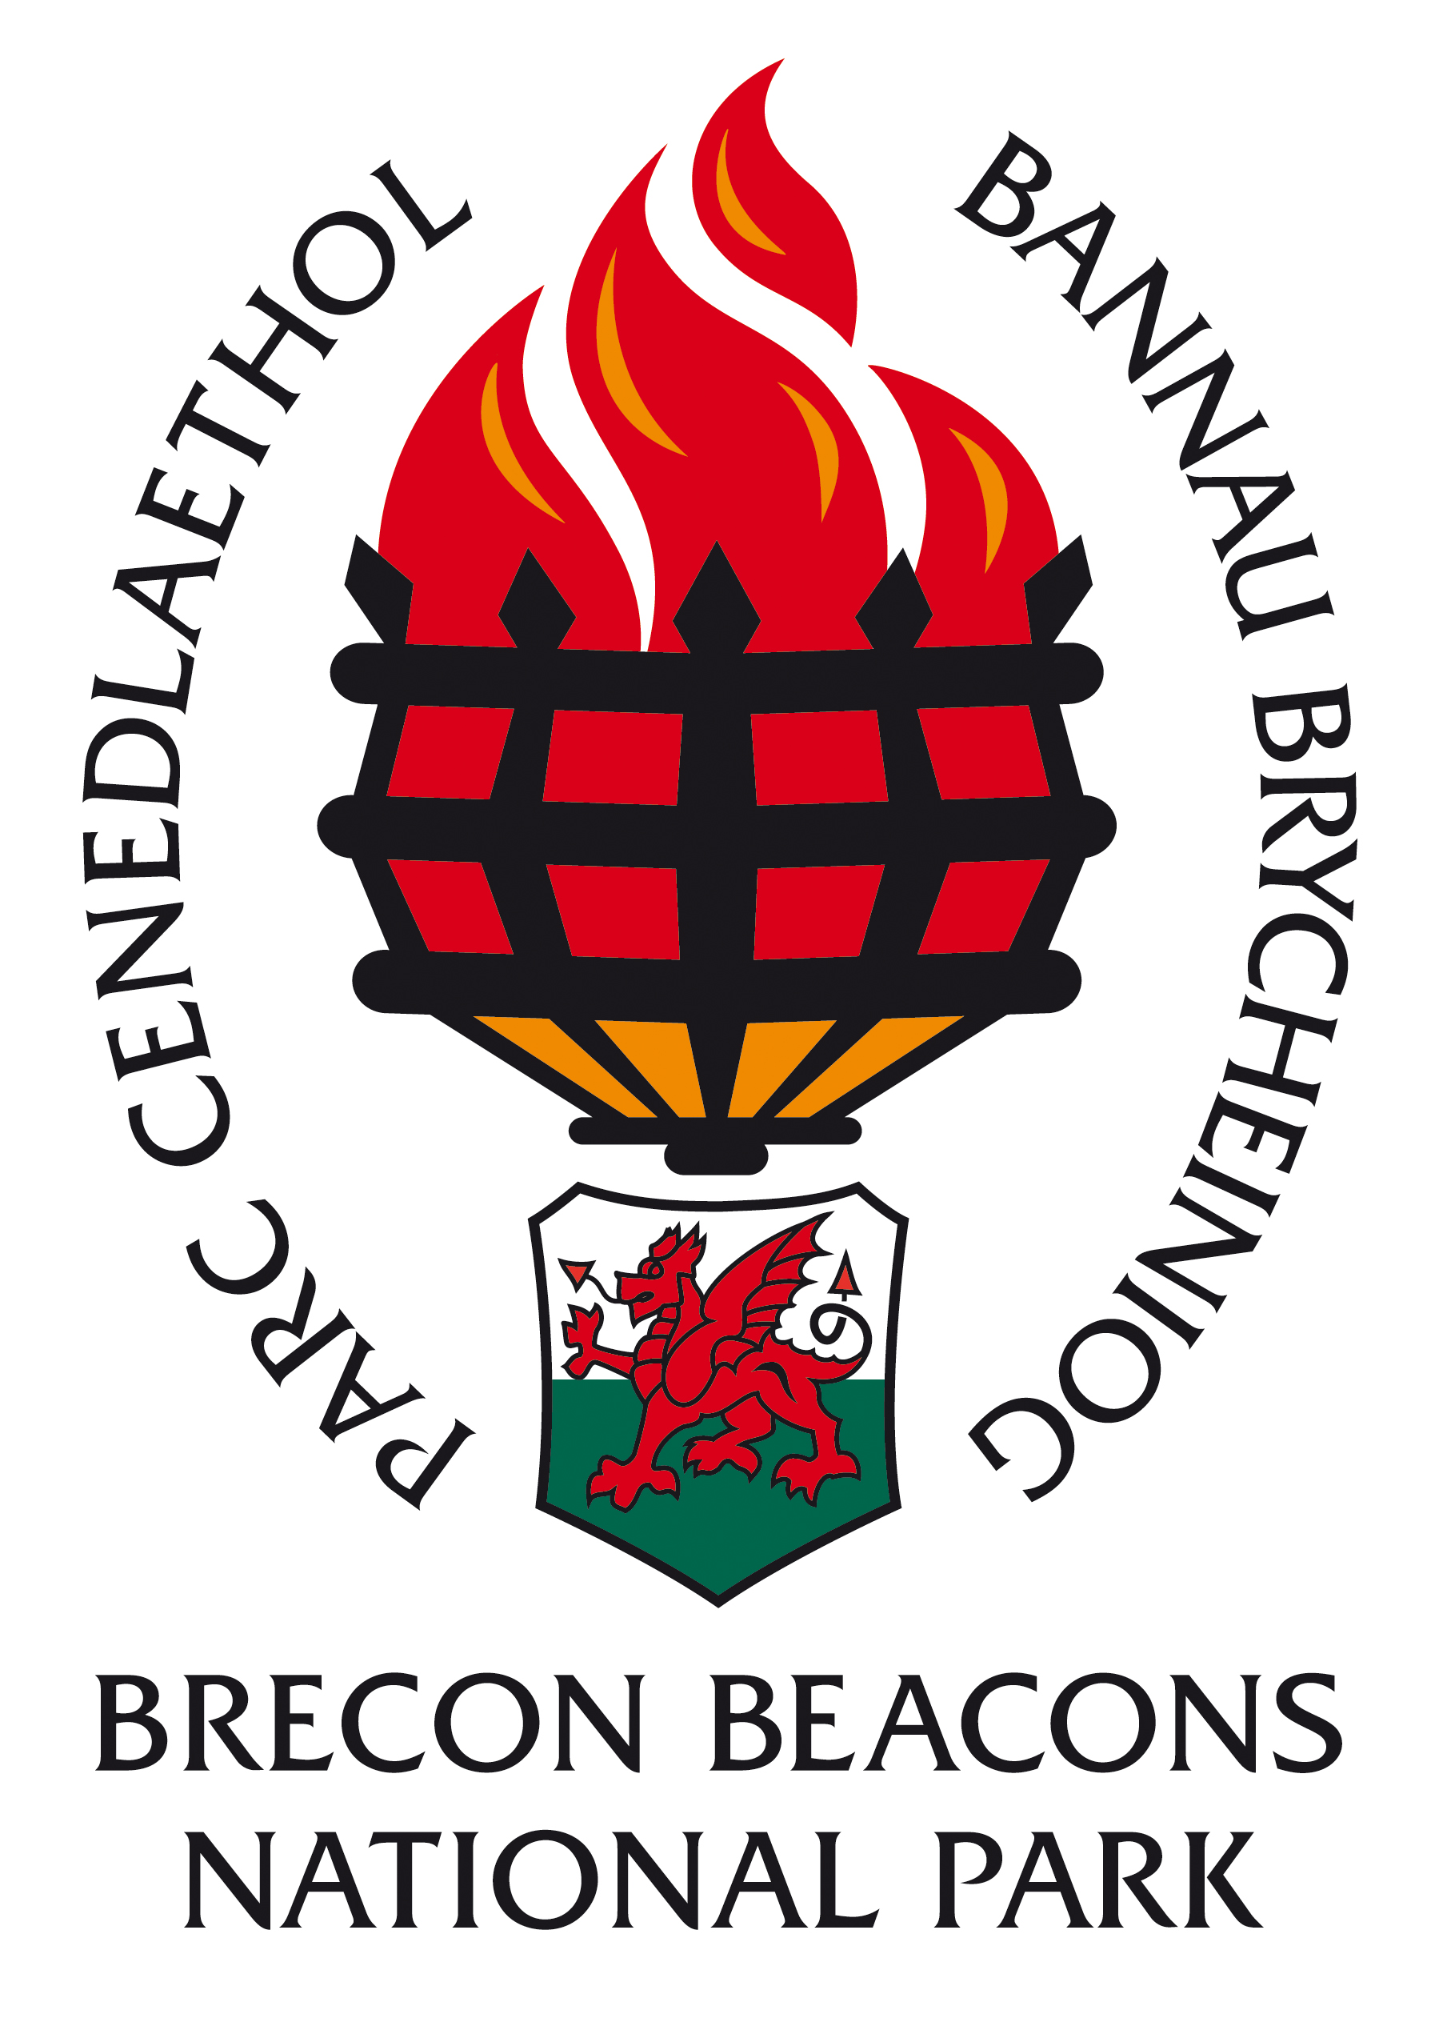

INFORMATION FOR CANDIDATES

Project Administrator

Grade 6: £19,446 – 20,541 per annum, pro rata

Fixed Term Contract – 31st July 2020
30 hours per week

CONTENTS

- Return details
- Brecon Beacons National Park Overview
- The Staff
- Organisational Chart
- Job Description
- Person Specification
- Guidance notes for appointees

CLOSING DATE: 7th June 2018
INTERVIEW DATE: 19th June 2018

COMPLETED APPLICATION FORMS SHOULD BE RETURNED TO:

(CONFIDENTIAL)

HUMAN RESOURCES DEPARTMENT
BRECON BEACONS NATIONAL PARK AUTHORITY
PLAS Y FFYNNON
CAMBRIAN WAY
BRECON

LD3 7HP

Thank you for your interest in the post of Project Administrator in the Countryside & Land Management Directorate

Applications must be received by 11.00am on the morning of 7th June 2018. Unfortunately late applications will not be considered.

Would candidates please note that it is not the practice of the National Park Authority to acknowledge applications, nor to inform candidates of the outcome of their applications. Please assume that if you receive no further communication, your application has been unsuccessful.

If you have a disability please indicate this to us in a covering letter. Should you meet the essential criteria and be called to interview, please let us know of any special requirements needed.

Please note that all application forms and supporting information will be securely retained for six months and we may contact you should a suitable vacancy arise. After six months all application forms and supporting information will be destroyed. Should you object to your information being retained, please could you let us know and we will destroy your application form after the outcome of the recruitment process.

Where candidates are invited to interview, it is the Policy of the Authority to contact referees at that stage. Please could you identify any problems this may cause on your application form under the relevant section.
Please note that when completing your application form you must be able to demonstrate how you meet the essential criteria set out in the person specification relevant to this post. You should also demonstrate how you meet the desirable criteria set out in the person specification, but do not be deterred from applying if you do not meet all of the desirable criteria.

BRECON BEACONS NATIONAL PARK AUTHORITY

Background

National Parks were designated in order to protect beautiful areas for the benefit of the nation. They came about as a result of the 1949 National Parks and Access to the Countryside Act, which put a legislative framework in place for the establishment of National Parks in England and Wales.

The first two National Parks were designated in 1951 and in 1957 the Brecon Beacons National Park was designated covering an area of some 520 square miles (1346 sq. kilometres). Until 1995 the Brecon Beacons National Park Authority was a joint committee of the then local County Councils until the Environment Act of that year laid down legislation to establish National Park Authorities as independent, special purpose Local Authorities.

What do National Parks do?

National Parks have two purposes: Firstly to conserve and enhance the natural and cultural environment of the park, and secondly to promote awareness and understanding and enjoyment of its special qualities. These special qualities have been described as:

- the landscape and natural beauty
- the peace and tranquility
- opportunities for walking and access to open countryside
- open spaces and qualities of remoteness
- traditionally managed farm land and
- wildlife

In so doing the National Parks also have a duty to foster the social and economic well being of the communities within the Park.

In delivering on their purposes and duty there are five key functions of National Park Authorities. These are to:

- act as Local Planning Authority
- act as relevant Authority for access to open countryside under the CROW Act
- facilitate environmental programmes
- provide public information, interpretation and education services
- deliver the sustainable development fund on behalf of the Welsh Assembly Government.

The Brecon Beacons National Park Authority

The National Park Authority consists of 24 members, 16 nominated by the seven Local Authorities in the area and the other eight nominated by the Minister for Environment, Sustainability & Housing of the Welsh Assembly Government. The Authority’s total budget is £6.1 million of which £4.6 million is funded by the National Park Grant and Levy and £1.5 million from Income activities.

This split helps to ensure that the local and national interests are represented at National Park Authority level. There is a range of key committees responsible for managing the business of the Authority. In addition, working and advisory groups, both internal and external, have been established to help in the decision-making process. Some 110 full-time staff equivalents are employed in two Directorates – Countryside and Land Management & Planning, as well as the Chief Executive’s Department – PR & Communications, Finance, IT, Legal, Democratic Services and HR. Staff and Members cover a wide range of activities and services and it is the key role of officers to provide advice and guidance to Members of the Authority to help them make decisions and set the vision and strategies for the Authority.

The Authority’s key strategic document is the National Park Management Plan, which sets our aims, strategic objectives and Priorities for Action for the Authority (see http://www.breconbeacons.org/the-authority/planning/strategy-and-policy/npmp). In addition to this, we have an approved Unitary Development Plan (see http://www.breconbeacons.org/the-authority/planning/strategy-and-policy/udp) which provides the framework for future development within the National Park and are developing the Local Development Plan (see http://www.breconbeacons.org/the-authority/planning/strategy-and-policy/deposit-local-development-plan/useful-deposit-information). The Authority is also developing its State of the Park Report, which will summarise the changing status of environmental, social and cultural assets in the Park. With delegated responsibility for Rights of Way maintenance and management we are implementing the Authority’s Rights of Way Improvement Plan.

National Parks in England and Wales are Category V protected landscapes as defined by the World Conservation Union (IUCN). This recognises the involvement of people in shaping the landscapes. Like all National Parks in England and Wales, agriculture is very influential in how the landscape is managed. A viable, profitable, broadminded and innovative farming sector, working in close collaboration with the Park’s communities, local businesses and public and voluntary bodies is fundamental to the landscape’s future management. Flexibility and adaptability will be important qualities to address the challenges of climate change, energy descent pathways and demographic and social changes ahead.

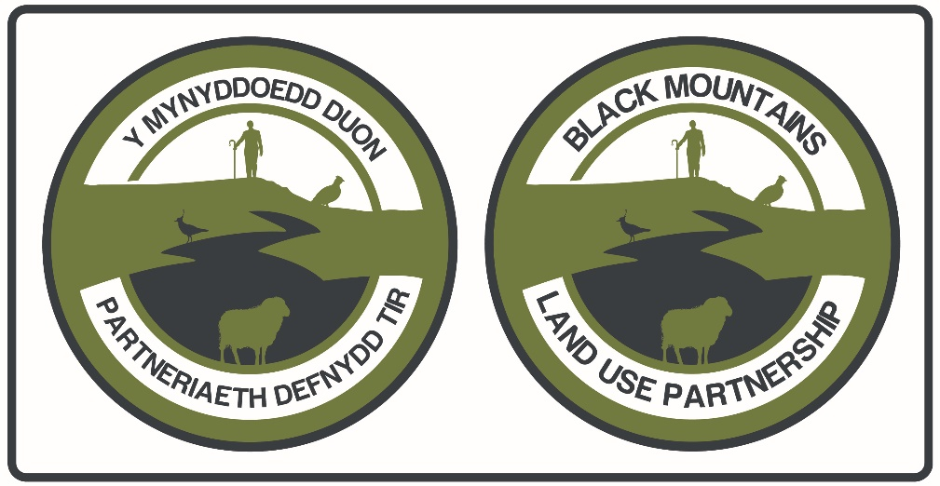

A summary of the Black Mountains Land Use partnership

The Black Mountains Land Use Partnership (the Partnership) is a collaborative venture among local landowners, graziers and relevant regulatory bodies. Established in 2015 through the Welsh Government’s Nature Fund, the Partnership promotes the restoration and sustainable management of the natural resources of the Black Mountains, an area covering over 24,600 hectares of upland and lowland habitat.

The objectives of the Partnership are to:
- To improve the quality of habitats including heather regeneration.
- To increase the area and quality of grazing land.
- To control erosion on strategic sites.
- To stabilise peat resources.
- To provide a source of materials to be used for restoration works in eroded peat/mineral soil areas to improve bog condition.
- To improve access at strategic locations particularly around turnout points to increase ease of turning out stock on the hill and improve the visitor experience.
- To promote understanding of traditional and contemporary grazing, conservation works and other upland management practices used on the hill.

The purpose of the Black Mountains Land Use Partnership (BMLUP) is to promote and effect the restoration and sustainable management of the Black Mountains. This could be seen, and indeed is, a potentially ground-breaking initiative that will have valuable influence elsewhere. It is too important to be seen as simply a project, and needs to be recognised as ‘real life’, affecting lives, businesses and environments long term. The potential is to support the development of a region, a community and an environment that is thriving, successful and balanced, recognising multiple interests and putting those who are in the fortunate position to be responsible for management, in the driving seat.

The Black Mountains consist of uplands and lowlands lying at the north-eastern border between the Brecon Beacons National Park in Wales and Herefordshire in England. The area is dominated by a group of old red sandstone hills of some 15,000 hectares (ha). With a number of hills rising up to just over 800 metres above sea level, the Black Mountains are also blessed with valleys and rivers, hedgerows and woodland, enlarging the area of management interest to over 24,600 ha. The area has a diverse landscape with rich cultural elements including many active family farms, a strong local food culture and vibrant market towns. The area is rich and diverse ecologically, and important environmentally. Within this landscape, the Black Mountains Site of Special Scientific Interest (SSSI) extends for some 6,783 ha in Wales. The Black Mountains and surrounding areas also benefit from an active art scene and tourism that relies heavily on the landscape features, farming and other business activities, and associated ecology. Its wide appeal and success comes from its landscape, geology and natural capital, and the effect of human activities based around pastoral farming and herding, and reliance on natural resources such as stone, wood and water, and rural living, that have influenced the biodiversity that has resulted over millennia. Over 10,500 ha are still part of an active Welsh common land agricultural system. Emerging waters from associated upland habitats, particularly blanket bogs, supply a vital resource to several regionally important rivers and streams supporting salmonid fisheries and numerous, other species and habitats. These systems become a part of the Rivers Usk and Wye which are designated Special Areas of Conservation (SACs) because of their important riparian features. Thus, what affects the uplands also impacts the lowlands, as well as the biodiversity in between.
The boundary of the Black Mountains Land Use Partnership is a pragmatic one, relying on the geology and geographic contours for guidance and political and cultural boundaries where necessary. The boundary follows the arc described by the A470 from Crickhowell to Cwmdu then along the A479 through Pengenfordd to Talgarth. Headed northeast the boundary follows the National Park boundary to Hay-on-Wye and continues along the National Park boundary to the southeast just west of the road crossing the Park boundary near the headwaters of Dulas Brook, linking Hay to Craswall. From Craswall the boundary continues south just to the west of the road running parallel to the River Monnow, through Longtown and down to Llanvihangel Crucorney. From here it travels westward north of a series of roads connecting Llanvihangel Crucorney to Forest Coalpit and then back toward Crickhowell, taking in Llanbedr, though not including Crickhowell itself. The southern boundary lies north of the Sugarloaf and does not include it.
Along with Waun Fach (811m), the Black Mountains range has many peaks that are well known to walkers, including Black Mountain (703m), Hay Bluff (677m), Pen y Gadair Fawr (800), Twmpa (680m), Pen Allt-mawr (719m) and Bal Mawr (607m). There are a number of circular walks as well as the Offa’s Dyke National Trail which runs along the border between Wales and England.
The Black Mountains provide a wide range of benefits to the environment and people locally and further afield. However, the conditions of the area are under threat in many aspects. This ultimately affects the quality and availability of services we can obtain from the Black Mountains.
Changes in climate and land use in and around the area are considered to have impacts on the state of the site. There is a need for integrated land management, which takes into account the competing needs of different aspects of the Black Mountains.
The partnership will work to identify the challenges and where possible will seek to develop and implement suitable solutions to address the challenges.

Summary of BMLUP SMS bid and the role of the Project Administrator

This Sustainable Management Scheme projectis a collaborative project between local landowners, graziers and regulatory bodies aims to bring about positive social, economic and environmental change through implementation of cooperative and sustainable land management across the Black Mountains
landscape.

The focus is on improved peatland and bracken management in tandem with improving the visitor experience in the area, developing skills and new employment opportunities. At its core, the project’s principle aim is to provide multiple benefits to the local communities but also wider across Wales.

Funding procured from the Sustainable Management Scheme is being used to develop and implement strategies for:

- Bracken management;
  - Ground-truthing and modeling data from the bracken control plan,
  - Implementing bracken control in a selection of priority sites,
- Peatland management;
  - Implementing restoration measures in and around Waun Fach,
  - Conducting revegetation trials on the Southern Scar,
  - Managing priority heathland habitat, using by-products for restoration,
  - Investigating a payment for ecosystems services (PES) scheme,
- And visitor management;
  - Telling the Black Mountains hill management story,
  - Creating a Black Mountains ambassadors scheme,
  - Developing a rural skills programme,
  - And employing Partnership rangers.

The role of Project Administrator

- Why the project is necessary: In order for a programme of this magnitude and complexity to be delivered effectively and efficiently, there needs to be a person who is responsible for regular tracking of individual projects and trouble-shooting. This person ensures all outputs are delivered on time and to specification and develops solutions where necessary, including final reports and financial reporting. While this work will be completed cooperatively with other members of the project team, the Project Administrator is the key point of contact on which others can rely.
- What you propose to do: The Partnership will hire, by way of the BBNPA procurement process, one part-time (0.8 FTE) Project Administrator who will be responsible for financial reporting and regular tracking of individual projects. This work will be done in concert with the programme monitoring and evaluation team, all of whom will communicate regularly with the Team Leaders. The Project Administrator will report back to the Project Executive who will report to the Project Board. Progress and troubleshooting will be discussed and resolved within these meetings. An external and internal project assurance structure has been developed to provide feedback up and down the management structure as required. Any feedback can then be incorporated into the programme at any point during the implementation phase.
- How you propose to do it: The Project Administrator will be hired using the BBNPA recruitment process. Costs include an allocation for communications and office supplies.
- Where you propose to do it: The Project Administrator will be housed at Glanusk Estate and at BBNPA offices to accommodate regular discussions with the BBNPA Finance Team who will offer assistance throughout the project. The post’s remit covers the Black Mountains Partnership area.

Black Mountains Land Use Partnership

Terms of Reference

Purpose

The purpose of the Black Mountains Land Use Partnership (the Partnership) is to promote the restoration and sustainable management of the Black Mountains.

Status

The Partnership is not a legal entity. As such, the Partnership cannot hold or expend funds itself. Projects and activities recommended or supported by the Partnership will be led by other organisations best placed to do so.

Objectives

- To improve the quality of habitats including heather regeneration.

- To increase the area and quality of grazing land.

- To control erosion on strategic sites.

- To stabilise peat resources.

- To provide a source of materials to be used for restoration works in eroded peat/mineral soil areas to improve bog condition.

- To improve access at strategic locations particularly around turnout points to increase ease of turning out stock on the hill and improve visitor experience.

- To promote understanding of traditional and contemporary grazing, conservation works and other upland management practices used on the hill.

Role

The role of the Partnership is:

- To raise awareness of and champion the sustainable management of the Black Mountains.

- To foster good communication between interest for the sake of coordinating activity in pursuit of the Partnership’s purpose.

- To work together on and, if appropriate, shape funding proposals for priorities identified by the Partnership.

- To seek funding for projects which further Partnership objectives.

- To lead the implementation of funded schemes in furtherance of Partnership objectives.

- To monitor the effectiveness of such schemes and evaluate their impact.

Membership

The Partnership shall consist of:

- Partnership Chair.
- Black Mountain Grazier Association
- Major private landowning interests, (landowner or representative agent).
- Young Farmer representative.
- Natural Resources Wales
- Natural England.
- Brecon Beacons National Park Authority.
- Dŵr Cymru Welsh Water.

The membership has been grouped into three categories – Graziers, Landowners and Other (including public agencies). The aim is to ensure that the Partnership is balanced between these categories. Appendix 1 details membership by category.

Those listed in Appendix 1 will nominate their representative to attend meetings. A substitute may attend. The name of any substitute shall be provided to the secretariat before the meeting.

Additional representatives from the organisations listed may be kept on a mailing list and /or attend meetings where this will be of value.

The Partnership may invite guests to attend meetings for a particular topic.

Any major funder may have non-voting observer status on the Partnership.

Member Responsibilities

- To promote the aims of the Partnership.

- To contribute knowledge, expertise and experience to the work of the Partnership.

- To support and play a full and active part in the work of the Partnership in fulfilling its roles and responsibilities as set out in the Terms of Reference.

- To assist the Partnership in achieving an independent and apolitical profile in the performance of its functions

- To attend Partnership meetings whenever possible and, if no longer able to attend meetings on a regular basis, to step down from the Partnership or to seek another representative from their organisation.

- To read and consider Partnership papers in advance of meetings.

- To recognise the validity of other members’ views and accept joint responsibility for the decisions of the Partnership once made.

- Operate in an open, accessible, responsive and accountable manner.

- To report back to their organisation if appropriate, on the outcome of Partnership meetings.

Meetings

Frequency

The Partnership will meet four times a year. Additional meetings can be called by the Chair in consultation with Partnership members.

Location

All Partnership meetings will be held in or near the Black Mountains area.

Other meetings, for example to liaise with funders or to explore a particular strand of work, may be held away from the Black Mountains area.

Decision Making

The Partnership will endeavour to operate by consensus, reflecting its main role of fostering good communication and co-ordination.

When a formal vote is required each member (or substitute) shall be entitled to one vote and decisions will be made on the basis of a simple majority of those present and entitle to vote.

The voting members are listed in Appendix 1.

The Chair will have the casting vote if there is a split decision.

Quorum

No decisions will be made by the Partnership unless at least two members of each membership category (as outlined in Appendix 1) are in attendance at a Partnership meeting.

Chair

The Chair shall serve for two years and for no more than three consecutive terms of office.

The responsibilities of the Chair are:

- To nurture participation from all key individuals and organisations involved in the Partnership.

- To foster a supportive and productive partnership approach to deliver activities identified by the Partnership in pursuit of its objectives.

- To build support for the aims and priorities of the Partnership.

- To chair meetings of the Partnership, having regard to agreed procedures.

- To represent the Partnership at appropriate events, meetings or functions.

- To act as a spokesperson for the Partnership where appropriate.

The Chair shall seek to fulfil their duties in a manner that is free from political bias and influence.

The Chair shall have no personal financial or other material interest in the Black Mountains.

The position of Chair shall be advertised and transparently recruited.

In the absence of the Chair for a specific meeting the Partnership may choose someone to take on that role for the duration of the meeting.

Task and Finish Groups

The Partnership has the right to establish task and finish groups in order to pursue strands of work. If such groups are established they shall:

- Be established at a Partnership meeting. This meeting shall determine the membership and the scope of the work of any task and finish groups.

- Report back to Partnership meetings during the time it is in existence.

- Not act on behalf of the Partnership unless it has been given the powers to do so by the Partnership.

Administrative Support (Secretariat)

Brecon Beacons National Park Authority will initially act as Secretariat for the Partnership.

The role of the Secretariat is:

- In consultation with the Chair of the Partnership, arrange and call meetings, record the proceedings of those meetings and support follow up actions arising from meetings.

- To act as a point of contact for the Partnership.

- To foster good communication between partners.

- To support the Partnership to identify opportunities for funding.

- To support the Chair in ensuring the proper functioning of the Partnership.

The role of the Secretariat shall be reviewed each year or as a result of the requirements of future funding programmes.

The Partnership shall work with appropriate lead bodies within schemes to further Partnership objectives as long as that body has the capacity and relevant regulatory infrastructure to perform the role of a lead body.

Termination

The Partnership shall be terminated if it is the desired wish of a majority of Partnership members or if one category of membership as outlined in Appendix 1 withdraws.

This arrangement may have to be reviewed in light of any future funding agreements.
Appendix 1 Voting Membership

The categories of membership are:

A. Graziers

Black Mountains Graziers Association shall have one named representatives from each of CL1, CL2, CL24, CL25, CL25, CL26, CL41, CL44, CL45 and Tack Wood

B. Landowners

Glan Usk Estate
Tregoyd Estate
Bal Mawr/ Bal Bach Estate
Duke of Beaufort Estate
Michaelchurch Estate
Ffwddog Estate

C. Other

Natural Resources Wales
Welsh Water
Natural England
Brecon Beacons National Park Authority
Young Farmers

Countryside & Land Management

Conservation

BRECON BEACONS NATIONAL PARK AUTHORITY
in collaboration with the
BLACK MOUNTAINS LAND USE PARTNERSHIP

Job Description

Post Designation: Project Administrator
Date effective to: 31st July 2020
Grade: Grade 6
Responsible to: Senior Ecologist and Project Board
Responsible for: Administration of Welsh Government Sustainable Management Scheme Grant Projects

Job Purpose:

To provide administrative support to the Black Mountains Land Use Partnership in the implementation of their Sustainable Management Scheme (SMS) Grant projects, particularly the preparation of Project grant claims and monitoring reports.

Hours of Work and Duration:

0.8 FTE until 31st July 2020.

Main Duties

- To provide administrative and financial information support to the Partnership in the implementation and monitoring of the Partnership’s SMS projects.
- To work with the BBNPA Financial Managers as well as other partners to gather the financial information in order to make claims.
- To assist the Partnership in fulfilling BBNPA procurement policy and other administrative requirements.
- To ensure that project timesheet data are provided by the Partnership’s project team members and to collate this for the grant claims.
- To work with project partners to ensure their data are provided in an accurate and timely form.
- To produce progress reports and financial evidence to make claims against the SMS Grant.
- To prepare grant claims according to the BBNPA Financial Managers’ requirements and timetable in a timely and accurate manner for approval by the Senior Ecologist and ultimately by the Project Board.
- To assist the Project Board in the monitoring of project finances and outcomes to ensure that it is delivering the expected results and that they comply with all financial and other regulations.
- To attend and take minutes of meetings, seminars and conferences as required.
- To assist the Black Mountains Land Use Partnership in undertaking their wider duties as shall be agreed with the Project Board.
- Any other duty, appropriate to the grade and nature of the post, as required by the Project Board.

BRECON BEACONS NATIONAL PARK AUTHORITY
in collaboration with the
BLACK MOUNTAINS LAND USE PARTNERSHIP

Project Administrator

Person Specification

Essential Criteria Method of Assessment

A good standard of education, preferably Application form & certificate to include English and Mathematics GCSE
or equivalent and secretarial studies diploma

Experience in processing financial Application form & interview information

Good written and verbal communication skills Application form & interview

Excellent IT skills - word processing/data Application form & test entry, especially use of spreadsheets

Well organised with ability to structure Application form & interview complex information

At least two years general office experience Application form & interview with good organisational skills and
experience in processing financial information.

Desirable Criteria Method of Assessment

Experience in grant management Application form & interview

Experience of arranging and minuting Application form & interview meetings and/or events

Experience of working as part of a team Application form & interview

Ability to communicate in Welsh or Application form & interview
willingness to learn

NOTES FOR GUIDANCE FOR PERSONS TAKING UP AN APPOINTMENT WITH THE BRECON BEACONS NATIONAL PARK AUTHORITY AS

Project Administrator

Salary

The salary range is from £19,446 - £20,541 per annum, pro rata

Period of employment

Fixed Term Contract – 31st July 2020

Working hours

30 hours per week.

Salary is paid monthly (last day of month) into bank/building society account.

Annual leave entitlement

21 days per annum, plus 8 public holidays and 2 extra statutory days. Leave entitlement rises annually to 25 days per annum after 5 years’ service.

If you transfer from the service of an outside Authority to the Brecon Beacons National Park Authority, you are able to bring with you your accrued leave entitlement (accrued due to length of service) up to a maximum of 25 days.

Pension

The pension scheme in place is a standard Local Government one; the employee contributes 5.5% (up to £14,100) which rises to 5.8% (£14,101) of their contractual hours worked and the employer currently contributes 23%.

Location

The position will be based in the National Park Headquarters in Brecon with additional office space available at Glanusk Estate.

