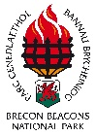
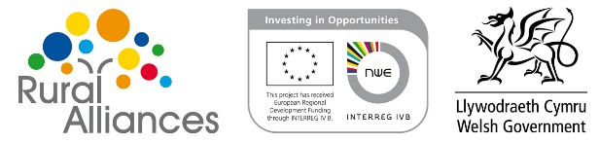
Brecon Beacons National Park Authority
Rural Vibrancy Survey Results
December 2014

Contents page No
1.0 Background
1.1 Introduction 3
1.2 Rational for the Study 3
1.3 Methodology 4
1.4 Issue 4

2.0 Vibrancy Measures
2.1 Overall Vibrancy 4
2.2 Average across the flowers 5-6
2.3 Joint action, active involvement and interaction 6-7
2.4 Local Business Activity 7
2.5 Local Economy 8
2.6 Common Objectives, Democracy and Communications 9
2.7 Integration and Inclusion between different groups 10
2.8 Activities and Facilities 11

3.0 Tourism Questions
3.1 Visitors help keep our shops and pubs open, bringing economic benefits
to the National Park 12
3.2 Tourism directly benefits me/ my family 12-13
3.3 Tourism indirectly benefits me/ my family 13
3.4 Tourism should be actively encouraged and promoted 13-14
3.5 Tourists are often irresponsible and don’t respect our community 14
3.6 We welcome visitors into our town 14-15
3.7 Conclusion 15
4.0 Town by Town findings
4.1 Crickhowell 15
4.2 Brecon 16
4.3 Hay on Wye 16-17
4.4 Talgarth 17
4.5 Overall findings and themes 18

5.0 Appendices
5.1 M-E-L Rural Vibrancy Proposal
5.2 Brecon Beacons National Park Authority Residents Survey – August 2013
5.3 Rural Vibrancy Survey Comparisons
5.4 Hay-on-Wye Final Report
5.5 Talgarth Final Report
5.6 Brecon Final Report
5.7 Crickhowell Final Report

‘This project has been funded by the EU’s Interreg IVB NWE programme together with the Welsh Government’s Targeted Match Funding programme’.
1.1 Introduction
The Rural Vibrancy survey provides rural communities with a tool to assess the individual perceptions of residents or community groups in rural areas. Collectively, when these perceptions are pulled together we can form an overall picture of how the community views itself. The survey looks at all key aspects of the community under the headings of Joint Action, Active Involvement and Interaction, Local Business Activity, Local Economy, Common Objectives, Democracy and Communication, Integration and Inclusion between different Groups and Activities and Facilities. In addition to this a small number of tourism related questions were added to the end of the interview, these were sourced from residents survey that was completed in August 2013 (See Appendix 1). These were added to cross-compare against the benchmark data already held by Brecon Beacons National Park Authority (BBNPA).
The Rural Vibrancy survey was created as part of the Rural Alliance Project, Rural Alliances is a €1million project for the Brecon Beacons. It is 50% funded by the ERDF Interreg IVB North West Europe Programme and in addition the Welsh Government’s Targeted Match Fund has contributed £320,000. Rural Alliances will focus on three key themes: Bringing entrepreneurs and communities together through the creation of new alliance structures to form self-supporting, inclusive, confident rural communities. Benchmarking and measuring rural vibrancy through a transnationally agreed process and forging new relationships between the public, private and community sectors to safeguard and enhance public services and rural resources. The project contributes to a more cohesive EU society as it derives from a cooperation of people from different countries working on common issues that touch the lives of EU-citizens
The project involves twelve different partners from Wales, Ireland, France, Germany, Netherlands and Belgium. The Rural Vibrancy survey was created in collaboration between University of Wales, Trinity Saint David (UK) and Philipps Universität Marburg (DE). The survey is being tested by all partners across the project in various formats.
1.2 Rational for the survey
The survey was commissioned to establish an indication of which dimensions of the toolkit are perceived strongest or weakest in the communities of Hay on Wye, Talgarth and Crickhowell (Brecon was later added to the survey as budget allowed). We can then analyse the results to look at trends across the four towns and they can be used to raise issues in relation to these perceptions, to stimulate discussion and then agree actions needed to address imbalances. Key stakeholders in the respective communities will be forwarded the results.
In addition to the telephone interviews the survey is available to complete online (www.ruralvibes.eu), it is available to complete in English, Welsh and several other European languages. Information on the survey and links to it are also available on the tourism pages of the national parks authority website (www.beacons-npa.gov.uk/communities/tourism-new/rural-alliances/rural-vibrancy) and the communications team are also tweeting the link to encourage additional community members to fill it in.

1.3 Methodology
BBNPA commissioned M-E-L (http://www.m-e-l.co.uk) to undertake the surveys, as outlined in their proposal (See appendix 2) the surveys were adapted for telephone interviews as this was the most cost effective method and were undertaken between September and November 2014. Telephone numbers were obtained through Random Digit Dialling (RDD).
In order to achieve a representative sample of each of the communities the research team aimed to gain a sample in each area large enough to yield a +4% confidence interval (this means if 50% of respondents rate “the level to which the local community takes care of its natural environment as high, we can be 95% certain that the real result lies somewhere between 46% and 54%).This was exceeded in Crickhowell (3.6%) and Brecon (3.9%), however in Hay on Wye (4.3%) and Talgarth (5.1%) M-E-L were unsuccessful in finding a big enough sample size so they have a slightly higher confidence interval.
Each measure of vibrancy analysed below is the mean score from the surveys, respondents were given the same five point scale as outlined on flowers in the original survey (high, medium, low, not applicable and don’t know). The mean score is the average score given (“don’t know” and “not applicable” were removed) on a scale of one to three, where three is “high” translated as meaning vibrant. These mean score indices can be compared to better understand where the community perceives they are most vibrant or conversely, where they feel there is room for improvement.
1.4 Issues
It is worth noting that there were a number of comments from the general public regarding the survey. A small number of queries came in from people who were registered ex-directory (RDD is an entirely legal process that allows people who registered with the telephone preference service (TPS) and/or ex-directory to provide them with an opportunity to participate in research) but once it was explained to them that it was a legitimate survey being undertaken on behalf of BBNPA everyone was satisfied, it is though, something to be aware of when undertaking future survey projects.
2.0 Vibrancy Measures
2.1 Overall Vibrancy
Each community in addition to individual measurers of vibrancy, were asked to rate the overall vibrancy of their area from one to five (five being high).
Town | Hay on Wye | Talgarth | Brecon | Crickhowell | Average
Average Score | 3.7 | 3.5 | 3.4 | 3.9 | 3.625
% of residents that rated 4 or 5 | 65 | 56 | 49 | 70 | 60

Graph Key
Each of the following graphs (figures 2.2 – 2.8) are measured from 0 – 3, 3 being completely vibrant. Each graph is followed by an overview of the finding from each survey.

Figure 2.2 “Average across the flowers” looks at the average score that residents of each town in the survey scored each subject heading. For example for the “Joint Action, Active Involvement & Interaction” flower set of questions each average score for each question under that heading was added up and then divided by the number of questions (5 in this instance). This enables us to look at the resident’s perception in each of the towns on the broader subject heading of the survey. The graph above shows a number of interesting trends.
- There is a clear trend for all of the towns; they all rated “Integration and inclusion between different groups” the highest and the “local economy” the lowest and rank the flowers on the whole in the same order, the average across all four towns ranking is as follows (from high to low):
  - Integration and inclusion between different groups
  - Joint action, active involvement and integration
  - Activities and facilities
  - Local business activity
  - Common objectives, democracy and communication
  - Local Economy
- Residents of Crickhowell have scored their town higher than any of the others on almost all of the subject heads and in some cases “Joint action, active involvement and interaction, local business activity and activities and facilities by quite a margin.
Figure 2.3 “Joint action, active involvement and interaction” looks at the first set of questions in the survey. The residents of Crickhowell’s perception of the “level to which the local community takes care of its natural environment” is the highest. This is a trend across all four communities. Interestingly the residents of Hay’s perception of the “level of public sector support provided towards community initiatives” is the lowest on this set of questions. Although the other three communities have this lower down they have on average all ranked “level of own person attendance at social events and activities” as the lowest. It would be interesting to find out the reason for this, is it because the events and activities are of poor quality or perhaps not reasonably accessible down to any number of factors? It would also be interesting the gauge what the demographics are of the community members that get involved in running local social events and activities i.e are they newcomers, people who have been in the area all their lives etc.

Figure 2.4 “Local business activity” gauges the resident’s perceptions on local business activity in each of the four communities. The residents of Brecon’s perception on this theme was lower than the other three communities but there is a trend across all four of them. They all rate “level to which local businesses support one another” highest. The average in Crickhowell is 2.53 which is really quite impressive and may have something to do with the successful “Totally Locally” scheme they are currently running. Residents of Brecon have ranked “level of potential for local businesses to grow” and “diversity in types of local businesses” joint lowest (average of 1.68) both of these are the lowest scoring subjects in the other three communities as well.

Figure 2.5 “Local Economy” shows a strong pattern across all four communities, the chart clearly shows that the residents perceptions of “level of your own spending with local shops and businesses” as high which is really positive to see (if would be interesting to break it down into what is brought locally and what isn’t). However all four communities perception of “level of job opportunities in the local community” and “diversity of job opportunities” are low (incredibly Hay, Brecon and Crickhowell’s average score for the latter were all 1.27, Talgarth’s slightly lower at 1.23).

Figure 2.6 “Common objectives, democracy, and communication” again shows a number of trends across the four communities involved in the survey. The majority of the towns perceived the “level of promotion of local culture and heritage” slightly better than “level of promotion of social activities, clubs, societies, or interest groups”. There is a noticeable drop across all four communities when rating the “level to which you feel you have an influence on local issues” and this is noticeably the lowest scorer for all four communities in this category.

Figure 2.7 “Integration and inclusion between different groups” shows a general trend showing the communities in general perceive “feeling of personal safety” as the highest in this category. Although the other communities are not much lower Crickhowell’s average was 2.86 which is really good to see that community members feel safe where they live. However they also have perceived that the “level to which young adults consider this a community as a desirable place to live” as the lowest. This is not surprising as young people not wanting to settle in a rural community has long been a problem in rural areas in the UK as a whole but it shows it’s perceived as a problem in each of the four communities included in this survey; with Talgarth’s resident’s average score being the lowest at 1.87. Another observation is that the community of Hay on Wye ranked “level of confidence crime is controlled” as there third lowest this differed from the three other communities that engaged in the project.

You can find many similarities in Figure 2.8 “Activities and facilities” across the four communities surveyed. With each community each rate the “level to which the local natural environment improves your quality of life” as the highest and this is key in getting communities on board with the National Park and working towards achieving our statutory purposes. At the other end all four communities perceive the “adequacy of public transport for your needs” as the lowest, the lowest being Hay on Wye with an average of 1.36, this may need further consultation to find out the exact needs in relation to public transport and if anything can be done to meet these or whether it’s just a perception and public transport isn’t utilised or given enough credit. Interestingly there is a trend between Crickhowell and Hay where they perceive “adequacy of commercial services provisions for your needs” much higher than “adequacy of shared community facility provision for your needs”, whereas both Brecon and Talgarth rate them quite similarly.
3. Tourism Questions
As well as the rural vibrancy questions we were able to tie a small number of additional direct tourism related questions onto the end of the survey these were taken from the Brecon Beacons Residents Survey that was complete in August 2013. The table below looks to compare each of the community’s responses to those gathered park wide 18 months earlier. There is a slight difference in that in the residents survey they were give 6 options; Strongly Agree, Agree Slightly, Neither, Disagree Slightly, Disagree Strongly or Don’t Know where as in the rural vibrancy survey they had 4 options Agree, Neither, Disagree and Don’t know.
3.1 Visitors help keep our shops and pubs open, bringing economic benefits to the National Park area
 | Strongly Agree | Agree Slightly | Neither | Disagree Slightly | Strongly Disagree | Don’t know
Residents Survey 2013 | 68% | 25% | 4% | 1% | 1% | 1%
 | Agree |  |  | Disagree
Talgarth | 94% |  | 2% | 4% |  | 0%
Hay on Wye | 95% |  | 1% | 4% |  | 0%
Crickhowell | 94% |  | 2% | 4% |  | 0%
Brecon | 96% |  | 2% | 2% |  | 0%

Overall the four communities echo the resident’s survey with very minor differences between them but overwhelmingly residents perceive that visitors help keep our shops and pubs open, bringing economic benefits to the National Park area.
3.2 Tourism directly benefits me/ my family
 | Strongly Agree | Agree Slightly | Neither | Disagree Slightly | Strongly Disagree | Don’t know
Residents Survey 2013 | 11% | 12% | 40% | 7% | 24% | 7%
 | Agree |  |  | Disagree
Talgarth | 40% |  | 15% | 45% |  | 0%
Hay on Wye | 54% |  | 10% | 36% |  | 0%
Crickhowell | 42% |  | 9% | 49% |  | 0%
Brecon | 41% |  | 15% | 49% |  | 0%
The residents that were interviewed in the rural vibrancy survey perceived the direct tourism benefits to them and their families as much greater than those originally surveyed in 2013. If you average across the four communities the percentage that agree you get 44.25%, Hay being the highest with 54% agreeing with the statement. If you compare this to the resident survey from 2013 only 23% agreed that tourism directly benefited them/ their family and over half of those (12%) only slightly agreed.

3.3 Tourism indirectly benefits me and/ or my family
 | Strongly Agree | Agree Slightly | Neither | Disagree Slightly | Strongly Disagree | Don’t know
Residents Survey 2013 | 15% | 27% | 31% | 6% | 15% | 6%
 | Agree |  |  | Disagree
Talgarth | 64% |  | 8% | 28% |  | 0%
Hay on Wye | 70% |  | 6% | 24% |  | 0%
Crickhowell | 63% |  | 5% | 31% |  | 0%
Brecon | 60% |  | 8% | 32% |  | 0%

Much like the previous question residents from the four communities interviewed as part of the rural vibes survey also reacted more positively to indirect benefits from tourism than those interviewed in the resident’s survey in 2013. Again Hay on Wye had the highest average that agreed with the statement at 70%, the average across the four was 64.25%. Only 42% of the residents interviewed as part of the survey in 2013 agreed with the statement, with over half 27% only slightly agreeing.

3.4 Tourism should be actively encouraged and promoted
 | Strongly Agree | Agree Slightly | Neither | Disagree Slightly | Strongly Disagree | Don’t know
Residents Survey 2013 | 69% | 23% | 4% | 2% | 1% | 1%
 | Agree |  |  | Disagree
Talgarth | 97% |  | 2% | 1% |  | 0%
Hay on Wye | 94% |  | 3% | 4% |  | 0%
Crickhowell | 96% |  | 2% | 3% |  | 0%
Brecon | 97% |  | 2% | 2% |  | 0%

The recent survey is more positive to actively encouraging and promoting tourism than the resident’s survey back in 2013, but only just. The average across the four town that agree is 96% whereas in the residents’ 92% agree, 23%, less than a third agreeing slightly. This indicates that residents of the four communities are happy for their towns and nearby attractions to be actively promoted.

3.5 Tourists are often irresponsible and don’t respect our community
 | Strongly Agree | Agree Slightly | Neither | Disagree Slightly | Strongly Disagree | Don’t know
Residents Survey 2013 | 10% | 27% | 11% | 22% | 27% | 3%
 | Agree |  |  | Disagree
Talgarth | 19% |  | 9% | 72% |  | 0%
Hay on Wye | 24% |  | 6% | 70% |  | 0&
Crickhowell | 19% |  | 6% | 75% |  | 0%
Brecon | 26% |  | 9% | 66% |  | 0%
The question in the residents survey and the rural vibrancy survey differ slightly in that in the residents survey they were asked to what extent do they agree with the statement “Walkers are often irresponsible and don’t respect the countryside” in the vibrancy survey they were asked if “tourists are often irresponsible and don’t respect the countryside”. Like with most of the tourism questions that have proceeded the residents interviewed as part of the vibrancy survey had a more positive view on tourists and on average only 22% agreed with that statement. An overwhelming average of 70.75% disagreed with the statement with residents of Brecon noticeably the lowest at 66%. In the resident’s survey just under half of those interviewed, 49% disagreed with the statement, with 37% agreeing.
3.6 We welcome visitors into our town
 | Strongly Agree | Agree Slightly | Neither | Disagree Slightly | Strongly Disagree | Don’t know
Residents Survey 2013 | 60% | 30% | 5% | 2% | 2% | 1%
 | Agree |  |  | Disagree
Talgarth | 94% |  | 2% | 4% |  | 0%
Hay on Wye | 98% |  | 0% | 2% |  | 0%
Crickhowell | 99% |  | 1% | 1% |  | 0%
Brecon | 91% |  | 2% | 5% |  | 0%
The results of the residents and vibrancy survey are similar when asked about welcoming visitors into their respective towns. The average of the four towns interviewed was that 95.5% of residents agreed with the statement, Brecon residents were notably the lowest at 91%. The resident’s survey reflects this with 90% of residents agreeing with the statement and 60% strongly agreeing with the statement.

3.7 Conclusion
On the whole the responses from the vibrancy survey on the topic of tourism was more positive than the residents survey and on the whole they are happy with the level of tourism visits their respective towns receive and that the industry should be actively encouraged and promoted through various channels. Regarding the statements on the theme of tourism directly or indirectly benefiting the residents and their families, although there was still a mixed response there was a noticeable difference from the resident’s survey from 2013.
4.0 Town by town findings

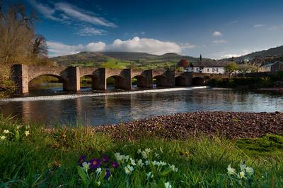
4.1 Crickhowell
Overall the residents of Crickhowell perceive the town to be more vibrant than the residents of the other towns included in this survey. Figure 2.1 “Overall Vibrancy” (p4) shows the average score Crickhowell’s residents rated the overall vibrancy as 3.9 (out of 5), this is above the total average across the four towns which was 3.625. This is reflected across all the questions and figures above with Crickhowell the best scorer on all most all the themes and areas.
Interestingly on average the residents rated “feeling of personal safety” the highest at 2.86 (out of 3), with “level to which the local natural environment improves your quality of life” at 2.81 a close second. Following that was “level to which you value local culture and heritage” 2.72 and “level of friendliness and openness of local people” at 2.71.
The area that scored poorest and therefore perceived the worst by residents of Crickhowell was “level of job opportunities in the local community” with an average of 1.26. This was closely followed by “diversity of job opportunities (range of different types of jobs available)” which scored an average of 1.27. “Adequacy of public transport for your needs” was next lowest, which scored 1.57 and forth lowest was “level to which you feel you have an influence on local issues” with an average of 1.6.

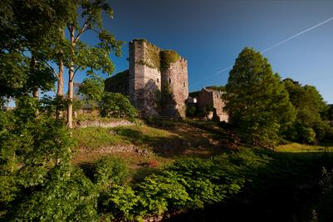
4.2 Brecon
Overall the residents of Brecon perceived the vibrancy of the town as lower than those of the other towns that took part in the survey. Figure 2.1 “Overall Vibrancy” (p4) shows the average score in Brecon when residents rated the overall vibrancy in the area as 3.4 (out of 5), this is below the total average across all four towns which was 3.625.
Interestingly on average the residents rated “feeling of personal safety” the highest across all the questions at 2.72 (out of 3). This was very closely followed by “level of friendliness and openness of local people” which scored an average of 2.71. The third highest average was “level to which you value local culture and heritage” which scored 2.63, forth was “level of confidence that crime is controlled”, the average score for that question was 2.59.
The area that was perceived the worse by the residents of Brecon was “diversity of job opportunities (range of different types of jobs available)” the average score for this was 1.27. A very close second, and along the same lines with an average of 1.28 was “level of job opportunities in the local community”. Third lowest was “level to which you feel you have an influence on local issues” which averaged 1.5, and forth lowest was “adequacy of public transport for your needs” which had an average score of 1.55.

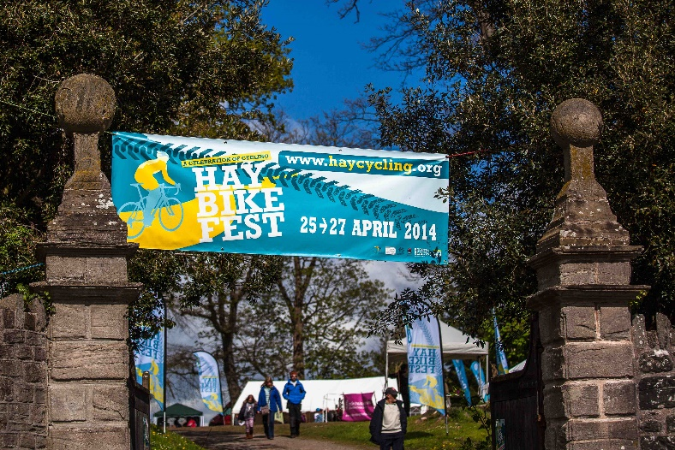
4.3 Hay on Wye
Figure 2.1 “Overall Vibrancy” (p4) shows the resident’s perception of the vibrancy in Hay on Wye was on average 3.7 (out of 5), this is slightly higher than the average across the four towns which was 3.625.
Areas that the residents perceived as most vibrant were “feeling of personal safety” which scored an average of 2.83 (out of 3), and “level of which the local natural environment improves your quality of life” which scored an average of 2.77. These were followed by “level of friendliness and openness of local people” which had an average score of 2.69 and “level to which you value local culture and heritage” with an average score of 2.68.
The area where residents perceived was the least vibrant was “diversity of job opportunities (range of different jobs)” which scored an average of 1.27, this was closely followed on the same theme by “level of job opportunities in the local community” which had an average score of 1.29. The third lowest scoring subject was “adequacy of public transport for your needs” which scored an average of 1.36, this was followed by “adequacy of access to adult education and training provision for your needs” this averaged 1.58.

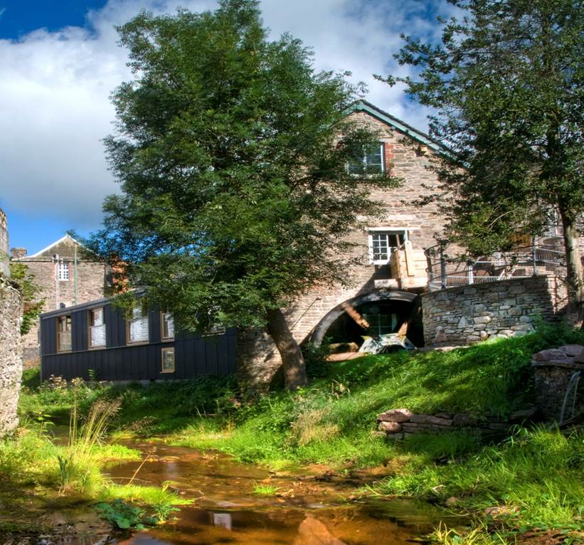
4.4 Talgarth
From figure 2.1 “Overall Vibrancy” (p4) we can see that the residents of Talgarth’s perception of overall vibrancy in the town is 3.5 (out of 5) this is slightly below the average of the four towns included in the survey which was 3.625.
The theme that the residents of Talgarth perceive as most vibrant is the “feeling of personal safety” which scored an average of 2.78 (out of 3). Second was “level to which the local natural environment improves your quality of life” which had an average score of 2.62. “Level of friendliness and openness of local people” was third highest with an average score of 2.59, this was followed by “level of which you value local culture and heritage” which scored an average 2.48.
On the other hand there were areas that the residents of Talgarth perceived as not as vibrant. The least vibrant area was “diversity of job opportunities” which scored an average of 1.23. Just behind that on a similar theme was “level of job opportunities in the local community” which scored an average of 1.24. Considered the third least vibrant by the residents was “adequacy of public transport for your needs” which scored 1.53, and just behind that was “level to which you feel you have an influence on local issues” which scored an average of 1.65.

All photo credits ©Brecon Beacons National Park Authority
4.5 Trends across the Brecon Beacons
Area/ Theme | Average score from all 4 towns (out of 3)
Feeling of personal safety | 2.7975
Level to which the local natural environment improves your quality of life | 2.7275
Level of friendliness and openness of local people | 2.645
Level to which you value local culture and heritage | 2.6275
Figure 4.1 “Top four scoring areas across all four towns”

Area/ Theme | Average score from all 4 towns (out of 3)
Diversity of job opportunities (range of different types of jobs available) | 1.26
Level of job opportunities in the local community (current availability of jobs) | 1.2675
Adequacy of public transport needs | 1.5025
Level to which you feel you have an influence on local issues | 1.595
Figure 4.2 “Lowest four scoring areas across all four towns”
Analysing the data town by town it became apparent that there were a clear number of areas that residents of each town felt were vibrant and areas that they felt were less vibrant and these were almost all the same across all four towns. For instance residents of each town recognised that “feeling of personal safety” was the most vibrant and “level to which the local natural environment improves your quality of life” as the second most vibrant. The third and fourth most vibrant do vary slightly in order but on average residents choose either “level of friendliness and openness of local people” or “level to which you value local culture and heritage”. Figure 4.1 above shows the average across all four towns together.
Similarly with the areas residents perceived the least vibrant there were commonalities emerging from all four towns too. There are slight variations between lowest and second lowest (see figure 2.5 “Local Economy” p8) but the areas perceived the least vibrant by residents were “diversity of job opportunities” and “level of job opportunities in the local community” which implies that that both of these subjects are real issues faced in the Brecon Beacons National Park. These were generally followed by “adequacy of public transport needs” and “level to which you feel you have an influence on local issues”. The only variation was that residents of Hay on Wye replaced the latter with “adequacy of access to adult education and training provision for your needs” in their average bottom four.

5.0 Appendices
- M-E-L Rural Vibrancy Proposal
- Brecon Beacons National Park Authority Residents Survey – August 2013
- Rural Vibrancy Survey Comparisons
- Hay On Wye Final Report
- Talgarth Final Report
- Brecon Final Report
- Crickhowell Final Report

