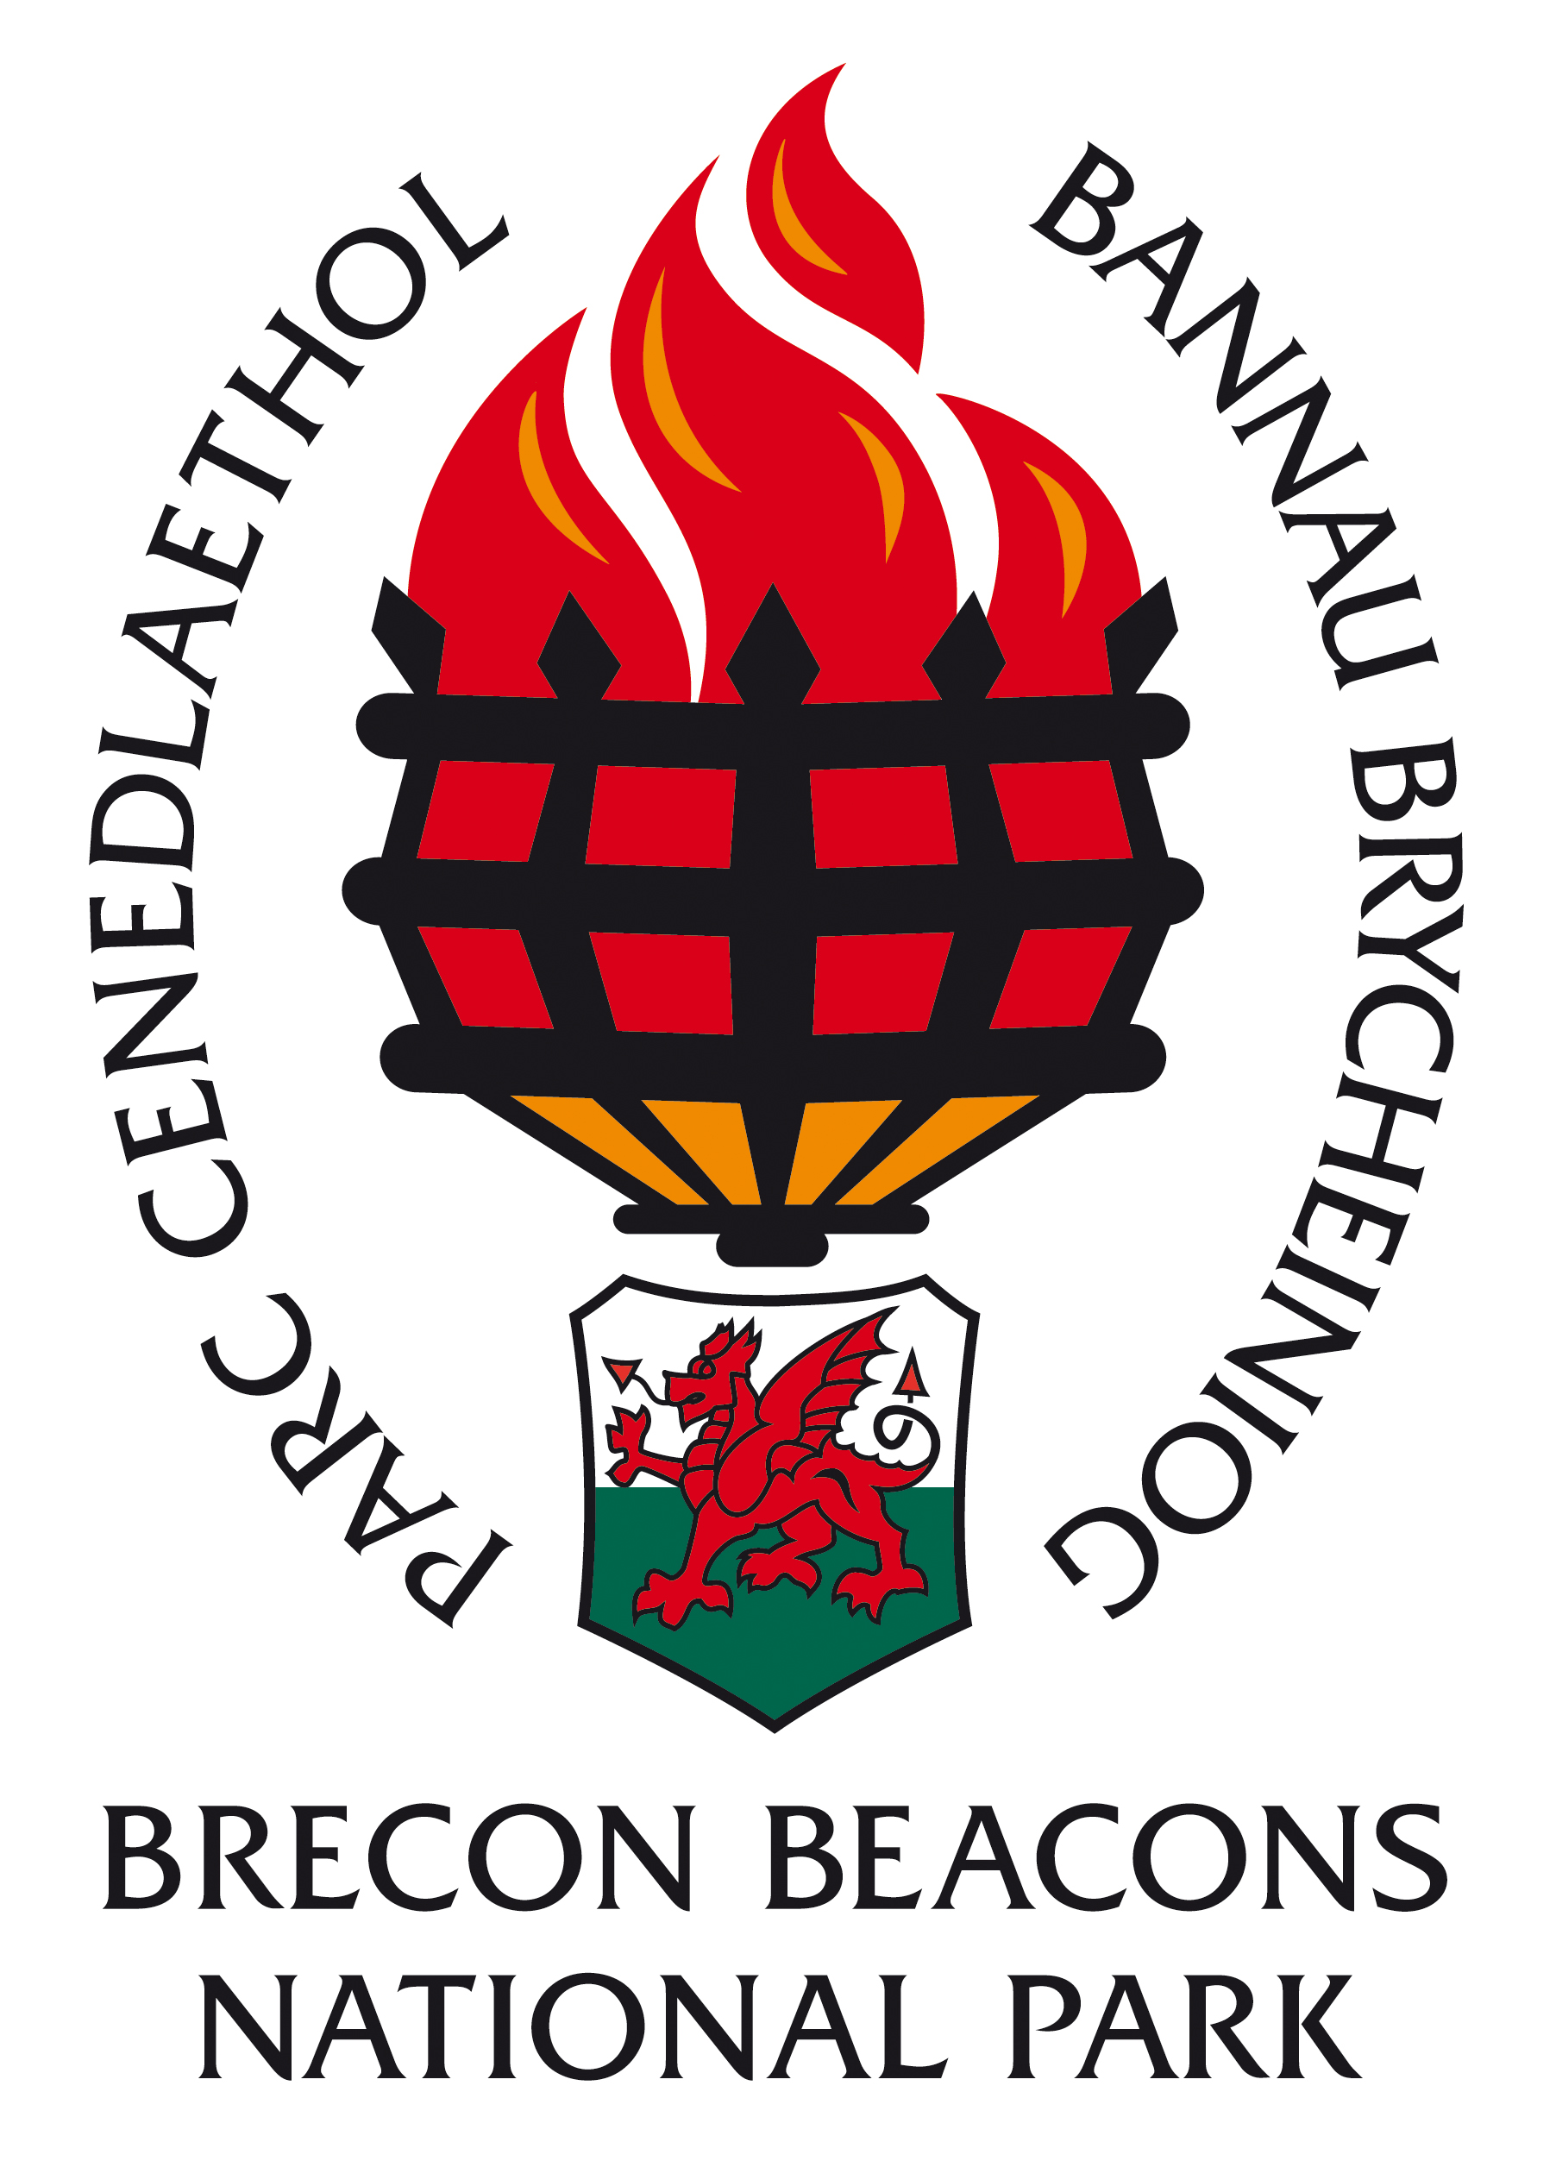

INFORMATION FOR CANDIDATES

Sustainable Tourism Administrator

Grade 6: £18,746 - £20,138 per annum, pro rata

Fixed Term Contract – 31st December 2019

7.5 hours per week

CONTENTS

- Return details
- Brecon Beacons National Park Overview
- The Staff
- Organisational Chart
- Job Description
- Person Specification
- Guidance notes for appointees

CLOSING DATE: 25th September 2017
INTERVIEW DATE: 6th October 2017

COMPLETED APPLICATION FORMS SHOULD BE RETURNED TO:

(CONFIDENTIAL)

HUMAN RESOURCES DEPARTMENT
BRECON BEACONS NATIONAL PARK AUTHORITY
PLAS Y FFYNNON
CAMBRIAN WAY
BRECON

LD3 7HP

Thank you for your interest in the post of Sustainable Tourism Administrator in the Countryside & Land Management Directorate

Applications must be received by 11.00 a.m. on the morning of 25th September 2017. Unfortunately late applications will not be considered.

Would candidates please note that it is not the practice of the National Park Authority to acknowledge applications, nor to inform candidates of the outcome of their applications. Please assume that if you receive no further communication, your application has been unsuccessful.

If you have a disability please indicate this to us in a covering letter. Should you meet the essential criteria and be called to interview, please let us know of any special requirements needed.

Please note that all application forms and supporting information will be securely retained for six months and we may contact you should a suitable vacancy arise. After six months all application forms and supporting information will be destroyed. Should you object to your information being retained, please could you let us know and we will destroy your application form after the outcome of the recruitment process.

Where candidates are invited to interview, it is the Policy of the Authority to contact referees at that stage. Please could you identify any problems this may cause on your application form under the relevant section.
Please note that when completing your application form you must be able to demonstrate how you meet the essential criteria set out in the person specification relevant to this post. You should also demonstrate how you meet the desirable criteria set out in the person specification, but do not be deterred from applying if you do not meet all of the desirable criteria.

BRECON BEACONS NATIONAL PARK AUTHORITY

Background

National Parks were designated in order to protect beautiful areas for the benefit of the nation. They came about as a result of the 1949 National Parks and Access to the Countryside Act, which put a legislative framework in place for the establishment of National Parks in England and Wales.

The first two National Parks were designated in 1951 and in 1957 the Brecon Beacons National Park was designated covering an area of some 520 square miles (1346 sq. kilometres). Until 1995 the Brecon Beacons National Park Authority was a joint committee of the then local County Councils until the Environment Act of that year laid down legislation to establish National Park Authorities as independent, special purpose Local Authorities.

What do National Parks do?

National Parks have two purposes: Firstly to conserve and enhance the natural and cultural environment of the park, and secondly to promote awareness and understanding and enjoyment of its special qualities. These special qualities have been described as:

- the landscape and natural beauty
- the peace and tranquility
- opportunities for walking and access to open countryside
- open spaces and qualities of remoteness
- traditionally managed farm land and
- wildlife

In so doing the National Parks also have a duty to foster the social and economic well being of the communities within the Park.

In delivering on their purposes and duty there are five key functions of National Park Authorities. These are to:

- act as Local Planning Authority
- act as relevant Authority for access to open countryside under the CROW Act
- facilitate environmental programmes
- provide public information, interpretation and education services
- deliver the sustainable development fund on behalf of the Welsh Assembly Government.

The Brecon Beacons National Park Authority

The National Park Authority consists of 24 members, 16 nominated by the seven Local Authorities in the area and the other eight nominated by the Minister for Environment, Sustainability & Housing of the Welsh Assembly Government. The Authority’s total budget is £6.1 million of which £4.6 million is funded by the National Park Grant and Levy and £1.5 million from Income activities.

This split helps to ensure that the local and national interests are represented at National Park Authority level. There is a range of key committees responsible for managing the business of the Authority. In addition, working and advisory groups, both internal and external, have been established to help in the decision-making process. Some 110 full-time staff equivalents are employed in two Directorates – Countryside and Land Management & Planning, as well as the Chief Executive’s Department – PR & Communications, Finance, IT, Legal, Democratic Services and HR. Staff and Members cover a wide range of activities and services and it is the key role of officers to provide advice and guidance to Members of the Authority to help them make decisions and set the vision and strategies for the Authority.

The Authority’s key strategic document is the National Park Management Plan, which sets our aims, strategic objectives and Priorities for Action for the Authority (see http://www.breconbeacons.org/the-authority/planning/strategy-and-policy/npmp). In addition to this, we have an approved Unitary Development Plan (see http://www.breconbeacons.org/the-authority/planning/strategy-and-policy/udp) which provides the framework for future development within the National Park and are developing the Local Development Plan (see http://www.breconbeacons.org/the-authority/planning/strategy-and-policy/deposit-local-development-plan/useful-deposit-information). The Authority is also developing its State of the Park Report, which will summarise the changing status of environmental, social and cultural assets in the Park. With delegated responsibility for Rights of Way maintenance and management we are implementing the Authority’s Rights of Way Improvement Plan.

National Parks in England and Wales are Category V protected landscapes as defined by the World Conservation Union (IUCN). This recognises the involvement of people in shaping the landscapes. Like all National Parks in England and Wales, agriculture is very influential in how the landscape is managed. A viable, profitable, broadminded and innovative farming sector, working in close collaboration with the Park’s communities, local businesses and public and voluntary bodies is fundamental to the landscape’s future management. Flexibility and adaptability will be important qualities to address the challenges of climate change, energy descent pathways and demographic and social changes ahead.

Fforest Fawr UNESCO Global Geopark

Geoparks are designated by UNESCO as high quality landscapes with especially strong geological interest which commit themselves to using their natural and cultural strengths to further sustainable socio-economic development. They come together at a European level under the European Geoparks Network (www.europeangeoparks.org) and globally as the Global Geoparks Network (www.globalgeopark.org). Fforest Fawr Geopark (www.fforestfawrgeopark.org.uk) was established in 2005 in response to an analysis of the needs of the west of the National Park for more focused socio-economic development. Since then we have been working with a series of partners, especially local communities and their businesses, to develop tourism product and improve the range of activities available to visitors. We have now come to the point where sufficient product is available to invest in the marketing of the Geopark to visitors and to enhancing its profile with local people. We have been fortunate to gain funding to develop this side of our work as part of a 13 Geopark partnership under Interreg VB Atlantic Area.

Atlantic Geoparks

The Atlantic Geoparks project is worth €2million overall. It involves 13 Geopark partners from North Pennines in the UK and Marble Arches on the Republic of Ireland/Northern Ireland border to Lanzarote and the Azores in the Atlantic Ocean. The project will involve regular partnership meetings in partner areas (at least every 6 months) which the Geopark Marketing Officer and Geopark Development Officer will be required to attend on a shared basis.

The project aims primarily to generate and market a transnational ‘Geopark Route’ so that visitors can see that if they have enjoyed an experience in one Geopark then there are others which are managed to the same standards and which will offer different but linked opportunities. The route will be created by linking cooperatively produced digital marketing media from Augmented/Virtual Reality to high quality video and social media campaigns. The Geopark Marketing Officer will work closely with the Geopark Development Officer to develop and populate our local contribution to these transnational products and to use them locally to promote Fforest Fawr.

Other parts of the project include the production of a Geoparks Handbook, outlining best practice in managing a Geopark and which Fforest Fawr will lead on as well as a Transnational Geo-conservation Charter, Sustainable Tourism Indicators and other project elements. The Geopark Marketing Officer will engage with all these elements.

The Geopark Marketing Officer will also be involved in promoting local Geopark activities as part of the overall project. He/she will work closely with the Authority’s existing Communication Team as well as the Geopark Development Officer on web, social media, PR, print and other communications channels. The Authority also helps lead our Sustainable Tourism Partnership together with Local Authorities and Brecon Beacons Tourism which represents local tourism businesses. Partnership documentation including our Tourism Strategy is available at http://www.beacons-npa.gov.uk/communities/tourism. All promotion and marketing work undertaken by the project will be channels through the marketing structures created within the Partnership and the Marketing Officer will be fully engaged in Partnership activity. Currently the Partnership manages the destination website (www.breconbeacons.org – although significant work is planned on this website during this winter), works together on social media, coordinates print and contracts with a PR agency who organized trips for journalists into and around the area. All these channels can be accessed by the project through negotiation with partners.

Countryside & Land Management

BRECON BEACONS NATIONAL PARK AUTHORITY

Job Description

Post Designation: Sustainable Tourism Administrator
Date effective to: 31st December 2019
Grade: 6
Responsible to: Sustainable Tourism Manager
Responsible for: Administration of Sustainable Tourism Programmes

Job Purpose:

To provide administrative support to the Tourism Team in the implementation of Atlantic Geoparks and other Programmes, particularly the preparation of grant claims and monitoring reports.

Hours of Work and Duration:

7.5 hours per week until 31st December 2019

Main Duties

- To provide administrative and financial information support to Programme Teams in the implementation and monitoring of various tourism team Programmes
- To work with the Programmes’ Financial Managers to make claims
- To assist the Programme Teams in fulfilling BBNPA procurement policy and other administrative requirements
- To ensure that Programme timesheet data is provided by Programme Team members and to collate this for the grant claims
- To produce progress reports and financial evidence to make claims against the Programmes
- To prepare grant claims according to the Programmes’ Financial Managers’ requirements and timetable in a timely and accurate manner for approval by the Sustainable Tourism Manager
- To assist the Sustainable Tourism Manager in the monitoring of finances and outcomes to ensure that it is delivering the expected results and that they comply with all financial and other regulations.
- To organise, attend and take minutes of meetings, seminars and conferences as required.
- To assist the Sustainable Tourism Team in undertaking their wider duties as shall be agreed with the Sustainable Tourism Manager
- Any other duty, appropriate to the grade and nature of the post, as required by the Chief Executive.

BRECON BEACONS NATIONAL PARK AUTHORITY

Sustainable Tourism Administrator

Person Specification

Essential Criteria Method of Assessment

A good standard of education, preferably Application form & certificate to include English and Mathematics GCSE
or equivalent and secretarial studies diploma

Experience in processing financial Application form & interview information

Good written and verbal communication skills Application form & interview

Excellent IT skills - word processing/data Application form & test entry, especially use of spreadsheets

Well organised with ability to structure Application form & interview complex information

At least two years general office experience Application for &interview with good organisational skills and
experience in processing financial information.

Current driving licence Sight of licence

Desirable Criteria Method of Assessment

Experience in grant management Application form & interview

Experience of arranging and minute Application form & interview meetings and/or events

Experience of working as part of a team Application form & interview

Ability to communicate in Welsh or Application form & interview
willingness to learn

NOTES FOR GUIDANCE FOR PERSONS TAKING UP AN APPOINTMENT WITH THE BRECON BEACONS NATIONAL PARK AUTHORITY AS

Sustainable Tourism Administrator

Salary

The salary range is from £18,746 - £20,138 per annum, pro rata.

Period of employment

Fixed Term Contract to 31st December 2019

Working hours

7.5 hours a week

Salary is paid monthly (last day of month) into bank/building society account.

Annual leave entitlement

21 days per annum, pro rata, plus 8 public holidays and 2 extra statutory days. Leave entitlement rises annually to 25 days per annum after 5 years service.

If you transfer from the service of an outside Authority to the Brecon Beacons National Park Authority, you are able to bring with you your accrued leave entitlement (accrued due to length of service) up to a maximum of 25 days.

Pension

The pension scheme in place is a standard Local Government one; the employee contributes 5.5% (up to £13,700) which rises to 5.8% (£13,701) of their contractual hours worked and the employer currently contributes 23%.

Location

The position will be based in the National Park Offices in Brecon.

