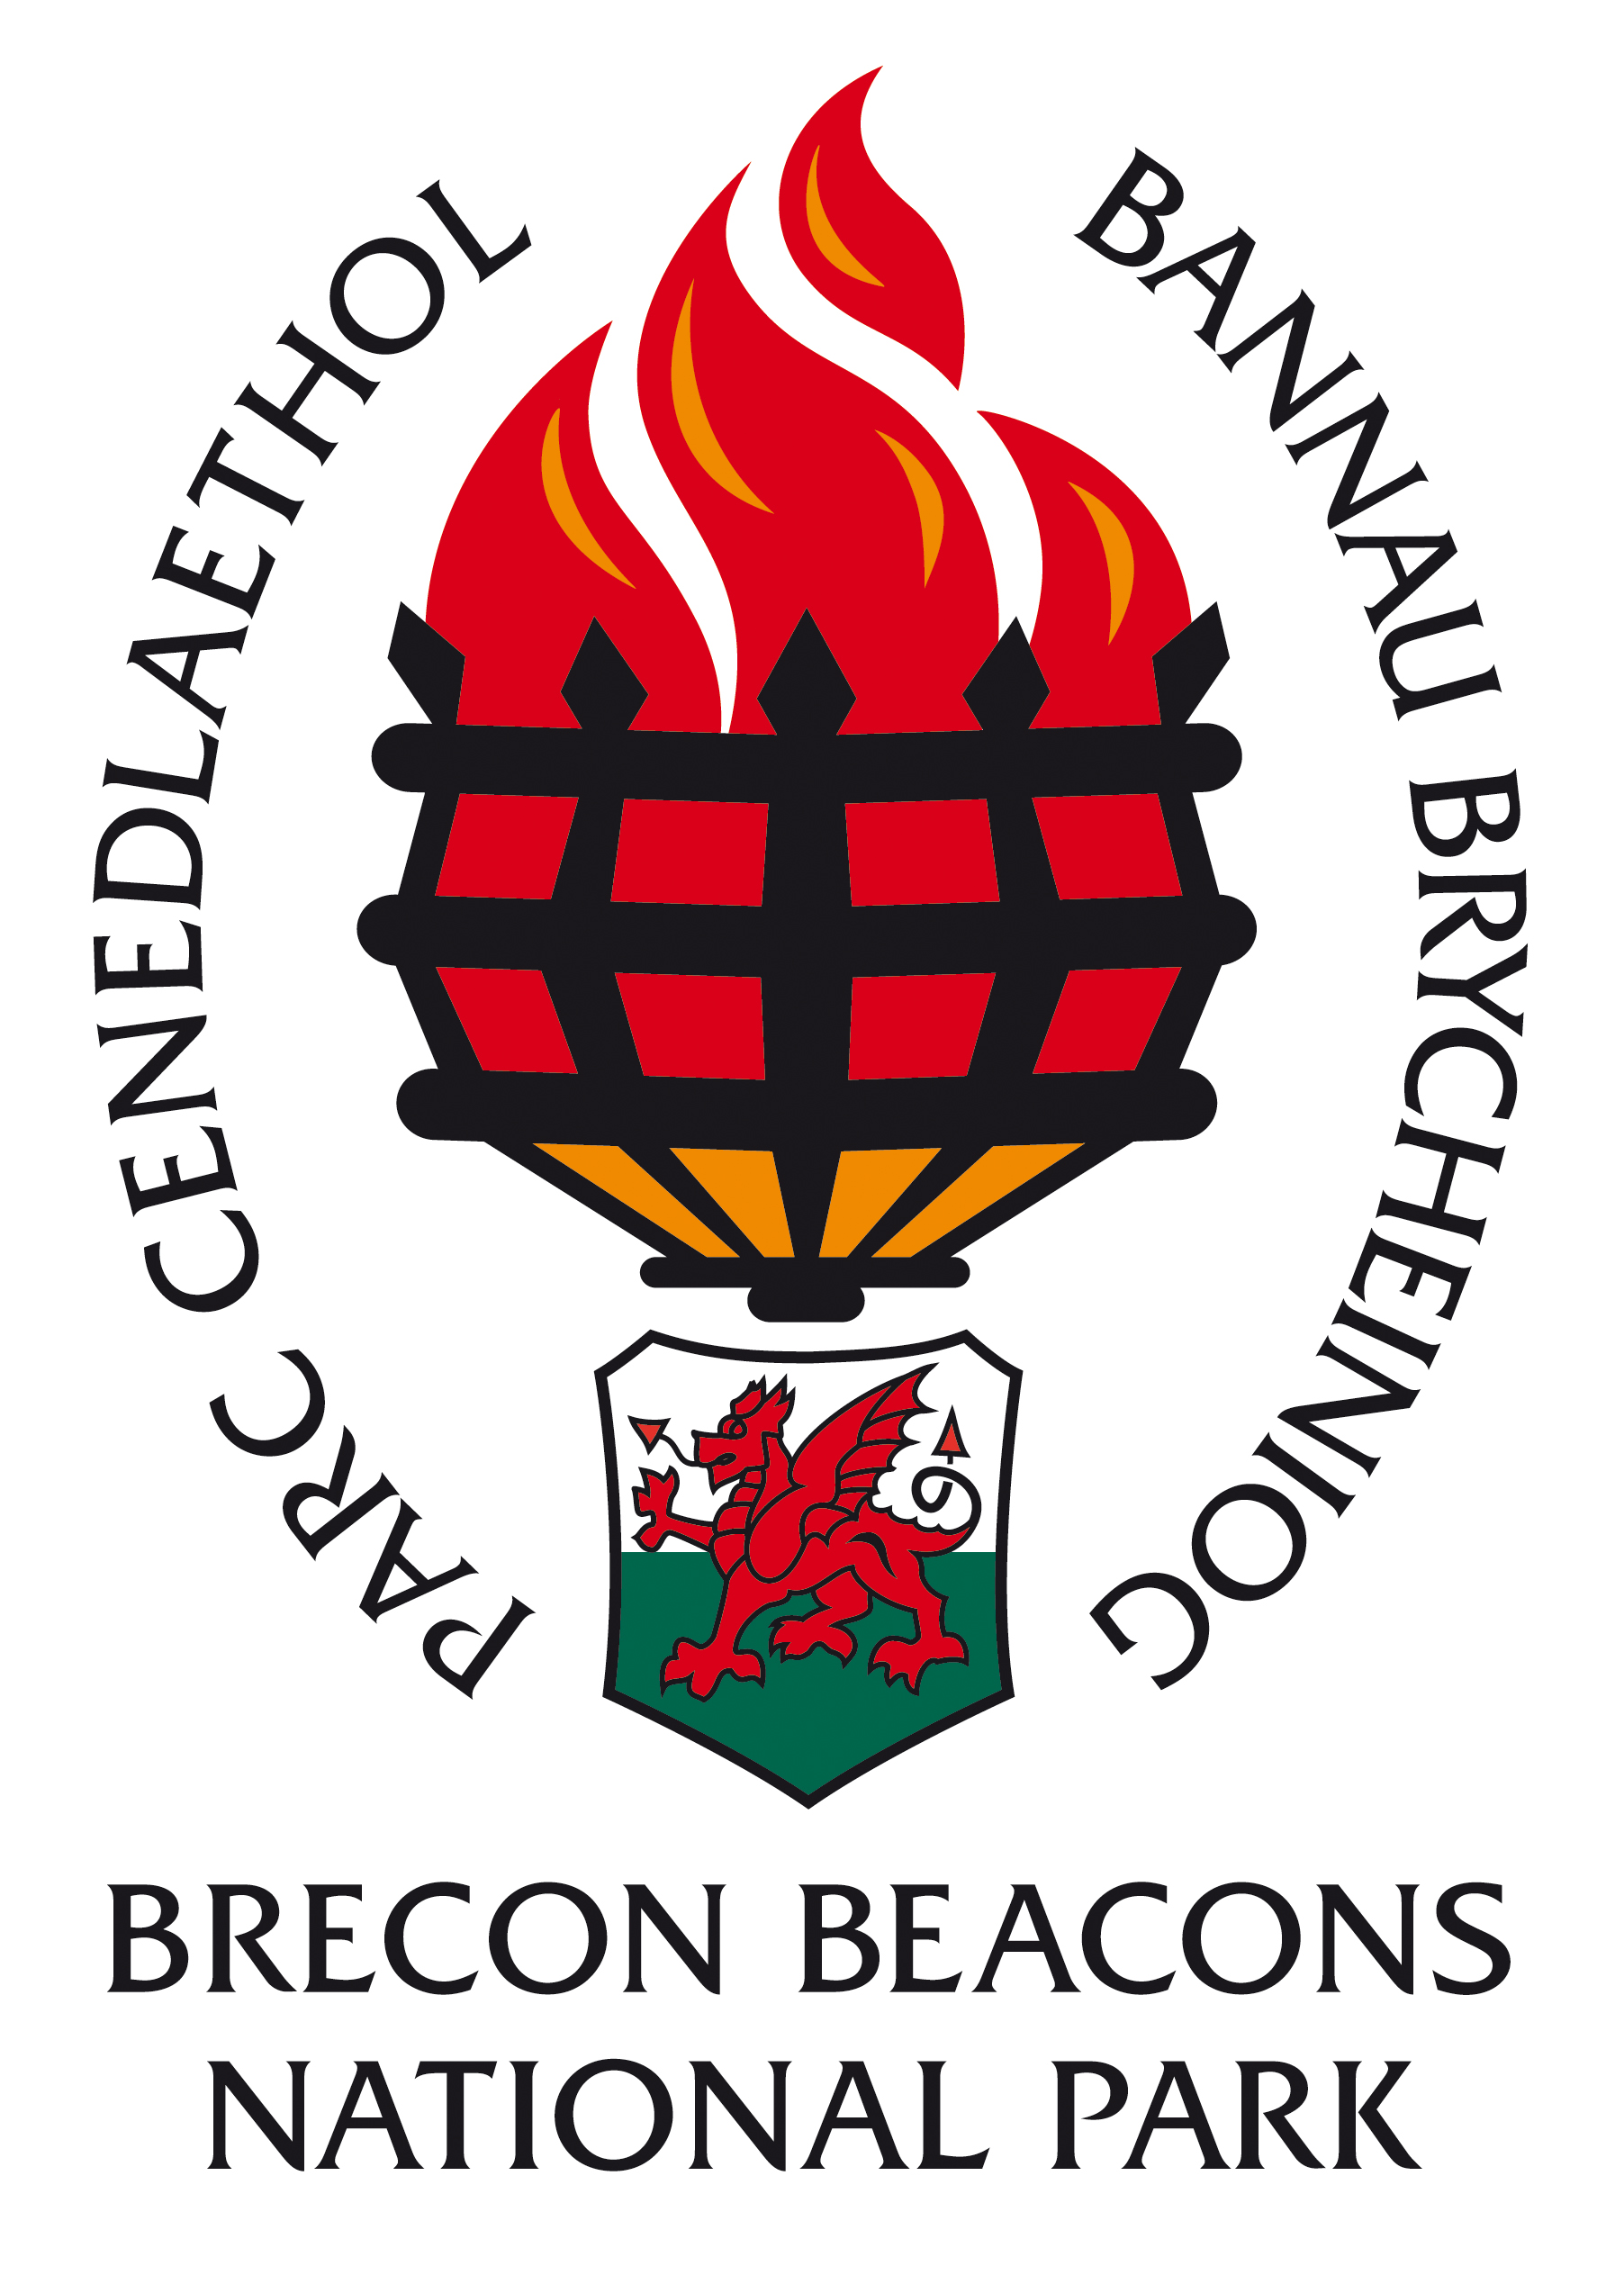

INFORMATION FOR CANDIDATES

Skills in Action Trainee Warden

£14,466 per annum pro rata

37 hours per week

Fixed Term Contract: 1stDecember 2017 – 31st May 2018
3 Posts based in Brecon and 1 post seconded to Torfaen Council based in New Inn, Pontypool

CONTENTS

- Return details
- Brecon Beacons National Park Overview
- The Staff
- Organisational Chart
- Job Description
- Person Specification
- Guidance notes for appointees

OPEN DAY at National Park Visitor Centre, Libanus, Brecon
Saturday 30th September 2017 (10:30am- 2:30pm)
CLOSING DATE: 16th October 2017 INTERVIEW DATE: 26th October 2017

COMPLETED APPLICATION FORMS SHOULD BE RETURNED TO: (CONFIDENTIAL)

HUMAN RESOURCES DEPARTMENT
BRECON BEACONS NATIONAL PARK AUTHORITY
PLAS Y FFYNNON
CAMBRIAN WAY
BRECON

LD3 7HP

Thank you for your interest in the post of Trainee Warden in the Countryside & Land Management Directorate

Please complete the attached application form. PLEASE NOTE: Instead of the box on the 3rd page “your case for appointment” please complete the attached sheet “Skills in Action Trainee Warden Case for appointment”. This is your chance to let us know about any interests, hobbies or experience you have which help fit you for the trainee warden job.

Applications must be received by 11.00am on the morning of 16th October 2017 . Unfortunately late applications will not be considered.

Would candidates please note that it is not the practice of the National Park Authority to acknowledge applications, nor to inform candidates of the outcome of their applications. Please assume that if you receive no further communication, your application has been unsuccessful.

If you have a disability please indicate this to us in a covering letter. Should you meet the essential criteria and be called to interview, please let us know of any special requirements needed.

Please note that all application forms and supporting information will be securely retained for six months and we may contact you should a suitable vacancy arise. After six months all application forms and supporting information will be destroyed. Should you object to your information being retained, please could you let us know and we will destroy your application form after the outcome of the recruitment process.

Where candidates are invited to interview, it is the Policy of the Authority to contact referees at that stage. Please could you identify any problems this may cause on your application form under the relevant section.
Please note that when completing your application form you must be able to demonstrate how you meet the essential criteria set out in the person specification relevant to this post. You should also demonstrate how you meet the desirable criteria set out in the person specification, but do not be deterred from applying if you do not meet all of the desirable criteria.

Skills in Action Trainee

Background
Skills in Action is a four year project supported by the Heritage Lottery Fund’s Skills for the Future programme. There are three delivery partners; Brecon Beacon National Park Authority, Pembrokeshire Coast National Park Authority, Torfaen County Borough Council.

The Skills in Action traineeship provides placements with the aim of providing individuals with hands-on work based experience in conservation/estate management. Central to the ‘traineeship offer’ is the opportunity to learn new skills and acquire knowledge through working with estate/conservation management teams.

The traineeship is aimed at those interested in pursuing a career in practical conservation/estate management or similar areas of work. The project aims to recruit primarily from local populations and award placements to those who seem most likely to benefit from the opportunity.

Introduction
The Skills in Action trainee role is designed for people wishing to develop a career in practical conservation/estate management or the natural heritage management sector as a whole.

The traineeship will provide you with the skills and experience that are essential to be successful in obtaining employment within this highly competitive sector. As part of the one year placement you will have the opportunity to undertake additional training relevant to the role.

Skills in Action trainees will work with one of the three project partners (Brecon Beacon National Park Authority, Pembrokeshire Coast National Park Authority, Torfaen County Borough Council) alongside existing warden/ranger teams. Trainees will work on sites and at locations appropriate to each partner, undertaking a range of practical conservation management work. Opportunities will also be provided for individuals to gain additional experience/skills in the heritage management sector working with rangers and environmental educators for example.

Objective of the traineeship

To provide hands on work experience and training in conservation management to those most likely to benefit- providing skills attractive to potential employers.

Key tasks and responsibilities

- Undertaking seasonal conservation/estate management work to the required standard with one of three project partners
- Working effectively as part of a team to deliver the above
- Completion of the objectives and tasks as specified in your Individual Training Plan to be agreed with your Supervisor
- Undertaking appropriate training to improve skills and knowledge in relation to practical conservation management.
- Be accountable for your own development by undertaking and completing the project’s reviewing and reporting procedures
- Completing the placement satisfactorily with a view to increasing employability.

Core requirements
Experience
(No previous experience of practical countryside/estate management required)
- Proven ability to absorb and apply new information
- Ability to carry out practical projects ( eg. helping with DIY, gardening, farming)

Knowledge
- Passion and enthusiasm for current environmental issues and the National Park local area

Skills
- Proven ability to work outside, in a variety of weather conditions and on practical tasks
- The ability to work with a range of people from different age groups and backgrounds
- Adaptable and flexible, with proven qualities as a strong team player, able to work closely with others, and ability to work on one’s own initiative

Motivation
- A genuine desire to work in countryside/estate management
- Willing and able to add to own abilities and to the wider environmental heritage workforce

The placement will involve considerable amounts of travel and therefore a valid driving licence is desirable or the ability to use other forms of transport to get to the required locations to undertake the traineeship effectively. The placement will be based at Brecon Beacons Ffrwdgrech Depot, Brecon (3 people) / Torfaen Council New Inn offices(1 person). Please state at the top of the application for whether you are appyling for Skills in Action Trainee Warden-BBNPA OR Skills in Action Trainee Warden-Torfaen OR Both

BRECON BEACONS NATIONAL PARK AUTHORITY

Background

National Parks were designated in order to protect beautiful areas for the benefit of the nation. They came about as a result of the 1949 National Parks and Access to the Countryside Act, which put a legislative framework in place for the establishment of National Parks in England and Wales.

The first two National Parks were designated in 1951 and in 1957 the Brecon Beacons National Park was designated covering an area of some 520 square miles (1346 sq. kilometres). Until 1995 the Brecon Beacons National Park Authority was a joint committee of the then local County Councils until the Environment Act of that year laid down legislation to establish National Park Authorities as independent, special purpose Local Authorities.

What do National Parks do?

National Parks have two purposes: Firstly to conserve and enhance the natural and cultural environment of the park, and secondly to promote awareness and understanding and enjoyment of its special qualities. These special qualities have been described as:

- the landscape and natural beauty
- the peace and tranquility
- opportunities for walking and access to open countryside
- open spaces and qualities of remoteness
- traditionally managed farm land and
- wildlife

In so doing the National Parks also have a duty to foster the social and economic well being of the communities within the Park.

In delivering on their purposes and duty there are five key functions of National Park Authorities. These are to:

- act as Local Planning Authority
- act as relevant Authority for access to open countryside under the CROW Act
- facilitate environmental programmes
- provide public information, interpretation and education services
- deliver the sustainable development fund on behalf of the Welsh Assembly Government.

The Brecon Beacons National Park Authority

The National Park Authority consists of 24 members, 16 nominated by the seven Local Authorities in the area and the other eight nominated by the Minister for Environment, Sustainability & Housing of the Welsh Assembly Government. The Authority’s total budget is £6.1 million of which £4.6 million is funded by the National Park Grant and Levy and £1.5 million from Income activities.

This split helps to ensure that the local and national interests are represented at National Park Authority level. There is a range of key committees responsible for managing the business of the Authority. In addition, working and advisory groups, both internal and external, have been established to help in the decision-making process. Some 110 full-time staff equivalents are employed in two Directorates – Countryside and Land Management & Planning, as well as the Chief Executive’s Department – PR & Communications, Finance, IT, Legal, Democratic Services and HR. Staff and Members cover a wide range of activities and services and it is the key role of officers to provide advice and guidance to Members of the Authority to help them make decisions and set the vision and strategies for the Authority.

The Authority’s key strategic document is the National Park Management Plan, which sets our aims, strategic objectives and Priorities for Action for the Authority (see http://www.breconbeacons.org/the-authority/planning/strategy-and-policy/npmp). In addition to this, we have an approved Unitary Development Plan (see http://www.breconbeacons.org/the-authority/planning/strategy-and-policy/udp) which provides the framework for future development within the National Park and are developing the Local Development Plan (see http://www.breconbeacons.org/the-authority/planning/strategy-and-policy/deposit-local-development-plan/useful-deposit-information). The Authority is also developing its State of the Park Report, which will summarise the changing status of environmental, social and cultural assets in the Park. With delegated responsibility for Rights of Way maintenance and management we are implementing the Authority’s Rights of Way Improvement Plan.

National Parks in England and Wales are Category V protected landscapes as defined by the World Conservation Union (IUCN). This recognises the involvement of people in shaping the landscapes. Like all National Parks in England and Wales, agriculture is very influential in how the landscape is managed. A viable, profitable, broadminded and innovative farming sector, working in close collaboration with the Park’s communities, local businesses and public and voluntary bodies is fundamental to the landscape’s future management. Flexibility and adaptability will be important qualities to address the challenges of climate change, energy descent pathways and demographic and social changes ahead.

Countryside & Land Management
Sustainable Development Team

BRECON BEACONS NATIONAL PARK AUTHORITY

Job Description

Post Designation: Trainee Warden
Date Effective From: 1stDecember 2017 – Fixed Term Contract Post (6 months) 5 Days per week
Grade: N/A
Responsible to: Supervised by Sustainable Communities Officer

Objective of the traineeship

To provide hands on work experience and training in conservation management to those most likely to benefit- providing skills attractive to potential employers

Key tasks and responsibilities

- Undertake seasonal conservation / estate management work to the required standard with one of the three project partners
- Working effectively as part of a team to deliver the above
- Completion of the objectives and tasks as specified in your Individual Training Plan to be agreed with your Supervisor
- Undertake appropriate training to improve skills and knowledge in relation to practical conservation management
- Be accountable for your own development by undertaking and completing the project’s reviewing and reporting procedures.
- Completing the 6-month placement satisfactorily with a view to increasing employability.

BRECON BEACONS NATIONAL PARK AUTHORITY

Person Specification

Skills In Action Trainee Warden

Essential Criteria | Method of Assessment
Knowledge
Knowledge and interest in current environmental issues and the National Park local area | Interview and practical exercise
Skills
Proven ability to work outside, in a variety of weather conditions and on practical tasks | Interview and practical exercise
The ability to work with a range of people from different age groups and backgrounds | Interview and practical exercise
Adaptable and flexible, with proven qualities as a strong team player, able to work closely with others, and ability to work on one’s own initiative | Interview and practical exercise
Experience
Proven ability to absorb and apply new information | Practical exercise
Ability to carry out practical projects (eg helping with DIY, gardening, farming)  Driving licence or currently learning | Interview
Motivation
Enthusiasm to work in countryside management | Interview and practical exercise
Willing and able to add to own abilities and to the wider environmental heritage workforce | Interview
NOTES FOR GUIDANCE FOR PERSONS TAKING UP AN APPOINTMENT WITH THE BRECON BEACONS NATIONAL PARK AUTHORITY AS
Trainee Warden

Salary

The salary is based on National Living Wage £14,466 per annum pro rata

Period of employment

6-Month Fixed Term Contract

Working hours

37 hours per week (Monday to Friday)

The nature of the post’s duties may from time to time require evening and weekend work. Paid overtime is not available but time off in lieu of hours worked will be given if agreed in advance

Salary is paid monthly (last day of month) into bank/building society account.

Probationary Period

During your one month probationary period, the period of notice for termination of your placement will be one week by either side. After successful completion of your probationary period the minimum period of notice is four weeks by either side.

Annual leave entitlement

21 days per annum pro rata, plus 8 public holiday’s per annum pro rata and 2 extra statutory days

10 days of leave are to be taken on dates set by the employer

Pension

The pension scheme in place is a standard Local Government one; the employee contributes 5.5% (up to £13,500) of their contractual hours worked and the employer currently contributes 19.3%.

Location

The position will be based in the National Park Ffwdgrech depot in Brecon or Torfaen County Council HQ at New Inn Pontypool

