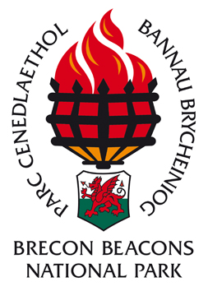

Tretower Court — A Servant’s Life
Supporting the study of Tudor life and knowledge of National Parks
A partnership between Cadw and Brecon Beacons National Park Authority Education Service.
Schools can bring up to 60 pupils and spend the day on site.
2 x 1.5 hour sessions of education activities.
Available in Welsh and English.
Morning session :
Group 1(max 30 pupils) Pupils are welcomed by a servant- half have a tour of the garden, kitchen, buttery, pantry, server and hall, as if they are applying for the 2 servant vacancies, with ‘skills tests’ along the way.
The other half explore artefacts in the Tudor treasure chest. The groups change activities half way through the session.

Group 2 (max 30 pupils) Pupils try their hand at outdoor activities such as hurdle making, rush peeling and using Tudor measurements. They will investigate whether life was more environmentally friendly than it is today. There is also the opportunity to explore the Tower and learn about the Brecon Beacons National Park.
Afternoon session :Groups swap sessions.
Cost: £360 per group of up to 60 pupils, accompanying adults free.
For further information or to book call 01874 620463 or email lora.davies@beacons-npa.gov.uk

