



**Walk activities**

**Colour palette**

**Resources:**

* Bookmark sized pieces of card with double sided sticky tape up the centre.

To record and remember your walk or visit ask your group to collect and stick to the card a selection of leaves/colours from the natural environment. Or simply record the journey by collecting small examples of things found along the way e.g. a small flower/ petal, leaf, berry…

Compare colour palettes afterwards

**Useful tips**

*These can be laminated and used as bookmarks or for a display.*

*Larger items do not stick very well and this activity does not work well in the rain.*

*Please only pick very common or fallen leaves/flowers.*

*Hang on to sticky tape strip. It is useful to cover centre of palette to transport home.*

*Avoid spiky/stingy and poisonous plants! Eg holly/nettles/foxgloves*

*Wash hands thoroughly afterwards.*

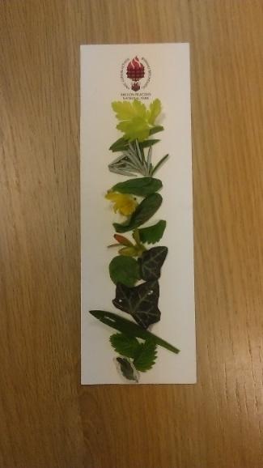

**Sounds**

Spend 30 seconds to a minute with everyone in silence, listening to the sounds around them.

Count the number of different sounds you hear.

Compare/list sounds afterwards

**Useful tips**

*Choose a place with a variety of potential sounds, away from a road.*

*Closing the eyes helps people to listen better .*

*Cupping hands behind the ears also helps.*

**Journey sticks**

**Resources**

* Wool in pre-cut lengths or balls of wool and scissors.
* Dry sticks about 30 cm long.

Discuss how we get from one place to another e.g. using a map and compass or sat nav.

Tell them how Native Americans used to decorate a stick as a reminder of the places they passed on the route and to tell others about it.

Show an example of a decorated stick and recite the journey it tells. The colour of the wool can represent the terrain etc

eg green = grass. black =road, blue = water, yellow = sunshine and so on.

Things to collect: Leaves, feathers, sheep’s wool, bird’s feathers, pine cones, seeds.

grasses or blossom.

Demonstrate how to tie the wool onto the stick then wind it continuously around the stick.

Bind materials onto the stick by winding wool around or by tying knots. Change colour by winding one colour over another.

Recalling journeys- each person describes their journey to someone else. Alternatively another person has to work out their journey from the stick.

**Useful tips:**

*Knots can be fiddly, winding over an end to hold it works better.*

*Straight sticks with few knobbly parts are easier to work with.*

*Attaching pre-cut lengths onto a separate stick for easy selection saves time and effort with balls of wool and scissors which can get tangled.*

*Avoid prickly, stingy, poisonous plants*

*Only pick things which are common/lying on the ground.*

*Wash hands afterwards*

