Welsh Language Standards Annual Report 2016-17

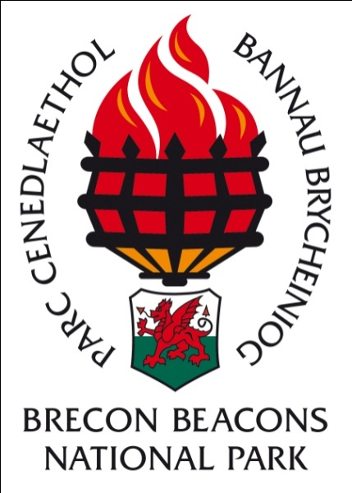

Background to the Report
Historically the Brecon Beacons National Park Authority has adhered to a Welsh Language Scheme, with the last scheme approved by the Authority in 2013.
The Welsh Language Measure 2011 established a legal framework to impose duties on certain organisations to comply with standards in relation to the Welsh Language.
The standards to be adhered with by the Brecon Beacons National Park Authority are contained in the Compliance Notice issued to the Authority.
Between September 2015 and the end of January 2017 the Authority has appealed a number of standards, with the Welsh Language Commissioner agreeing to vary or withdraw some standards.
The final compliance notice received in 2017 can be seen in Enclosure 2. The Authority must adhere to these Welsh Language Standards.

These regulations (standards) were made to impose duties on county councils and county borough councils in Wales, National Park Authorities and Welsh Ministers. The aim of the Standards is to:
- provide greater clarity to organisations on their duties on the Welsh language
- provide greater clarity to Welsh speakers about the services they can expect to receive in Welsh
- ensure more consistency of Welsh language services and improve their quality.
- There is a statutory process to follow to impose standards on organisations

This report is the first annual report on the Welsh Language Standards. This Annual Monitoring Report will be considered for approval by The Brecon Beacons National Park Authority on 30th June 2017 prior to being published on the Authority’s website in accordance with the requirements of the standards.

Introduction
The (most recent) 2011 census identified the Welsh speaking population for the National Park as a whole at 10.3%. The average for Wales is 19%. Nevertheless some communities within the National Park - mainly in the West - have approximately 50% Welsh Language speakers.
As part of its commitment to the Welsh Language the Brecon Beacons National Park Authority has followed a Welsh Language Scheme for many years and as a result the Authority was already meeting the requirements for many of the standards introduced from April 2016.
The main principal of the standards is that the Welsh Language is treated no less favourably than the English Language and standards are categorised as follows:-
- Service Delivery Standards – in relation to the delivery of services in order to promote or facilitate the use of the Welsh Language
- Policy Making Standards – require organisations to consider what effect their policy decisions will have on the ability of persons to use the language and on the principle of treating Welsh no less favourably than English
- Operational standards – standards which deal with internal use of Welsh by organisations
- Promotional standards – require organisations to adopt a strategy setting out how it proposes to promote and facilitate the use of Welsh
- Record Keeping Standards – these standards make it necessary to keep records about some of the other standards

Achievements in 2016-17
During the year we have ensured implementation of the standards and have undertaken a dialogue with the Welsh Language Commissioner on a number of them.
The Welsh Language essential posts within the Authority are targeted at service delivery in the Welsh speaking areas. In addition both receptionist posts at our Headquarters are classed as ‘Welsh Essential’ posts and both are currently filled by Welsh speakers.
12 new or vacant posts were assessed during the year, with all being categorised as “Welsh Language Desirable”.
The level of ability in Welsh speaking within the Authority’s staff is above both the local average for communities within the National Park boundaries and also above the national average, with 22% of the whole staff classing themselves as Fluent or Intermediate users of the Welsh Language. A further 13% are learning Welsh.
In March 2012 the Authority adopted the policy of considering the potential positive or negative impacts for Welsh language users resulting from Committee decisions. The Welsh Language is an integral part of the Equality Impact Screening process for all strategy and decisions reports submitted to Committee for approval. Policy decisions made during 2016-17 have been classified as neutral in terms of their effect on the Welsh Language across the Park.
There were no complaints regarding our Welsh Language Service in the year. The Authority received one Freedom of Information request relating to the Welsh Language.
1139 participants took part in courses delivered in Welsh by the Authority’s Education team, which represents a 14% increase on last year.
Agendas and minutes for the Authority’s committees are now produced in Welsh
Press releases are issued at the same time in Welsh and English and we now have 131 followers of our Welsh Facebook page.
Both websites www.beacons-npa.gov.uk and www.breconbeacons.org are now bilingual. The Authority has also facilitated the development of a Welsh Language Policy for the Brecon Beacons Sustainable Destination Partnership.
A policy for using Welsh in the workplace has been developed and approved by the National Park Authority in April 2017. The policy now sits alongside all other staff policies.
Over 75% of the staff have received Welsh Language awareness training during 2016-2017. Further sessions will be arranged over the coming year to cover the remaining staff and new starters.
The Sustainable Development Fund has awarded a two year grant to develop Welsh & Outdoor Activities, a project being run by Menter Iaith Brycheiniog a Maesyfed.
In 2016 the Brecon Beacons National Park Authority organised a joint stand representing all 3 Welsh National Parks at the National Eisteddfod in Abergavenny. The stand was staffed by fluent speakers and Welsh learners from all 3 Welsh National Parks and included volunteers. Based in the science area a planetarium enabled visitors to learn more about the Dark Skies across the Country and see a ‘star show’. There were also opportunities for visitors to try their hand at pond dipping, make national park/dark skies based craft and talk about the National Park with experts from across the Welsh family of National Parks.

A five year Welsh Language Promotion strategy has been agreed by the National Park Authority.

The implementation/action plan approved by the Authority is being used to monitor progress.
The Welsh Language skills of employees
The Welsh Language Survey was conducted and compared with the previous year’s actual head-count (rather than number of posts). During the year the Authority has reduced staff numbers. We are pleased to report that this has not affected our ability to provide services in Welsh.
In 2016-17 the percentage of learners increased at 13%. Overall the combined percentage for intermediate and fluent welsh speakers was 22%, the preceding year this figure stood at 21%. 24% of staff have a Welsh Language qualification.

 | Non Speaker | Basic | Learner | Intermediate | Fluent |  | Welsh Qualifications
Number of individual staff 2016-17 | 29 | 44 | 14 | 10 | 15 |  | 17 staff have GCSE/O Level, 6 A level and 2 degrees. 2 people have other qualifications.
% of staff 2016-17 | 26% | 39% | 13% | 9% | 13% |  | 24% of staff have a Welsh language qualification
Number of individual staff 2015-16 | 33 | 48 | 15 | 10 | 16 |  | 22 staff had GCSE/O level or equiv, 7 A-level or equiv, 2 Degree level and 6 other qualifications
% of staff 2015-16 | 27% | 39% | 12% | 8% | 13% |  | 25% of staff had a Welsh language qualification
The number and percentage of staff who were able to speak Welsh by service provision:
Planning (27 staff)
 | Non Speaker |  |  | Basic |  |  | Learner |  |  | Intermediate |  | Fluent
Number of individual staff 2016-17 | 10 |  |  | 10 |  |  | 3 |  |  | 2 |  | 2
% of staff within directorate 2016-17 | 37% |  |  | 37% |  |  | 11% |  |  | 7% |  | 7%
Number of individual staff 2015-16 | 12 |  |  | 8 |  |  | 3 |  |  | 2 |  | 2
% of staff within directorate 2015-16 | 44% |  |  | 30% |  |  | 11% |  |  | 7% |  | 7%
The level of Welsh Speakers (fluent & intermediate) in the Planning Department remained stable in 2016-17 at 14%

Countryside (61 staff)
 |  | Non Speaker |  |  | Basic |  |  | Learner |  |  | Intermediate | Fluent
Number of individual staff 2016-17 |  | 12 |  |  | 26 |  |  | 6 |  |  | 7 | 10
% of staff within directorate 2016-17 |  | 20% |  |  | 43% |  |  | 10% |  |  | 11% | 16%
Number of individual staff 2015-16 |  | 13 |  |  | 32 |  |  | 8 |  |  | 5 | 11
% of staff within directorate 2015-16 |  | 19% |  |  | 46% |  |  | 12% |  |  | 7% | 16%
The net effect in the year was a reduction of six staff, one non-speaker, six basic, and one fluent offset by an increase of two intermediate. The numbers able to speak Welsh at an Intermediate and Fluent level increased by 4%.
Chief Executives Office (24 staff)
 |  |  | Non Speaker |  |  | Basic |  |  | Learner |  | Intermediate | Fluent
Number of individual staff 2016-17 |  |  | 7 |  |  | 8 |  |  | 5 |  | 1 | 3
% of staff within directorate 2016-17 |  |  | 29% |  |  | 33% |  |  | 21% |  | 4% | 13%
Number of individual staff 2015-16 |  |  | 8 |  |  | 8 |  |  | 5 |  | 2 | 3
% of staff within directorate 2015-16 |  |  | 31% |  |  | 31% |  |  | 19% |  | 8% | 12%
The Chief Executive’s office lost one intermediate speaker during the year.

Staff study through Aberystwyth University Welsh for Adults Language Courses. The Authority is currently supporting 9 staff to attend Welsh lessons.
Two staff achieved distinctions in the Canolradd (Intermediate exam) and one member of staff passed the Sylfaen (Foundation) course in August 2016.
Over the last year a number of in-house coffee mornings have taken place with the Menter Iaith Officer offering staff the opportunity to come along and chat in Welsh or to discuss work related translations.
In January/February 2017 staff received Welsh Language Awareness Training. Over 75% of the staff were trained across 6 sessions. The course was run by the Welsh language Officer, with the help of the Menter Iaith. As a result 95% of participants indicated that their awareness of the Welsh Language and welsh culture had improved, 90% felt that they were now able to comply with the Welsh Language Standards and 45 people indicated an interest in learning/ improving their Welsh in the future.

Complaints
During 2016/17 there have been no complaints regarding our compliance with the Welsh Language Standards. One freedom of information request in relation to the Welsh Language was received.

Promoting and Facilitating the Welsh Language
The Brecon Beacons National Park Authority is committed to promoting the use of the Welsh Language wherever possible and aims to ensure that residents and visitors are able to receive the service in Welsh if they so choose to do.
The statutory framework for the Welsh language in the Brecon Beacons National Park which gives strength to this strategy is as follows:
- The Welsh Language (Wales) Measure 2011
- The Well Being of Future Generations Act 2011:
The latter sets a clear well-being goal of
- A Wales of a vibrant culture and a thriving Welsh Language.
- A society that promotes and protects culture, heritage and the Welsh Language
- One million speakers by 2050 – The Welsh Government target announced at the National Eisteddfod in August 2016.

The Welsh Language Promotion Strategy was approved by the NPA on 7th April 2017 and is now available on the website.
We have encouraged partnership groups to develop a Welsh Language Policy including the Sustainable Destination Partnership and the Black Mountains Land Use Partnership. The Brecon Volunteer Bureau produced its first ever bilingual poster as a requirement of a Sustainable Development Fund grant.
Recruitment for a Welsh Language Development Officer for the Welsh and Outdoor Activity Providers project supported by SDF and Arwain is due to commence shortly.
Welsh Culture Ambassador training has been carried out for Tourism businesses operating in the National Park. As a result 14 Welsh Ambassadors have been trained across the Park in the last year.
Education courses through the Medium of Welsh have been taken by 1139 pupils in 2016/17. These courses are promoted widely to Welsh Medium Schools.
In 2016 the Authority organised the Welsh Parks’ representation at the National Eisteddfod in Abergavenny and support is being given to the Urdd Eisteddfod in 2018 which is taking place in Builth Wells. Other opportunities for the promotion of the Language are being taken whenever possible.
All publications and interpretation panels, mobile phone apps etc. are produced bilingually. An example of the panel produced for the waterfalls area can be seen below.

The Waterfall Country Interpretation Panel
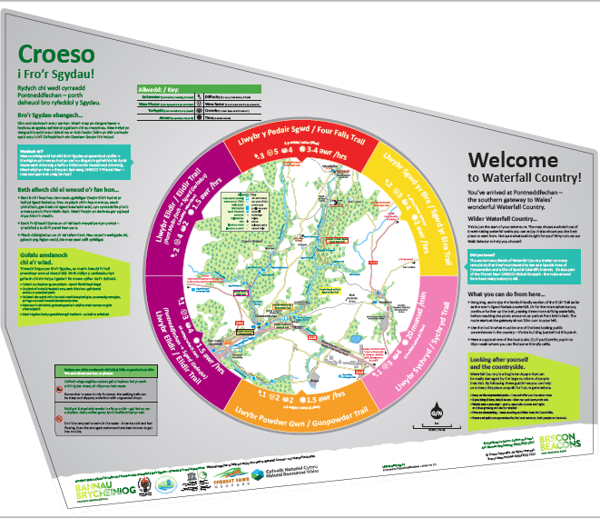

Welsh Language Standards Action Plan & Quality of Service
The implementation and action plan for the Welsh Language standards was agreed by the National Park Authority in April 2017 and will be pursued over the coming year. This document lists the standards to be complied with and the areas which require further work to implement suitable solutions. The report can be found on the National Park Authority website.
The Brecon Beacons National Park Authority is committed to the Welsh Language and makes use of the Welsh Government framework for translation services.

