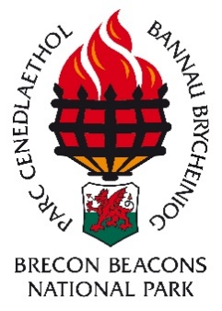
Upper Tawe Valley Japanese Knotweed control –
Small grant scheme- 2019
Guidelines

What is the project?
Brecon Beacons National Park Authority is currently running a pilot project to take action towards controlling invasive non-native species in the Tawe and Usk river catchments, with a focus on the top of the catchments. The project is looking to control three of the most damaging plant species: Himalayan balsam, Japanese knotweed and Giant hogweed.
As part of the ‘Invaders of the National Park’ project BBNPA will be trialling a grant scheme in 2019 to allow applicants to access grant money to control Japanese knotweed in the Upper Tawe Valley within the Brecon Beacons National Park.
Why Japanese knotweed?
Japanese knotweed is an invasive non-native plant that negatively affects our native wildlife and has the potential to damage buildings and structures. Its rapid growth rate and height means that it outcompetes and shades out our native plants and our native wildlife do not feed on it. Along riverbanks, when the plant dies back in winter, it leaves bare earth which is then subject to erosion. Its ability to grow through weaknesses in concrete and asphalt has led to problems with damaging structures and can affect property values and the ability to obtain a mortgage.

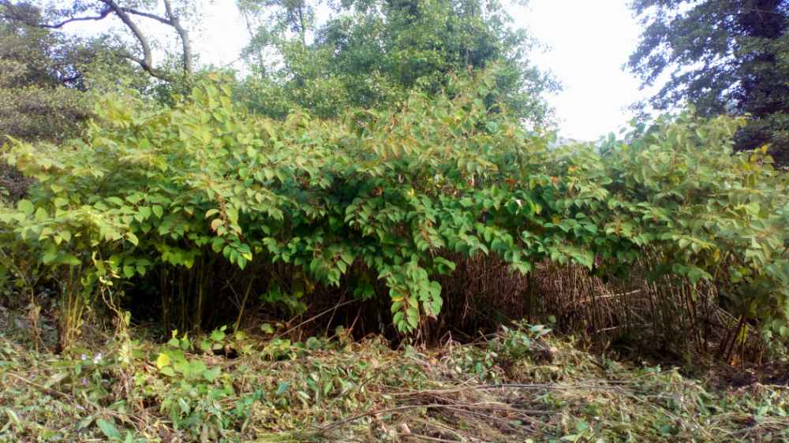 | 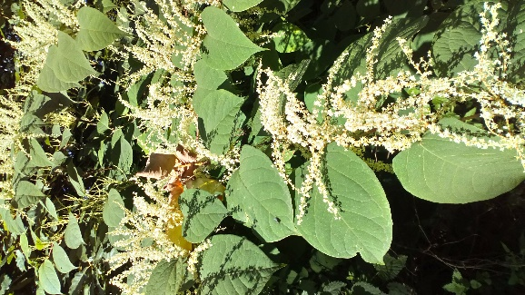
Figures 1 & 2 - A large stand of Japanese knotweed and knotweed in flower

What will the grant offer be?
To hire a professional contractor to control the knotweed using herbicide the grant scheme will offer 75% of the costs or £500 whichever is the lower. Note: If the applicant is VAT registered then the grant will be paid exclusive of VAT and the applicant must claim back the VAT themselves.
The Japanese knotweed must be:
- Within the boundary of the Brecon Beacons National Park.
- Within 20m of the River Tawe or one of its tributaries.
- On land owned by yourself, the applicant.
- Not on land owned by a Local Authority or another government organisation.
- The applicant must not be already receiving government money to control Japanese knotweed in that area for example through an agri-environment scheme, as this project is already funded by the Welsh Government.
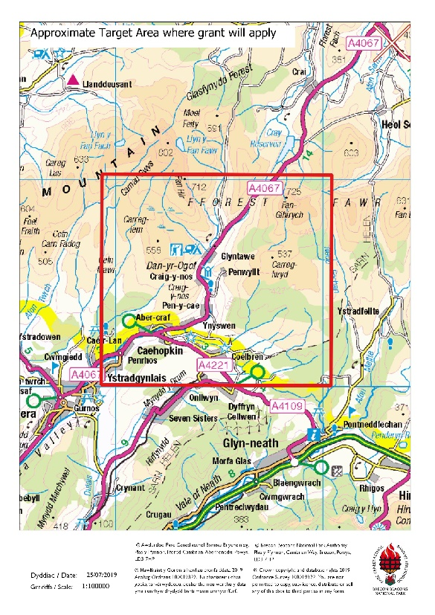
Figure 2 – Map of general target area where grant will apply (Please check with BBNP INNS team to see if your location qualifies, contact details at the end)

How to select a contractor
It may be appropriate to employ a specialist contractor for assessing the best method of control and to apply any pesticides.
If sprays are to be applied in or near water, the person carrying out or supervising the spraying must have the appropriate aquatic part of the qualification. Any spray operator used must hold the appropriate National Proficiency Tests Council (NPTC) certification for herbicide use or work under the direct supervision of a certificate holder.
Specialist contractors for the treatment of Japanese knotweed are usually members of the Invasive Non-Native Specialists Association (https//www.innsa.org/) or the Property Care Association (https://property-care.og/)
These organisations operate to strict standards encompassing all the legal requirements. Other contractors include Amenity Assured Compliant Contractors found through ww.basis-reg.co.uk or members of the National Association of Agricultural Contractors, (www.naac.co.uk).
Permissions you may need:
- If the Japanese knotweed is within 5 metres of a water course, agreement from Natural Resources Wales (NRW) is needed to use herbicides. In most cases this will be in the form of a ‘low risk agreement’ which does not require an additional application form to NRW. A link for checking whether a site is ‘low risk’ or ‘high risk’, for example there may be an abstraction downstream, is given at the end of this document. (Permission for treatment with herbicides must be given by Natural Resources Wales prior to application.)
- If the Japanese knotweed is on a designated site such as a Site of Special Scientific Interest (SSSI), Special Protection Area (SPA) or Special Area of Conservation (SAC) then the site will be classed as ‘high risk’ and written permission will be required before treatment from Natural Resources Wales.

This grant requires the following evidence:
- Natural Resources Wales (NRW) is the statutory body that permits the use of herbicides. NRW agreement is needed if using herbicide within 5m of a waterbody* or within a designated site such as Site of Special Scientific Interest, Special Area of Conservation, Special Protection Area, Ramsar site. (If neither of these conditions apply then you do not need consent from NRW). *a waterbody is defined as any body of water such as a lake, pond, ditch, stream, river etc.
- If your site is near a waterbody or within a designated site then NRW operate a system of low risk agreements which do not require an application and high risk agreements that do. Please see the NRW website for further information on which category your herbicide location falls into https://naturalresources.wales/permits-and-permissions/water-discharges-and-septic-tanks/using-herbicides/?lang=en
- For ‘low risk’ applications the evidence needed for the grant would be an email response from the NRW herbicide location screening service. Please note there is a 10 working day response time using this service.
- For a ‘high risk’ application the contractor/applicant must provide evidence of consent given by Natural Resources Wales. Due to the much longer turnaround time for this consenting process then we will accept evidence of submission of the AqHerb01 form to the NRW Permit Receipt Centre (they send a receipt email out).We will then allow a longer time for grant submission and consideration.
- The contractor carrying out the works must provide evidence of appropriate National Proficiency Tests Council (NPTC) certificate for using pesticides near water PA1 & PA6AW. All herbicides used must be used properly, in line with the product label.
- The works must be completed at the appropriate time of year which for Japanese knotweed in this case is late summer to 31st October 2019.
- The applicant must be willing to allow a BBNPA staff member to carry out a site visit before, during and after treatment if required.

The application process is as follows:
1/ Contact the Invasive Non-Native Species (INNS) team at BBNPA to have an initial discussion and possible site visit. This initial stage is very important as knowing the grid reference and location of the knotweed at an early stage will help with processing the application. (Contact details can be found at the bottom of this document).
2/ If advised by BBNPA staff, to then complete a grant application with evidence and send in by 26th August 2019.
3/ Offer letters will be sent out by the week commencing 2nd September, these letters to be signed and returned by the applicant to BBNPA.
4/ The applicant will then organise the work to be carried out with the contractor. Work must not be carried out before both parties have signed and dated the offer letter.
5/ Once works are complete the applicant must inform the INNS team and send in evidence of the work and copies of any invoices from the contractors.
6/ Once BBNPA are satisfied with the works carried out and the paperwork then we will pay the grant. This will include a visit by a BBNPA officer to view the Japanese knotweed before and after the control.
PLEASE NOTE: If you are VAT registered then the cost of VAT will not be able to be claimed from the BBNPA, you the applicant will need to claim that back yourselves.

What are the criteria?
This is a limited pot of grant money and if there are more applications than the total fund then distribution will be decided using the following criteria:
1/ Geographical location; the closer the Japanese knotweed is to the head of the river Tawe catchment the more likely we are to fund the works.
2/ Proximity to the river; the closer the Japanese knotweed is to the watercourse the more likely it is to be funded due to the higher likelihood of it being able to spread downstream.

Where can I get more information?
For information on using herbicides and the consent process from Natural Resources Wales:
https://naturalresources.wales/permits-and-permissions/water-discharges-and-septic-tanks/using-herbicides/?lang=en
For information on Japanese knotweed:
https://gov.wales/sites/default/files/publications/2018-01/japanese-knotweed-controlling-it-on-your-land.pdf

To contact the Invasive Non-Native Species (INNS) Team at the National Park:
Beverley Lewis, 07854997508, Beverley.Lewis@beacons-npa.gov.uk
Or David Jermyn, 07854997552, David.Jermyn@beacons-npa.gov.uk

The Brecon Beacons National Park Invasive Non-Native Species project is funded by the Welsh Government.

