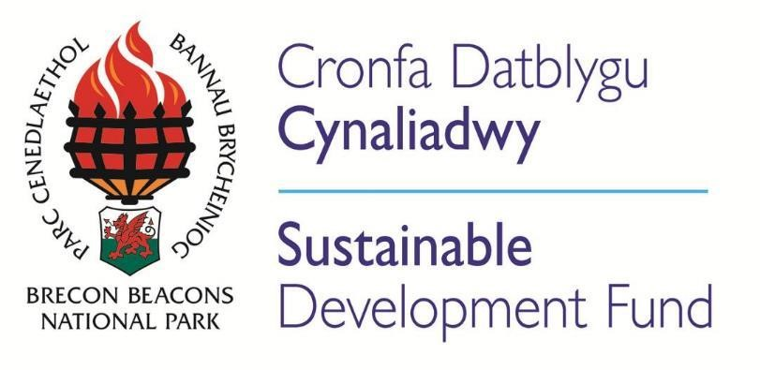
Sustainable Development Fund
Report for Year Ended 31st March 2019

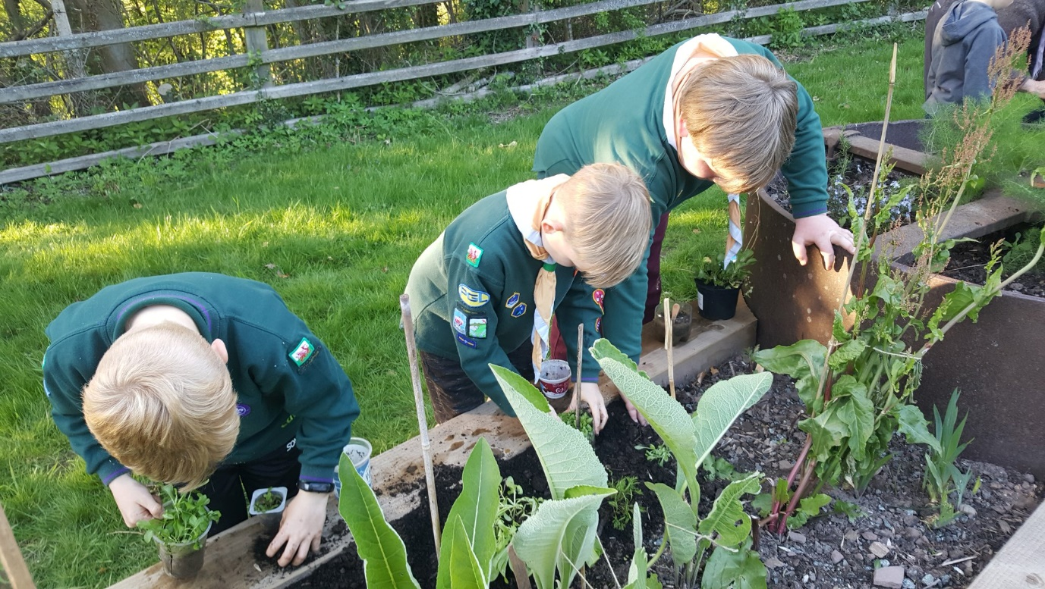
CHAIR’S FOREWORD

It is a joy to see the bright ideas which emerge from our communities across the Brecon Beacons National Park, and to see how much imagination and local commitment to sustainability there is. I hope you enjoy reading about the inspiring SDF-funded projects in this year’s annual report.
SDF is a net earner for the Park, levering in funding for sustainability projects. In 2018-19 for every £1 invested by SDF, £4 of match-funding has been raised. I congratulate everyone involved, and thank all the partners and funders. Of course, it is not only investment that makes for a successful project. Our two SDF officers Helen Roderick and Ceri Bevan support new applicants, help them to shape their applications, and check that they meet the Authority’s priorities. My huge thanks go to them for their sterling work, and for compiling and editing this report.
There are clear links between good public governance, investment and development. The SDF (Sustainable Development Fund) Committee is accountable to the public, allocating funds against objectives set by the National Park Authority, and against the Welsh Government’s Wellbeing of Future Generations Act. There is always some risk attached to funding new initiatives, and sustainable development projects can take years to come to full maturity, but we are risk takers, and we are patient, and we pride ourselves on backing project teams that have good ideas, and need the boost that seedcorn or match funding can provide.
It is a great pleasure to chair the SDF Committee. The six Members and up to fifteen local subject experts who provide support through the Grant Advisory Panel (GAP) are efficient and good-humoured. My thanks go to fellow Authority Members: Deputy Chair Cllr Karen Laurie-Penny, Chris Coppock, Cllr Michael Jones, Cllr Iain McIntosh and Cllr Kevin Madge, for their collegiate support and hard work in assessing and deciding on grant applications. My thanks also go to members of the Grant Advisory Panel, who give their time and expertise so generously to assist the SDF Committee with our funding decisions: Sarah Coakham (NRW), John Coombe (Brecknock Access Group), Cllr Richard Dixon (Llanelly CC), David Jones (FUW), Andrew King (Brecknock Bird Recorder), Abi McCullough (Clwyd Powys Archaeological Trust), Joyce Morgan-Gervis (Ty Mawr Lime), Margaret Underwood (voluntary sector), Cllr Chris Walsh (Brecon TC), Cllr Bernard Watkins (Maescar CC), Mike Wright (The Charter Group) and the Brecon High School students who have attended our meetings. Thanks to everyone for their knowledge, insight and challenge.

Deborah Perkin
August 2019

SDF Annual Report 2018/19
- Executive Summary
The Sustainable Development Fund awarded new grants to 27 projects in 2018/19. In total the Fund paid out £227,215 in the year to 34 projects. A range of conservation and enhancement projects were supported including the Black Mountains Upland Volunteer Development, Explosive Times at the Gunpowder Works, Pine Marten Conservation volunteer project, Henry Vaughan Garden restoration at Talybont and Amman Valley Community Connections near Brynaman.
The aim of the Sustainable Development Fund, first established in 2000, has been to develop and test ways of achieving a more sustainable way of living in a countryside of great natural beauty and diversity in which the local characteristics of culture, wildlife, landscape, land use and community are conserved and enhanced. The objectives of the Fund are:-
- To explore innovative ways of contributing as far as practicable to the Welsh Government’s vision of a sustainable Wales and of breaking down barriers that can act as obstacles to sustainability
- To integrate sustainable development with the special qualities of the National Park and demonstrate the contribution of a strong sense of place and local identity to wellbeing and sustainable living.
- To build capacity in local communities and to develop and support community based projects promoting sustainable development objectives.
- To generate greater awareness and understanding of sustainability amongst residents and visitors and facilitate positive behaviour change.

SDF Projects are assessed against, and make a significant contribution to, the Well-being Goals, as set out in the Welsh Government’s Well-being of Future Generations Act, whose goals inform the Brecon Beacons National Park Management Plan, which puts well-being at the heart of managing the landscape.

The projects supported in this financial year led to the creation or preservation of 15 jobs. The match funding ratio on a grants paid basis in 2018/19 is 4:1 which means that for every £1 of SDF spent this brought in a further £4 to projects. The match funding provided was in the ratio of 0.67: 1 private to public funding. 165 partner organisations have been involved in the delivery of SDF projects this year.
Of the £227,215 paid out to projects, £62,414 was spent on projects led by the Brecon Beacons National Park Authority including the Explosive Times project, Active Park for All Ages and volunteer projects in the Black Mountains and Pine Marten conservation.
30% of projects supported this year were primarily aimed at conserving or enhancing the natural beauty, wildlife and cultural heritage of the Park and 41% focused on promoting opportunities for the understanding and enjoyment of the special qualities of the Park by the public. The remaining 29% sought to foster the economic and social well-being of local communities within the National Park.
The Sustainable Development Fund has supported projects which meet a variety of well-being goals as demonstrated below.

SDF Annual Report 2018-19 – Projects which meet the Well-being goals
Well- being Goals |  |  |  |  |  |  | Project name | Brief Project Description
Prosperous | Resilient | Healthier | Equal | Cohesive Communities | Vibrant Culture | Globally Responsible
 |  |  |  |  |  |  | Phd – Moving the Park to a Low Carbon Economy | The Phd is trying to identify ways in which the Authority, in combination with its communities, can provide solutions to ever increasing energy and fuel costs and their effect on the environment.
 |  |  |  |  |  |  | Calon Cymru Development Project | The appointment of an administration worker for Calon Cymru has coordinated information & organised business between Calon Cymru and the villages and towns along the Heart of Wales line
 |  |  |  |  |  |  | Developing Volunteers in the Black Mountains | This programme has focused on developing the skills of volunteers in conjunction with Gwent Drug and Alcohol Service, with training & assessment being an integral part.
 |  |  |  |  |  |  | Community Boat Project | The Monmouthshire, Brecon & Abergavenny Canals’ Trust are refitting a disused canal boat to enable up to 36 passengers to learn about the fantastic heritage of the canal (includes disabled access)
 |  |  |  |  |  |  | Welsh & Outdoor Activity Providers | This project has enabled young people to enjoy outdoor activities through the medium of Welsh.
 |  |  |  |  |  |  | Brecon 20:20 Residents Survey | As part of the Brecon Place Plan project the Brecon 20:20 have undertaken a residents’ survey.
 |  |  |  |  |  |  | Big Pit Apprenticeship Scheme | SDF is supporting an apprentice at the Big Pit to undertake mining works and guiding in order to maintain the underground experience at this major Welsh attraction.
 |  |  |  |  |  |  | Ystradowen Intergenerational Community facilities | A development worker at Ystradowen has facilitated the opening of Café Henllys at the centre and grown the luncheon club, the fuel club and Ti a Fi (welsh playgroup)
 |  |  |  |  |  |  | Arts Alive – Caban Project | This project is establishing the feasibility of improvements to the Arts Alive building to enable better access and wider usage by the community.
Prosperous | Resilient | Healthier | Equal | Cohesive Communities | Vibrant Culture | Globally Responsible
 |  |  |  |  |  |  | Illumine Y Gaer – Powys CC | Working with young, socially disadvantaged people this project aims to create digital artwork from across the National Park for inclusion in the new Y Gaer building in Brecon.
 |  |  |  |  |  |  | Black Mountains College | The feasibility of establishing a University in the National Park and options for its location will be explored during this project.
 |  |  |  |  |  |  | Culture Step – Llangattock Green Valleys | This project celebrates the installation of the micro hydro schemes by Llangattock Green Valleys.
 |  |  |  |  |  |  | Talyllyn Phone Box | The Llyn Safaddan History Group have transformed their old telephone kiosk into a local history information centre.
 |  |  |  |  |  |  | Brecon Scout Hut Improvements | This project has seen the modernisation of the scout hut ensuring that the benefits of scouting can be enjoyed by future generations in Brecon.
 |  |  |  |  |  |  | Active Park for All Ages | This National Park led project encourages people to get out into the Park and enjoy walking.
 |  |  |  |  |  |  | SWOAPG - Coordinator | A coordinator has been required to formalise the structure of the South Wales Outdoor Activity Providers Group and to set the group up as a fee paying membership organization.
 |  |  |  |  |  |  | Canal Boat for Trips/Work | This project has seen the employment of two people running boat trips along the canal near Brecon. In addition the boat is used to help clear fallen trees and other debris from the canal.
 |  |  |  |  |  |  | Young Talent Showcase – Brecon Jazz | The aim of this innovative project is to provide the opportunity for young performers to come to Brecon to ensure a sustainable future for Brecon Jazz.
Prosperous | Resilient | Healthier | Equal | Cohesive Communities | Vibrant Culture | Globally Responsible
 |  |  |  |  |  |  | Llangorse Sailing Club East Creek Project | This project will see the stabilisation of the East Creek at Llangorse to minimise future erosion issues, alongside other measures to help the lake.
 |  |  |  |  |  |  | Replacement of the Scout Hall Floor In Crickhowell | This project has seen the modernisation of the scout hall ensuring that the benefits of scouting can be enjoyed by future generations in Crickhowell and that the hall is fit for purpose for the variety of other groups using it.
 |  |  |  |  |  |  | Pine Marten Conservation Project | Volunteers will make & install pine marten boxes in the National Park. Monitoring of the wildlife using the boxes will take place using camera technology.
 |  |  |  |  |  |  | PV Upgrade & Battery Storage – Trap Village Hall | The award was granted to support Trap village hall to increase the efficiency of their PV panels and to install a battery system so that the electricity can be used in the evening when the hall is at its busiest.
 |  |  |  |  |  |  | Henry Vaughan Garden - Talybont | A group of volunteers from across the community have restored this community garden for visitors to enjoy.
 |  |  |  |  |  |  | Criw Craggy – Growing Together II | The SDF has continued to support members of Criw Craggy to undertake RHS Level 2 in Horticulture with the ultimate aim of rejuvenating the gardens at Craig y Nos.
 |  |  |  |  |  |  | Brecon to Hay Cycle Path Feasibility | Sustrans have been commissioned to establish the feasibility of a cycle path from Brecon to Hay along the old railway line.
 |  |  |  |  |  |  | Llangorse Common Community Toilets | Initially this project established the design & permission for building new toilets at Llangorse Common
 |  |  |  |  |  |  | Brecon Business Improvement District | SDF is match funding Welsh Government funding into the feasibility of establishing a Business Improvement District (BID) in Brecon

Prosperous | Resilient | Healthier | Equal | Cohesive Communities | Vibrant Culture | Globally Responsible
 |  |  |  |  |  |  | Llangorse Youth & Community Centre Energy Efficiency | This project includes the replacement of the existing boiler and the installation of energy efficient lighting at the centre leading to reduced running costs and lower carbon usage.
 |  |  |  |  |  |  | Ysgol Bro Dinefwr Farm Project | An outdoor learning space will be created to maximise the benefits of working with plants & animals for pupils at Ysgol Bro Dinefwr.
 |  |  |  |  |  |  | Ystrad Heritage – Adelina Patti | Ystradgynlais Heritage and Language Society will produce a historical pamphlet on Adelina Patti the famous opera singer who purchased, improved and lived at Craig Y Nos
 |  |  |  |  |  |  | Llangorse Common Community Toilets II | Phase II of this project will see the demolition of the old toilets and replaced with modern facilities.
 |  |  |  |  |  |  | Amman Valley Community Connections Project | Bringing together volunteers from across the community this project will see the making, installation & monitoring of bird boxes at various locations in the Amman Valley.
 |  |  |  |  |  |  | Brecon Wildflower Verges | This National Park project is working with community volunteers to plant selected areas in Brecon with wildflower seeds to improve the biodiversity of the area.
 |  |  |  |  |  |  | Explosive Times | The principal aim of the SDF funding within this project has been to enable the reconnection of the local community to the Gunpowder works site near Pontneddfechan.

The projects supported in 2018/19 have provided volunteering opportunities of over 50,000 hours, which represents a significant contribution to life across the National Park.

Expenditure on projects takes place across the National Park; this year the East of the Park, where the majority of people live, received the most grant aid. By area within the Brecon Beacons National Park the expenditure was as follows:-

Fund Management
The scheme is administered by the Sustainable Development Team. Applications are put before a joint meeting of the Grants Advisory Panel, made up of members of the community and the SDF Members Committee. The Grants Advisory Panel vote initially on applications and the final decision is made by the six Members of the Authority.

Conclusion
The Sustainable Development Fund, since its inception in 2000 has followed the sustainable development principles and operational guidelines developed by the Welsh Government. These guidelines and the fund criteria have further been developed to include the Well Being of Future Generations goals and the Brecon Beacons National Park Management Plan. Further work to redefine the fund in line with the Authority’s priorities to deliver economic and social benefit through delivery of the 1st purpose of conserving and enhancing natural beauty, wildlife & cultural heritage and the 2nd purpose of promoting opportunities for public enjoyment & understanding will be completed in the autumn of 2019. SDF is an important fund for communities across the Brecon Beacons National Park. Its main strengths are that:-
- SDF is part of the BBNPA delivery in line with the Sustainable Development principles which form part of the Wellbeing of Future Generations Act.
- SDF often acts as seedcorn funding, with our initial modest investment in a feasibility study or pilot project resulting in a lasting impact over the long term. Projects may attract substantial resources and/or develop into a self-financing model. Examples include the Monmouthshire, Brecon and Abergavenny Canal Trust Community Boat, Llangorse Common Community Toilets and the Black Mountains College.
- SDF acts as a catalyst to attract support from other funders and through donations. This year’s ratio is 4 : 1.
- Officer support helps build capacity within projects and communities making both more resilient. The SDF officers’ support of collaboration between applicants, other organisations and funders is well respected and valued by projects.
- Involvement of a wide cross section of the community is ensured through the excellent knowledge provided by the Grants Advisory Panel which forms part of the assessment process.
- The formation of partnerships to execute projects is widely encouraged. For example the Henry Vaughan Garden Project saw the local community including community council, litter pickers, businesses, WI, Gardening club, Navy and 1st Llangynidr Scout Group and BBNPA all working together to complete the project. SDF has brought together 165 partners to deliver projects in 2018/19.
- It is focused on Authority priorities and the Well-Being Act and the criteria can be adjusted to ensure that social & economic benefit is delivered while delivering the Authority’s two purposes.
- It is a very flexible and responsive tool to help support community, environmental, economic and cultural projects, some of which are directly managed by National Park staff.
- SDF is an important vehicle across the Authority’s key work areas of land use & nature recovery, inspiring people and places and communities & rural enterprise.

